F16 Rebuild

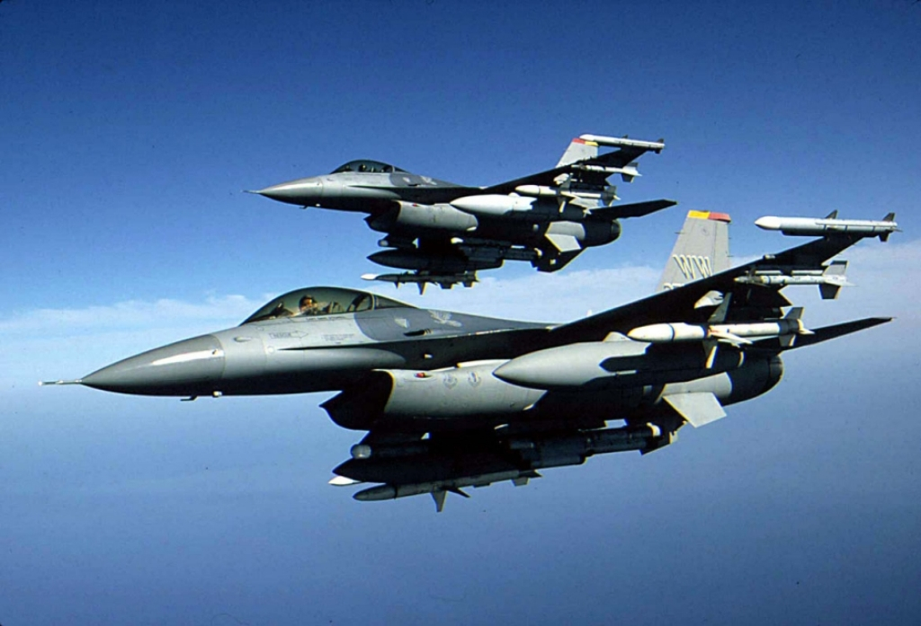

Introduction

After building a general purpose pit, it was time to build something that looks and felt a little more like a modern fighter. Pretty much everything in the first pit was made from scratch, to a very rough plan. That gave me plenty of flexibility when it came to dimensions. I tossed up which way to go with the new pit, really make it look and smell like an F16, or a general approximation. If you are considering building a viper pit this is a very important decision point. If you start building a scale pit then you need to finish building a scale pit. A scale pit has the advantages of being able to get most things, and they’ll fit right in. The challenge is for the bits you can’t get, finding suitable alternatives that can fit in the space of the original component.

Unfortunately for the bank account this pit is a scale pit. This decision was largely driven by drooling over Jason’s Pit Kit and Mikes Panels.

This is a living document that is almost guaranteed to have errors. If you spot any please give me a ping. I’m bnepethomas on the Viperpit site.

Acknowledgements

This document is built largely from others contributions in the Viperpit forums. The F16 layout diagram is from Martin "Pegasus" Schmitt. Pictures and details of the Beta Innovations product come from the product manuals.

Table Of Contents

Introduction 2
Acknowledgements 2
Table Of Contents 3
Table of Figures 7
Planning the F16 Pit 8
Build/Test Issues 10
To Dos 11
New Start-up 11
The Frame 11
Backlighting 13
Parts Suppliers 14
Inputs 17
Outputs 21
Using the Optocoupler 23
Testing the Electronics. 24
Cabling the pit 28
Back of Panel PCB 29
Wiring the JAY-EL switches 30
Wiring the panels 32
Functional Testing of Panels 34
Gauge Details 36
Airspeed Indicator 37
Attitude Indicator 38
Fuel Gauge 40
Centre Console Gauges 42
The Parallax Controller 42
Testing the Gauges 42
Programming the Gauges 44
Working out the Mach-No 50
Lighting the Pit. 50
Gauge Lighting 50
LO-LED64 Led Output 52
General Panel backlighting 53
Dimming the backlights 53
Air Core Backlighting 54
EL Sheets 55
ICP 56
The Centre Console 57
Centre Pedestal 63
Caution Panel 65
Gear Panel 67
The Panels in the Pit 70
The Electronics Bays 70
Falcon Modifications 72
Solid Background for MFDs in MFD view. 72
Keystroke Modifications 75
Test 76
Anti-G 77
Flt control 78
Manual Trim 80
Fuel 82
Aux Comm 85
Ext Lighting 89
EPU 92
Elect 94
AVTR 97
ECM 99
Jet Start 101
Audio2 103
Audio 104
UHF 107
Manual Pitch 109
Threat Warn Aux 111
CMDS 113
Gear Panel 117
MISC 121
Threat Warn Prim 124
Eyebrow Lights L 126
Eyebrow Lights R 128
Indexer R 135
ICP 137
INSTR 140
HIS – Not used 142
Fuel Qty Select 143
Caution Panel 146
Sensor Power 148
HUD Control 150
Nuclear consent 154
Lighting 156
Master Zeroize 158
Air Cond 160
KY-58 162
Avionics Power 164
Anti-Ice 168
Oxy Reg 169
DTU 170
Left MFD 171
Right MFD 173
Other 175
ACES-II 176
TQS 178
SSCG 179
Switch Mapping for non-Falcon 180
Test 180
Anti-G 180
Flt control 180
Manual Trim 180
Fuel 180
Aux Comm 181
Ext Lighting 181
EPU 181
Elect 181
AVTR 182
ECM 182
Jet Start 182
Audio2 182
Audio 183
UHF 183
Manual Pitch 183
Threat Warn Aux 183
CMDS 184
Gear Panel 184
MISC 185
Threat Warn Prime 185
Eyebrow Lights L 185
Eyebrow Lights R 185
Indexer R 186
ICP 186
INSTR 187
HIS – Not used 187
Fuel Qty Select 187
Sensor Power 187
HUD Control 188
Nuclear consent 188
Lighting 188
Master Zeroize 188
Air Cond 188
KY-58 189
Avionics Power 189
Anti-Ice 189
Oxy Reg 189
DTU 189
Left MFD 190
Right MFD 190
Other 191
ACES-II 191
TQS 191
SSCG 191
Centre Console Maintenance 193
Centre Console Base Maintenance 194
PFD Console Maintenance 195
Landing Gear Console Maintenance 195
High Level Module Assembly 196
Test Server as Built Documentation 199
PC Build Instructions 203
Miscellaneous Tidbits 206
Working with PICs 215
Paint for Panels 216
Modifying a Logitech Z10 into a F16 DED. 216
Ribbstick Installation 226
Installation Considerations 226
Design Concept 227
Installation 228
Force Adjustment 229
Technical Issues 229
Realignment Of Stick 230
RWR 230
Aircore Gauges 231
Assembling the Tubes 231
Which Version of Falcon 237
MFD Export from Lighting 239
Wiring Jays MFD Adaptors 246
I/O Card Pinouts 249
ICP Layout 253
Pinouts for the PCBs 254
PCB Modifications 256
PCB Circuit Diagrams 257
PCB Connectors Alphabetically Sorted 272
PCB Connector Pinouts 275

Table of Figures

Figure 1 The test environment 24
Figure 2 A full test run 24
Figure 3 Centre Air Core Gauges 50
Figure 5 RH Air Core Gauges 50
Figure 6 Backlighting of Misc Panel 53
Figure 7 Front Right all lit up 62
Figure 8 Rear of CP 62
Figure 9 Rear of CP 63
Figure 10 Rear of CP with oled USB 64
Figure 11 Caution Panel without gauges 65
Figure 12 Back of Caution Panel 65
Figure 13 Caution Panel Installed 66
Figure 14 Gear Assembly before modification 66
Figure 15 Additional Microswitch and backing plate 67
Figure 16 After installation of microswitch 67
Figure 17 Back of Gear Panel 68
Figure 18 Rear of Gear Panel 68
Figure 19 Gear Panel Installed 69
Figure 20 Primary Input Output Module 70
Figure 21 Power and Dimming Module 70
Figure 22 Gammatron Input 236
Figure 23 Gammatron Rotary Push Mapping 236
Figure 24 GammaRay Inputs 237
Figure 25 GammaRay Rotary Inputs 237
Figure 26 LOLED64 Side A 238
Figure 27 LOLED64 Side B Pinout 238
Figure 28 Jay-EL Bulb Pinout 238
Figure 29 Comport Usage 239

Planning the F16 Pit

The pit is based on learnings from the pit general purpose pit and Viperpit.org, a great source of information for F16 pit builders.

I wanted to improve the documentation of the new pit by using PCBs, then there should be little doubt as to what track goes where. Designing the PCB meant careful checking and rechecking before sending the GEBER files off to the manufacturer. The PCB design program I use is WinQCard (v37), which translates the circuit diagram into a PCB layout with auto-routing. It is sold by the number of holes it supports, which meant a trade off between the cost of paying for a larger pin count version of WinQCad versus getting several boards prototyped. I opted for the 1000 pin version which still meant multiple PCBs would have to be built.

The initial run was the PCBs that sit on the back of each panel. The PCBs are double sided and silk screened. Four PCBs per sheet where specified, cost for 10 boards (including tooling and shipping) was US$101 from www.ourpcb.com
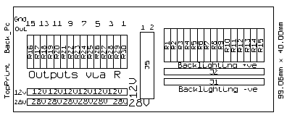
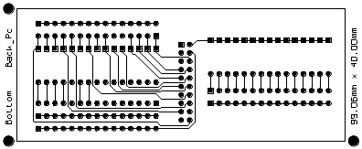
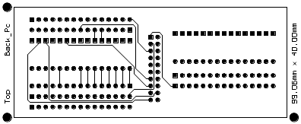

The larger PCBs too a little longer with the following checks:
- Compare data from the F16Callback spreadsheet on Viperpit against pictures of the F16 pit and Mike’s panels.
- Only buttons with Call backs where wired
- All panels were given provision for backlighting.
- One port on the GammaRay was left for used with rotary switches which are shared amongst all three panels.
- Output information from Oliver’s UCC Manual

Another decision point is where to split the PCBs. The drawings provided by Jason provide the answer. There needs to be three panels, with the split between the gear and misc panels.
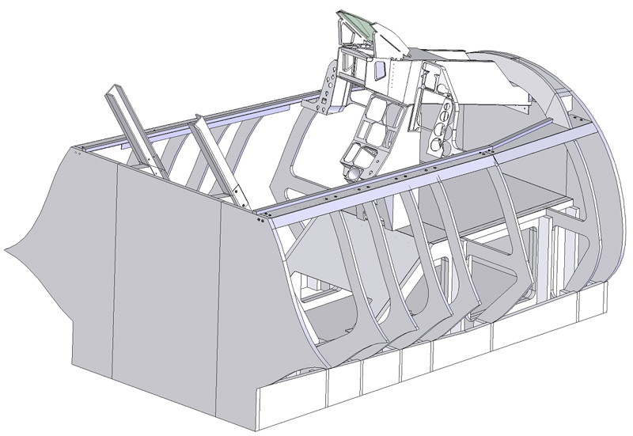
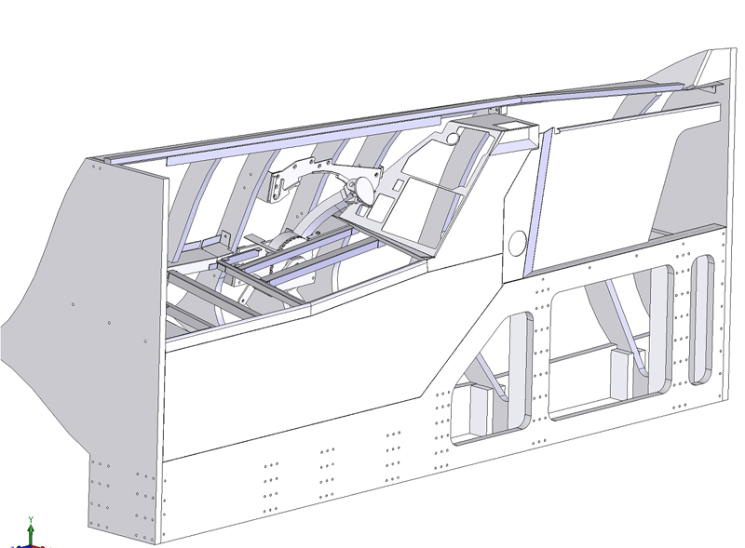

Build/Test Issues

Major
- Caution Led loose

Minor
- Radio Silence switches is a three position switch, only have a two position switch

To Dos

- 2* speed with LMFD button 19 pressed
- check autopilot
- config Cougar
  - – change radio to speedbrake
  - zoom in and out
- remove edges from MFDs
- Add interfaces for touch screen
- Install touch screen drivers
- Paint and assembly 240V distribution block
- Correct rudder USB interface, use PPJoy to emulate button press for both RH and LH pedals
- Code for FI and USB gauges
- Modify code for GPS interface to retry when no shared member and error handle. Extend support for Altitude export
- 2M extension for platform
- 4 Port powerboard with ears for TH2G location
- Covering for cables on walls
- Oriental Night for more paint
- determine Projector mounting

New Start-up
Power on PIT
Prim LCDs
Primary
- F4IM – load and select config file
- CP load
- F4 shared mem
- F4 MFD export (may be not looks like CPD and MFD Export fight
- Start BMS
Secondary
- Power on RWR and CPD lcd
- Boot secondary
- Disconn/recon cpd display until sync
- Start cpd, shared mem, and MFD export
- Start usim, load config, it no lights power off/on Electronflux via switch at front, click through Thread started errors
- Start F4 to pit and Sim Parallex shortcut from desktop
- Start GPSout using go.bat

The Frame

The pit is built using Jason’s kitset.

Figure 1 The Frame after one weekend
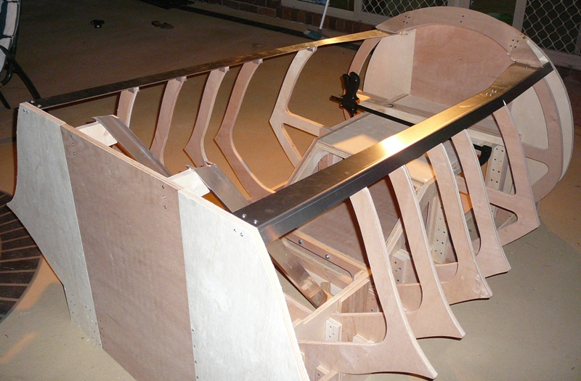

Figure 2 After a coat of paint
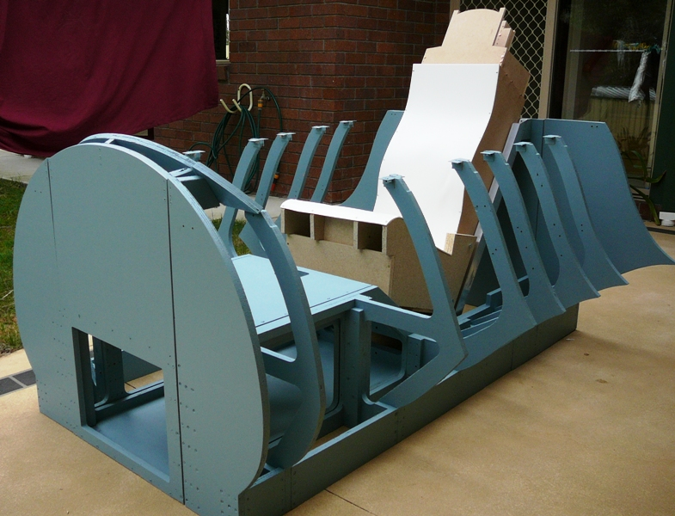

Figure 3 Add a hud tube and CP
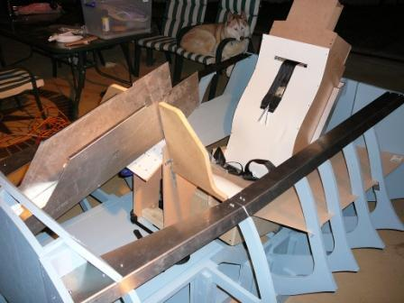

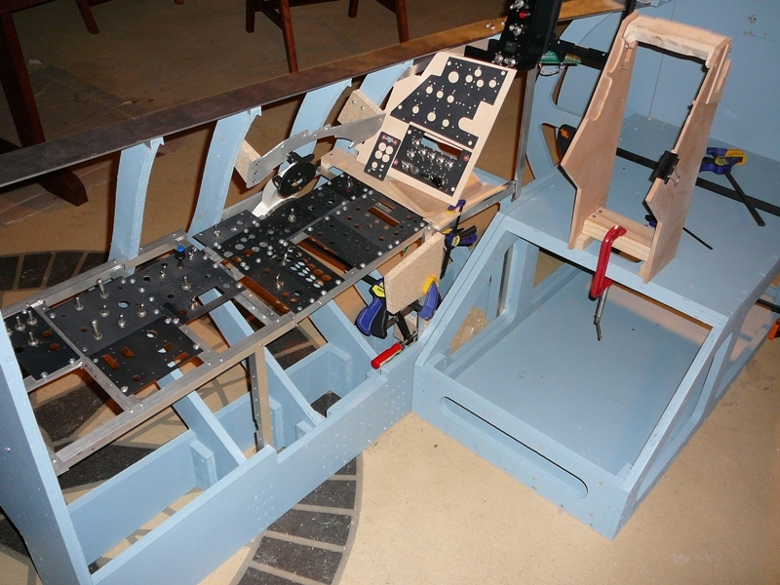

Backlighting

Although I built a prototype using PWM, the dimmer from Flight Data Systems (http://fdatasystems.com/LC_40.htm) offered multiple zones, which maps nicely into what can be used inside the F16 pit. Whilst PWM is electrically noisier than a linear regulator it is much more efficient, and enables you to use different number of leds in columns without impacting on the balance of light output as the voltage is dropped when occurs when a linear regulator is used.

Something I’m still looking at is which voltage to use to drive the backlights. I have plenty of current available with an ordinary PC power supply, but that also means more current flowing to each of the boards. There are something like 539 Leds used for backlighting alone. If the leds are wired in a series of three, then 180 s columns of leds need to be lit. If each column draws 20mA, then the total current draw is 3.6Amps. If a higher voltage is used, allowing 6 leds per column then the current is halved to 1.8Amps. The LC40 lighting system supports 1.5Amps per channel which gives around 16mA per column which should provide more than adequate light levels.

My thoughts is to use multiple channels to provide different light levels for
- Backlighting NVG (Night vision Green)
- Flood lighting NVG (to augment backlight when flying)
- Bright Red/White to flood the pit when getting in and out

I intend to wire the lights so they are aware of voltage levels in the simulation, so lights can be managed by master battery switches. As the sim doesn’t expose Panel light status the switch will be directly used.

I also like the Bright/Dim switch on the lighting controller, which is represented on the lighting panel in the pit.

Initially I’d used LEDs to backlight the panels. Whilst this approach provides a very effective backlight, it is time consuming, and for some panels meant I’d had to cut pieces out of the support rail.

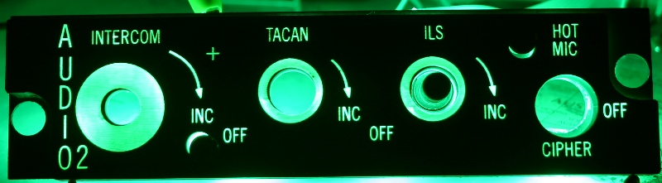

Mike then released precut EL sheets which made the backlighting thing a whole lot easier.

Parts Suppliers

Component | Supplier/Comments | Approx Cost
The F16 frame itself | Penny (designed by Jason) | USD$995
Throttle Arm and mechanism | Penny
Stick and Throttle Electronics | Thrustmaster Cougar | USD$193
Stick | Dave’s Ribstick | USD$620
Plans for Centre Console and Left and Right Instrument Panels, Hud Housing | Jason
Light Dimmers | LC40e Flight Data Systems | USD$131
Backlit Panels | Mike | USD$1332
Backlit Knobs | Airdance
EL Backlighting sheets | Mike | USD$550
Switches – Various | E-Bay (powerguy921)
Switches – Various | art-in-part Culter Hummer Toggle
Switches – Rotary 45 Degree | FDS (Flight Data Systems) | USD$14 each
Switches – Jay-EL | E-Bay (in_biz_since_1984)
Switches - Toggle | Allied Electronics
Switches - Toggle | 676-3240 7101TZQE | 4.980
Switches - Toggle | 676-3265 7203TZQE | 10.010
Switches - Toggle | 870-0579 S1AL-RO | 11.350
Switches - Toggle | 870-0580 S3AL-RO | 11.690
RWR | Oliver (shark.noir) | EUR 661
Seat Belt non-F16 | E-Bay (getnick)
Altimeter | Flight Illusions
Heading Indicator | Flight Illusions
Attitude Indicator | Flight Illusions
Airspeed indicator | Simkits
ICP | Mike and Jay (Crease Card)
EFlux | Beta Innovations
Pilot DED | Logitech Z10 Speakers | AUD$180
PFD | Logitech Z10 Speakers | AUD$180
Fuel Flow Indicator | Logitech G15 Keyboard | AUD$98
Alternate PFD and DED LCDs | Jay (Crease Card)
Alternate PFD and DED LCDs | Topway Hong Kong (LM19264FCC TOC-0342) | USD$82
Indexers | Mike | USD$350
Throttle Guide | Penny or Dunk
Cabin Internal Panels | Dunk
Gear Status Indicators | Dunk
Landing Gear box and Lever | Dunk
Front Glareshields | Dunk | USD$75
Toggle Switch guards | Dunk | USD$16
Eject Handle | Dunk
Centre Console Leg Guards | Penny
DED Cases | Dunk | USD$30
Seat Arm Lever | Mike
Aircore Gauges | Beta Innovations
Gauge Housings | Jarrod | USD$336
Gauge Faceplates | Mike | USD$65
Seat Stickers | aeyes@cockpits.net
Aircraft GPS | Lowrance 2000C | USD$630 + Shipping
Touchscreens for MFD | Ebay Hongkong
PCB Manufacture | www.ourpcb.com
PCB Design | WinQCad (with 1000 pins) | USD$300
Sheet Metal Folder | www.toolman.com.au | AU$125
Project Management Software | GantProject | Free
F16 MFDs | Real ones Jim Keane | USD$401
MFD to MM2 adaptor | Jae (Crease Guard) | USD$63
ICP to MM2 adaptor | Jae (Crease Card)
Warning Panel | Mike and Jae
Switch Guards | Coat Hanger | Free
Seat Cushions | Real Ones (HOwebman@cox.net) | USD$120
Standby Attitude indicator | Real one off ebay (inop) (powerguy921) | USD$34
Rudder Pedals | Simped | 244 Euro
Software to drive Z10 and G15 | Airdance | Free
Software to drive Touchscreen | Touchbuddy | Free
Software for LCD gauges | F4 Glass and Falcon Gauges | Free
Master Caution Button | Mike | USD$40
Eyebrow Indicators | Mike | USD$70
TWP Indicator Panel | Mike
ECM Indicator Block | Mike | USD$70
Right Inside Panel | Shockwave (David) | USD$320
Leds | Hong Kong
5mm megabright warm white led | Hong Kong lvehk
Video Card | Geforce 7950GX2 1G DDR3 Dual-GPU
8” Touch Screen | stivaskam | AU$225
Plasma-MM2 | Beta Innovations (*2) | USD$59
LO-LED64 | Beta Innovations – 64 Port Latched Led | USD$49
LBC-PWM | Beta Innovations – 12V PWM Dimmer | USD$29
LO-HV64 | Beta Innovations – High Voltage Latched | USD$79
EFlux | Beta Innovations -
GammaRay V2 | Beta Innovations - GammaRay | USD$275

Mike Panel Details
Air Cond 30.00 30.00
Air Cond Backplate 10.00 10.00
Anti-G 25.00 25.00
ANTI-G Backplate 10.00 10.00
ANTI-ICE 25.00 25.00
Anti Ice Backplate 8.00 8.00
Audio1 30.00 30.00
Audio 1 Bakplate 10.00 10.00
Audio2 25.00 25.00
Audio 2 Backplate 8.00 8.00
Aux Comm 35.00 35.00
Aux Comm Backplate 12.00 12.00
2 part bezel cover for Glass Gauges $70
the ACES safety lever $35
8 indicators @ $10 ea. = $80

Leo

1) Oil (AC360A)
2) Noz Pos (AC360B)
3) RPM (AC360C)
4) FTIT (AC360C)
5) EPU FUEL (AC360C)
1) HYD PRESS 1 & 2 (AC360A)
2) Cabin Pressure (AC360C)
Qty Price($) Product ID : Product Name
===========================================================================
3 $115.00 AC360AG : 1in 360 Deg Air-Core Movement Green
3 $130.00 AC360CG : 2in 360 Deg Air-Core Movement Green
AC360CG 2" 360 Deg Air-Core Movement Green 1 $130.00/ea
BKB-32 32 point breakout board 1 $26.00/ea
AC360BG 1.5" 360 Deg Air-Core Movement Green 1 $119.00/ea
NITRO NITRO - Expansion Card 1 $119.00/ea

The gauges I’ve purchased are the analog units, which work Dx10 8 Bit cards

Inputs

The directional inputs are based on the Cougar stick. Whilst the core of its electronics are used, there are a couple of mods for the inputs:
The stick itself has been replaced by Dave (Ribbs) Ribstick. The throttle mechanism will drive a mod kit from Cubby, and the pedals are from Simped Detier.

- GammaRay for bulk input
- Gammatron for Rotary Inputs (to get support for push Rotaries)
- Beta Innovations MM2. One for ICP and one for MFD, both using Jay’s adapters. I had originally allocated ports on the GammaRay, but the MM2 with Matrix scanning is a much better fit for Real MFDs, and also for the ICP.

Gammatron pinout
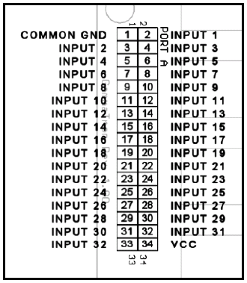

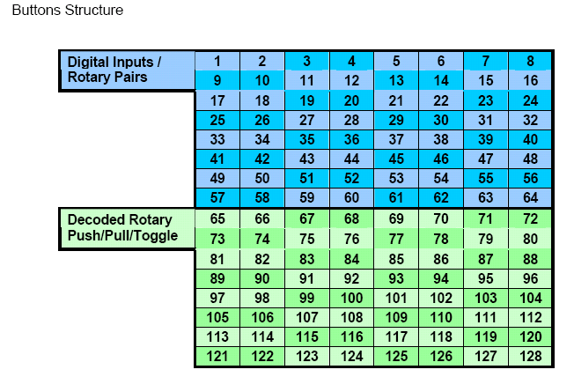

Gammaray Pinout
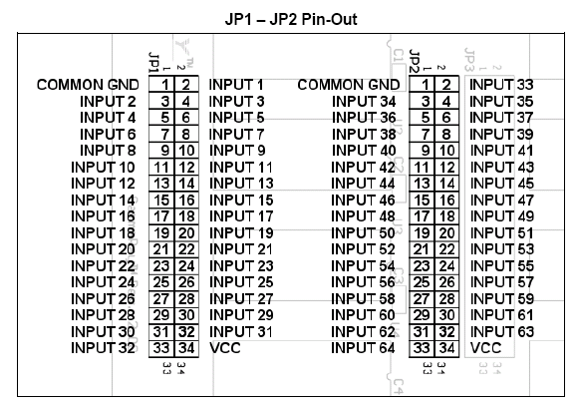
Gammaray Rotary Input mode
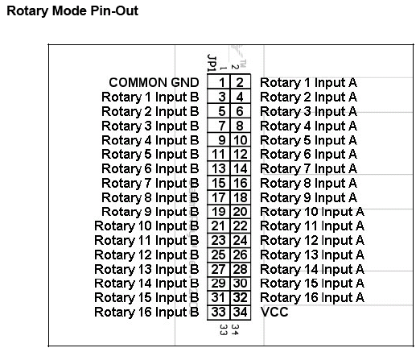

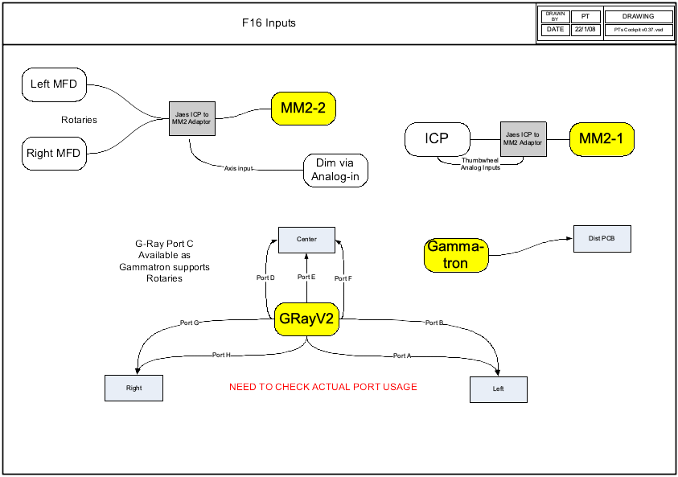
Jay added some new capabilities to the ICP in April 08, working thumbwheels:
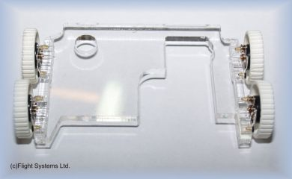

The MM2 has 8 analog inputs, so it can be used as an input for the thumbwheels, as the MM2 sits in the ICP housing there is no long analog runs that need to be supported. Will need to modify the ICP housing to fit the thumbwheel modification as it slightly widens the ICP assembly.

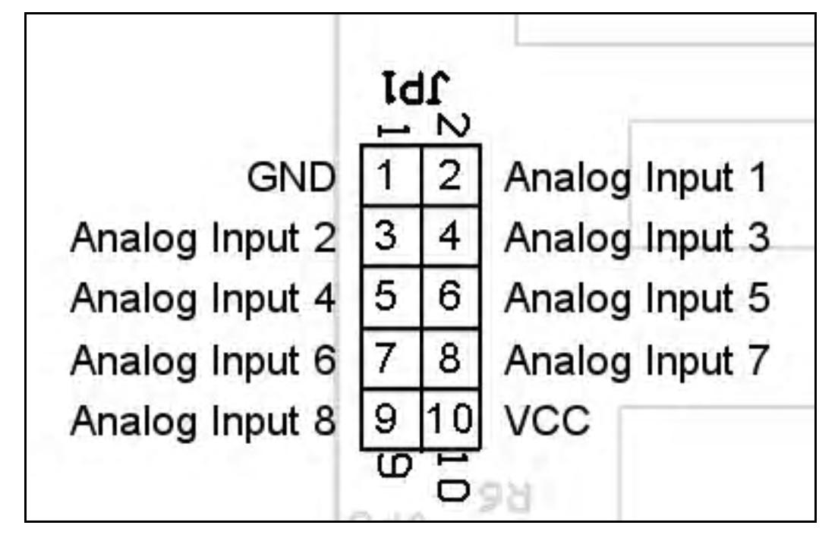.

Outputs

There are a number of outputs in the pit that can be driven from the simulator. Such needs can be addressed using products from a range of Simulator Suppliers. My first general purpose pit used a mix of cards Phidgets, custom LCDs, Parallax, Simkits, Flight Illusions. As none of these had native drivers for Falcon 4 there was plenty of custom code to be cut.

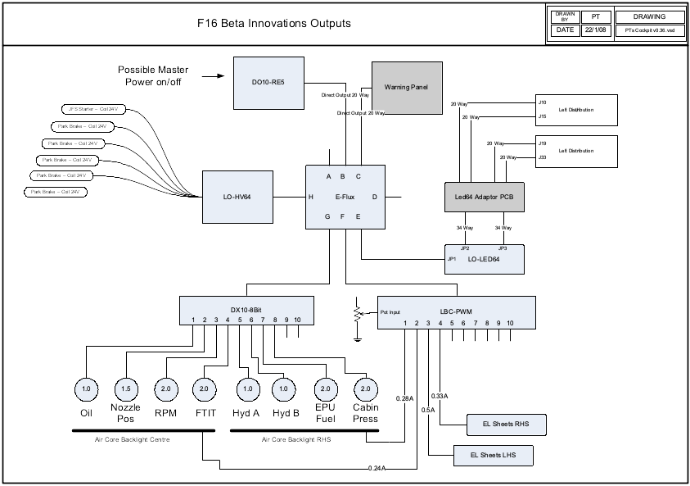

1. The UCC for RWR and PFD
2. Beta Innovations EFlux for Caution Panel and DAC outputs
3. EFlux using LOLED64 for driving leds. For larger current devices use opto-isolator.
4. Flight Illusions altimeter, attitude indicator, and gyro compass
5. The LC_40 dimmer from flight data systems
6. The Parallax 16 port servo card
7. The air core gauge driver from Beta Innovations

I’m attempting to use fewer suppliers for the new pit.
Output | Instance | Card | Comments
Leds |  | Beta Innovations via EFlux
Servos | Airspeed | Parallax or Beta Innovations via EFlux
Servos | Mach No | Parallax or Beta Innovations via EFlux
Servos | Jet Fuel | Parallax or Beta Innovations via EFlux
Magnetic Switches | Jet Starter | Beta Innovations High Voltage card via EFlux
Magnetic Switches | Park Brake | Beta Innovations High Voltage card via EFlux
Flood Lights/Leds | Floor Flood | LC40 PWM Dimmer
Flood Lights/Leds | Panel Flood | LC40 PWM Dimmer
Altimeter | Altimeter | Flight Illusions
Heading Indicator | Heading Indicator | Flight Illusions
RWR Indicator |  | Custom LCD driving by PHCC
MFD Backlight |  | LC40 PWM | 5V bulbs
Panel Backlighting | General Panels | EL Sheets via Beta Innovations PWM via Eflux
Aircore Guages | Nozzle Position |  | Cases by Jarrod, backlighting by Leo, Aircore by Leo
Aircore Guages | Engine RPM |  | Cases by Jarrod, backlighting by Leo, Aircore by Leo
Aircore Guages | Cabin Pressure |  | Cases by Jarrod, backlighting by Leo, Aircore by Leo
Aircore Guages | Oil Pressure |  | Cases by Jarrod, backlighting by Leo, Aircore by Leo
Aircore Guages | Hyd Press – A |  | Cases by Jarrod, backlighting by Leo, Aircore by Leo
Aircore Guages | Hyd Press - B |  | Cases by Jarrod, backlighting by Leo, Aircore by Leo
Aircore Guages | EPU Fuel |  | Cases by Jarrod, backlighting by Leo, Aircore by Leo
Aircore Guages | FTIT |  | Cases by Jarrod, backlighting by Leo, Aircore by Leo

The LO-LED64 can directly drive LEDS. For testing I used the patch/breakout board. Currently the brightness control option doesn’t work (May 2008)

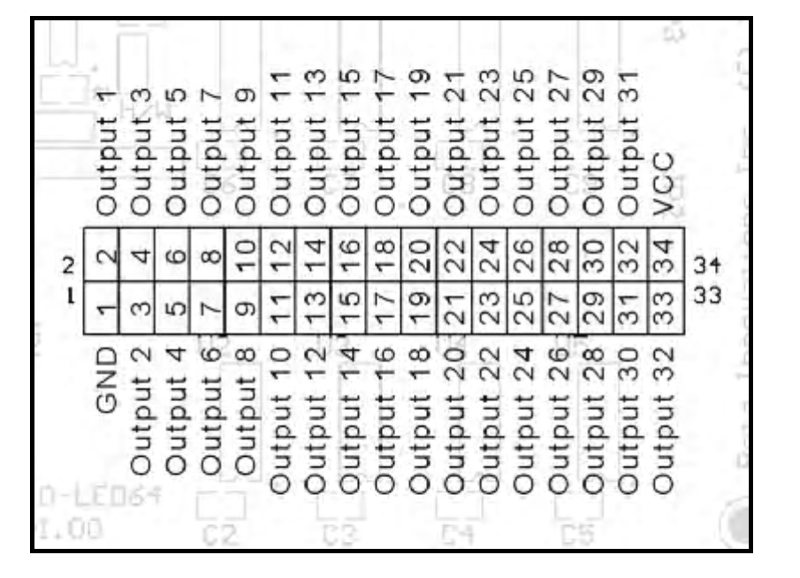

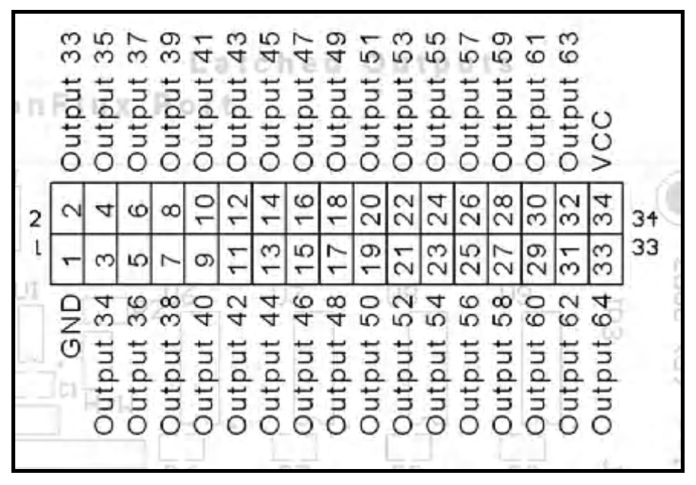

Using the Optocoupler

To reduce the likelihood of higher voltages finding their way back to other input or output devices I’m used a small optocoupler circuit to isolate the outputs of the LoLed64 from the 12V supplies driving the dimmers or Honeywell switches.

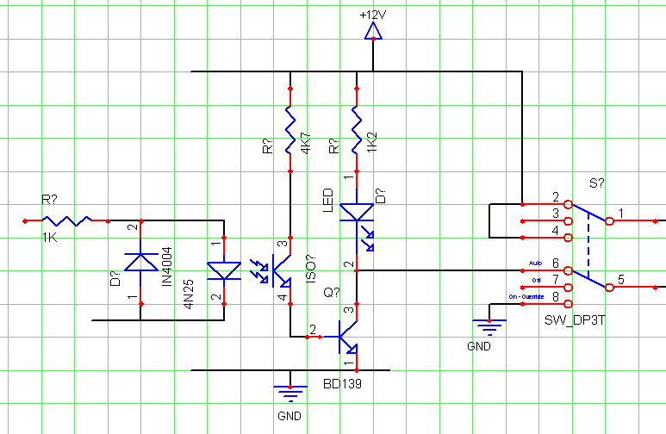

Testing the Electronics.

I’d built a jig to hold the front assembly so I could test the Centre Assembly out of the pit.
Figure 4 The test environment
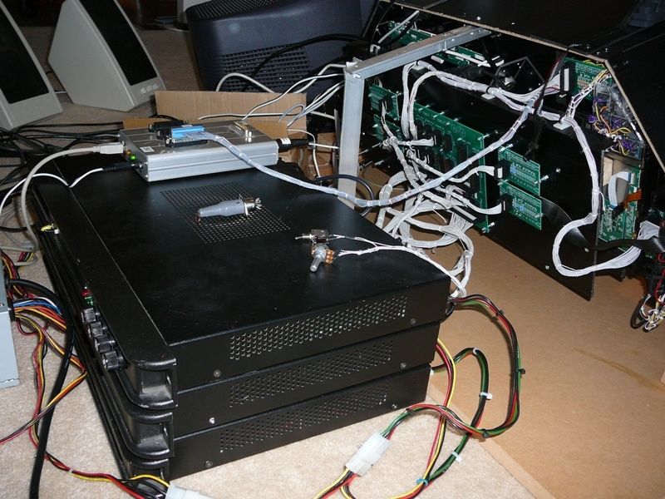

Figure 5 A full test run
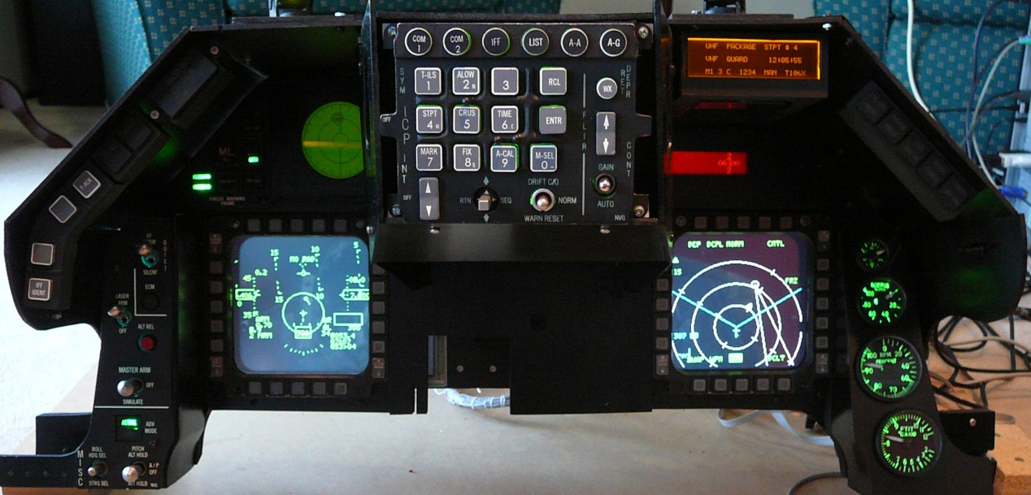

When powering up the ElectronFlux, initially the node LEDs will go yellow. Nothing happens until the USB is connected to the computer, and then LEDS and Relays start clicking.

You may need to update the firmware. Download from Beta Innovations site, this will normally require a username/password.

Upgrading ElectronFlux Firmware (from Readme file)

************************ I M P O R T A N T ***************************

DO NOT RESTART THE MODULE UNTIL ALL NODE PROCESSORS
HAVE BEEN UPDATED WITH THE LATEST FLASH.

********************* I N S T R U C T I O N S ************************

1) Unzip contents into a temp directory.
2) download and install the latest Device Manager if you haven't already done so.
3) Start Device Manager and restart the ElectronFlux module in Flash Mode.

Updating the Nodes flash memory.
4) Click on the "Node Configuration" tab.
5) Click on "Load..." button, locate and select the EFND_R###.bix file included in this zip file.
6) Click on the "Program" button. Flash update will begin.

Updating the Core flash memory.
7) Click on the "Device Configuration" tab.
8) Click on "Load..." button, locate and select the EF_R###.bix file included in this zip file.
9) Click on the "Program" button. Flash update will begin.

10) Click on "Execute" button once the update is complete. Device is now ready to use.

Configuring the EF Ports
Port F
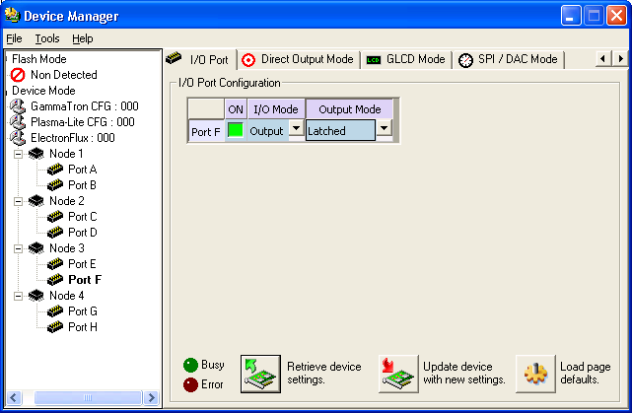

Port G
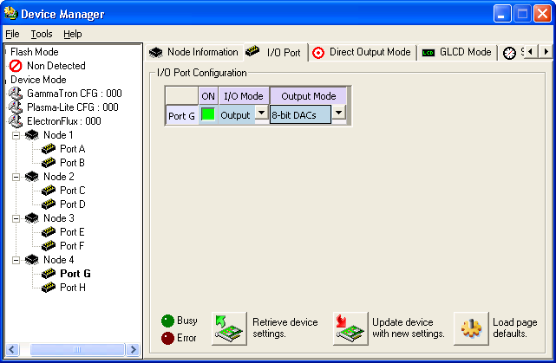

Port H

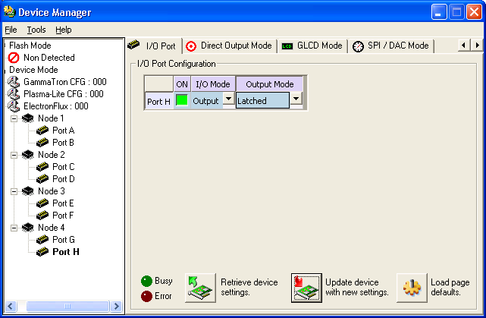

Testing the Ports

Use the Beta Innovations USB Toolkit

Select the Latched Outputs Toolkit, and then Port F. Now select the individual ports to test. With a supply voltage of 5.07Vs ,the port was rising to 5.06V.

With a Flatop White LED the following results were obtained:

Series R | mA | Offered V
10K | 0.23
1.5K | 1.34
820 | 2.30
330 | 4.96
220 | 6.82
150 | 9.08 – 9.43
100 | 12.26 | 4.67
56 | 17.12 | 4.5

With 4 Leds in a JAY-EL no resistor gives a total load of 41.2mA.
Series R (4 Leds) | mA
100 | 14.85
56 | 20.87
33 | 26.43

Cabling the pit

A quick count of switches, leds, and lamps shows that the pit has well over two hundred connections, and at least ten major electronic modules. Now given anyone of these modules may meet an untimely end, I didn’t want to throw a soldering iron into the middle of a mass of cables whenever a module needed replacing or testing.

With the F16 Pit I put together some PCBs using WinQCad (hopefully will be of use to others someday). As the pit breaks down into three blocks, left middle and right there are three distribution panels which connect back to the electronics.
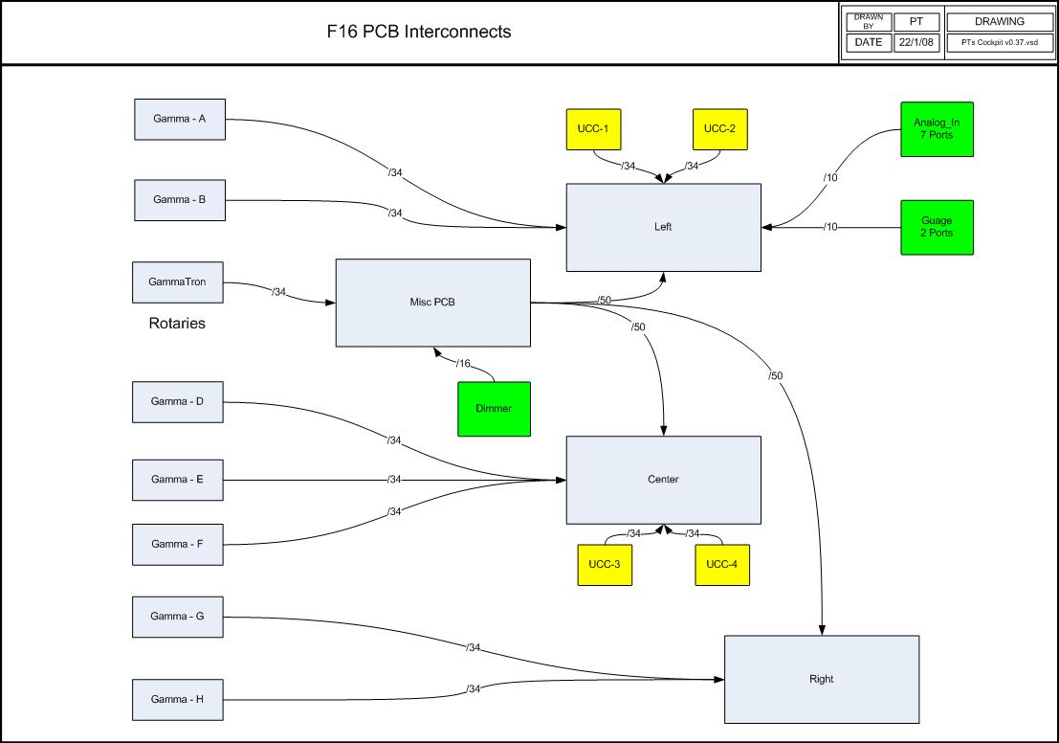

The Misc PCB provides a distribution point for the dimmer and rotary interface on the Gammatron.

Each Panel in the pit has a common PCB which provides connectivity to the GammaRay and UCC/ElectronFlux. The idea behind this is that only a single cable connects to the panel to the distribution PCB which in turn only has the minimal number of connectors back to the electronics. I’m planning to put all of the electronics in a single PC box/power supply simplifying the layout of the electronics and power supplies.

Back of Panel PCB

This is the building block of the pit, and has been designed to cover all of the panels aside from the MFDs which have a large number of connectors.

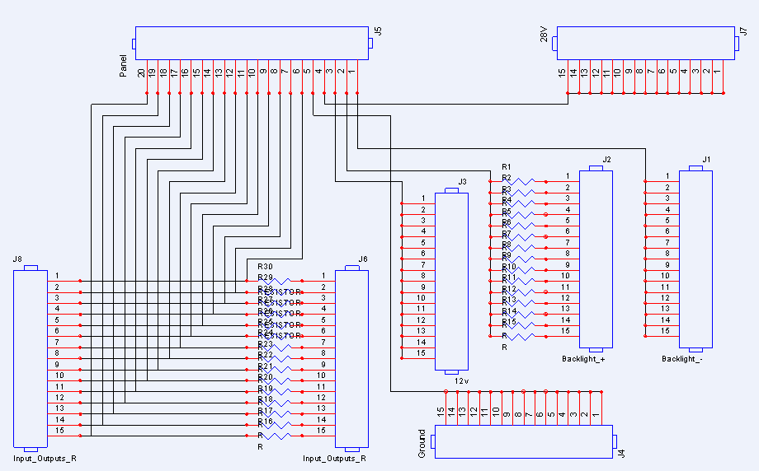

The PCB has 4 pins which 5 ports which are dedicated to the Backlight and power requirements. The remaining pins can either be inputs or outputs. The outputs can be driven via a resistor.

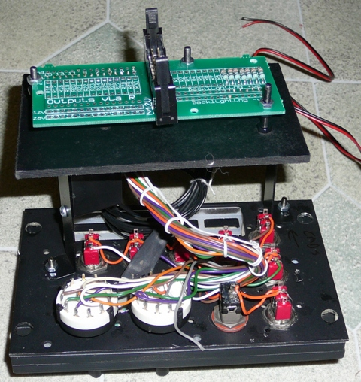

The distribution PCB is connected directly to the lighting controller, which has multiple channels. The first channel is for panel backlighting, the second for NVG lighting of the front of the panels, the third for while flood lighting of the pit in general.

Wire Colour | Wire Role
Light Blue | Backlight +ve
Dark Blue | Backlight -ve
Black | Ground
Yellow | Variable Voltages 28 to 12V for Lights and Leds
Purple | Return from lights –ve side going to output
Red | +12V
Green, crème, Brown, Orange, Gray, White | GammaRay Inputs

The PCBs have thicker tracks for the Gnd, Fixed voltages, and the Dimmer rails. The dimmer rails are separated from the general inputs/outs by Gnd and general rails which should provide additional noise isolation.

Wiring the JAY-EL switches

The Jay-EL switches I scored were from an F4 simulator. To change the bulbs simply put your finger nails around the front legend and pull it out.
Photo Disassembled switch

Each Switch holds 4 bulbs rated at 28Volts, 2 across the top and two across the bottom. Current draw at 28 is 40mA, 30mA at 16V. At 28V one bulb effectively lights the top or bottom of the switch. All four bulbs draw 160mA. At lower voltages if becomes more clearly apparent that two bulbs are in each row. Using a modification described in the appendix, I replaced modified the bulbs replacing the bulb with white leds. While I haven’t checked it out myself, a modeling company does offer bulbs with led inserts (http://www.trainaidsa.com/shop-leds.html)

Looking from the top of the switch the are pins labeled 4, 3, C, 2, 1 (from back, left to right)

Pin | Bulb Position
C | Common
1 | Bottom Left
2 | Top Left
3 | Top Right
4 | Bottom Right

What I also noticed is the case casing does get a little warm when the lights are on. I briefly did think about trying to series the bulbs to reduce current draw and brightness a little and then realised they all anchor to a single common.

The switches from the F4 Simulator have the following legends
White Front Legend | F-16 Equiv | Top Lighted Text | Bottom Lighted Text | Lens Colour
SYS TEST | Yes | TEST (Green) | TEST (Green) | Clear
Diamond Shape |  |  |  | Black
ML RST | Yes |  |  | Red
SEARCH |  | SEARCH (Yellow) | SEARCH (Yellow) | Clear
MODE | Yes | PRIORITY (Yellow) | OPEN (Green) | Clear
POWER |  | PWR (Green) | PWR (Green) | Clear
RECORD |  | RECORD (Green) | RECORD (Green) | Clear
AAA DEF |  | AAA (Yellow) | DEFEAT (Yellow) | Clear
TGT SEP | YES | TARGET (Green) | SEPARATE(Green) | Clear

The F16 TWP Stack looks like

 |  | HAND OFF (Record)
 | LAUNCH | MODE PRIORITY
Unknown/ Naval (AAA Def) | SYS TEST | TGT SEP

The Green Highlighted text have a direct match to the F4 Legends, the Yellow will have to wait until someone makes some matching lenses. As of mid 2008 Mike now makes inserts for the switches.

The switch has six contact connectors at the back. Basically a left and right side.
The top connector is common, middle is Normally Open, and bottom is normally closed.

Changing the lenses.
- Remove the bulb assembly
- There is a metal collar around the front with a couple of dimples, remove from front.
- Underneath this should be a clear lens, the coloured lens, and another clear lens.
- If the lens don’t simply dropout, remove a bulb and push them out fro the back.

The non-soldered switches

A few of the switches don’t have solder lugs, thought this was going to represent some challenges, but has it turns out all is good. Used the following lugs (from Dick Smith Electronics)

  - 5.3mm Ring Terminal Red
  - 3.2mm Spade Terminal Red
  - 4.3mm Spade Terminal Blue

Wiring the panels

As each panel has a connection back to the distribution panel, one of the challenges was how mount the connection on the back of the panel. I explored a couple options; making box frames like the real thing had promise until I discovered it didn’t fit into some of the locations as it hit the rails. Getting threaded pillars was also a bit of challenge. Ended up make simple brackets.

Start by setting up a document or spreadsheet to keep track of what you’ve purchased. There are a lot of panels in the F16 and it’ll probably take a while to get all the needed bits.

Here’s a suggested order to assemble panels:
- I highly recommend Mike Panels and Back-plates as they are to scale and back-light nicely
- Determine how the panels are going to be backlit. This is a major decision point as it impacts how much free space you’ll have on each panel. I originally used LEDs which provided a very bright light, but there were a few challenges. When the EL sheets appeared from Mike Williams, I changed tracked. See the panel backlighting section for more information.
- Determine how the cables are going to be terminated, for example I’m using distribution panels in the left, centre and right sides of the pit so it can be ‘easily’ disassembled. I also made the decision to use independent wiring for each panel so they can be individually removed. Another option would have been to wire the panels after they had been bolted in. Whilst this simplifies cabling it makes future modifications more challenging.
- As I discovered building a scale pit means that pretty much every needs to be correctly scaled, so build the shell of the pit first as it’s the thing you’ve got to squeeze things into
- Roughly mount the stick and throttle, as these can get in the way of bits protruding out of the back of the panel.
- Install the switches, rotaries and indicators (if possible) onto the panels. Check the switches are able to fit through the EL Sheet.
- Install the EL sheets.
- I also painted the heads of the bolts and the tops and sides of the nylon washers to give the pit a more polished look.
- Mount the panels and face plates
- Build the frames to support the panels and the Center Console. Whilst building the frame check that the panels with components can be mounted. You’ll probably find it’ll be time for some additional filing
- At this point you should have all the panels and faceplates mounted in the pit.
- Now its time to build the brackets to hold the connector of each of the PCBs.
- I used S shaped brackets, held where possible by the bolts that support the front faceplate. If the bolts are not in a suitable location 5 minute epoxy resin is used to attach the bracket to the base plate. Before gluing double check the bracket and PCBs are not going to collide with anything on the frame.
- Given I was using EL sheets I also mounted the inverter on the bracket; again ensuring it doesn’t hit anything on the panel or in the pit.
- Now mount the board the will sit between the bracket and PCB. This basically is an adaptor to deal with the different possible bracket positions and the relatively fixed holes on the PCB. Again check, that the back board doesn’t hit anything in the pit. Nylon washers should be used to provide insulation between anything metal and the PCB.
- A slot should be cut into the board that supports the PCB to allow wiring through (including the input to the EL inverter)
- The panel assembly can now be disassembled and given a coat of black satin paint.
- Partially assembly the panel and the wire up the switches and indicators.
- Test switches. Initially test switches with no power applied, all positions of all switches should be tested. Meter all switch inputs to check there are no crossed connections to indicator outputs.
- Test indicators
- Remount the EL sheet.
- Test backlighting
- If modifications are required to the panels, they can be touched up using the paint recommended in the painting section of this document. Once you’ve double checked all is good spray a couple of coats of sealant over the front panel.
- Cable-tie the EL sheet cabling and use hot melt glue to support the EL sheet connector.
- Run a final functional test before mounting the panel.
- And now move onto the next panel.

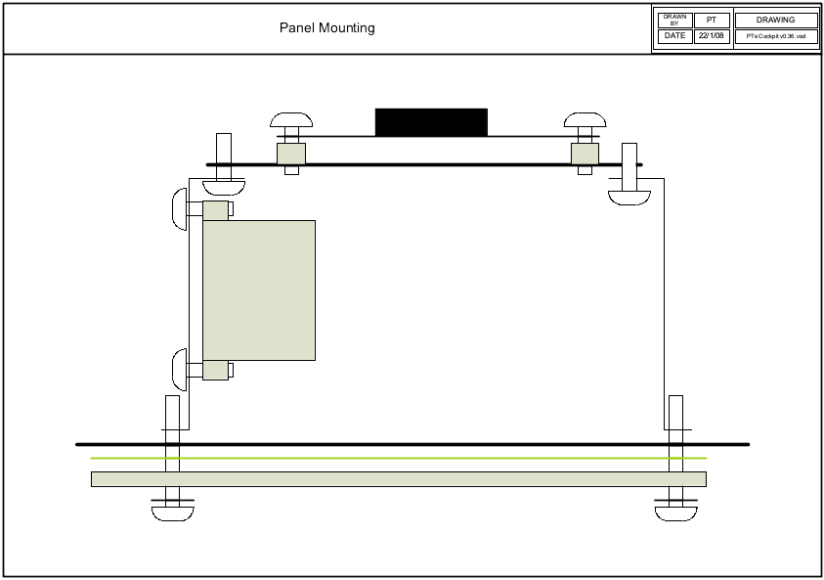

Functional Testing of Panels
Disconnect all Power and USB devices
Manually check continuity for LEDS on both signal and ground sides
Check rails are not shorted (note +28Rail on extension PCBs is now ground rail for Leds)
Check rails connect to connect rails on aggregation PCB
Connect on Led driving USB devices
Test Leds devices
Only if all led tests successful proceed
Shutdown power
Remove USB driving devices
Connect GammaRay ports
Test inputs.
Power off
Connect USB Driving devices
Check all inputs and outputs using USB toolkit.

The Centre Console Assembly

 | Left AOA Indicator (on top of front glareshield) | 3 LEDS
 | Right NWS, RDY Indicator (on top of front glareshield) | 3 LEDS
 | Misc Panel | Header PCB and EL Inverter
 | Left MFD | MM DB15 and 5V for back lighting
 | Right MFD | MM DB15 and 5V for back lighting
 | TWP | Header PCB
 | RWR | Connection to Aluminum Tube
 | Master Caution | Switch plus 3 Led
 | TF Fail
 | FACK
 | DED | 12 USB
 | Fuel Flow
 | Eyebrow warnings
 | Gauges
 | Left Display | 12 VGA USB
 | Right Display | 12 VGA
 | CP Flood
 | ICP

Gauge Details

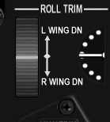
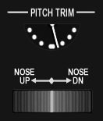
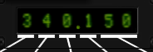
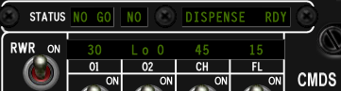
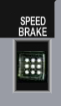
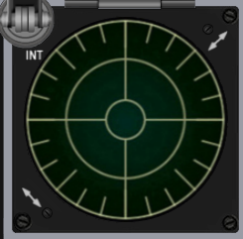 | 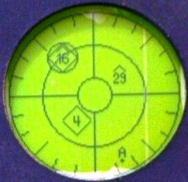
Airspeed Indicator  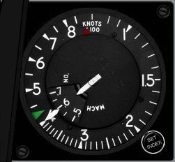 | 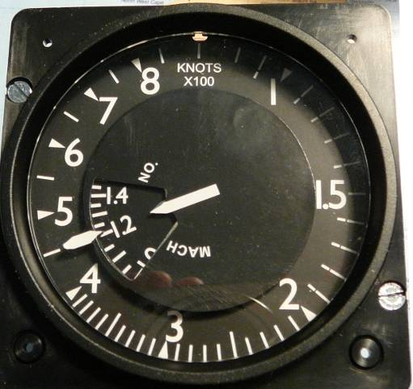  Simkit’s General Purpose Gauge with F16 Faceplate.  Airspeed indicator, the Simkit’s F16 indicator is pretty darn tidy, even the Mach-No dial works!
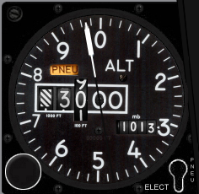 | 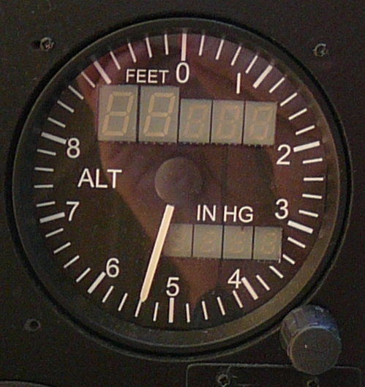  Not my first choice, as it isn't a close replica, but again the Simkit’s altimeter doesn't keep up with a nut at the stick of a viper, so the Flight Illusions one wins. I'd prefer to have white displays and be able to dim them, but I guess I'll have to wait until something comes out of Leo’s factory :). So for medium term Flight Illusions.
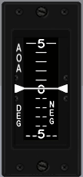 | 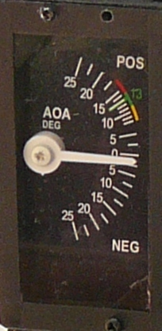  The AOA and VVI will be simple servos using RedDog's recently released templates.
Attitude Indicator  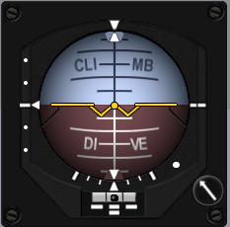 | 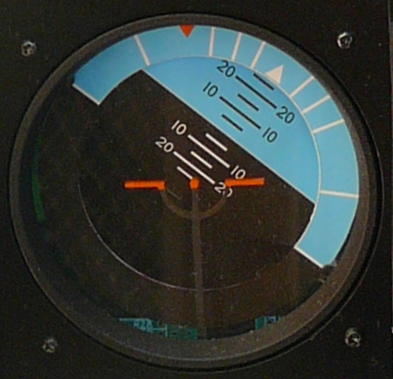  Attitude Indicator, Flight Illusions for this one as the Simkit’s Attitude indicator does not do full rolls.
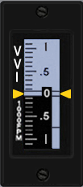 | 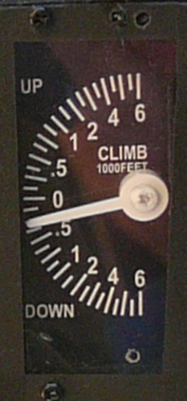
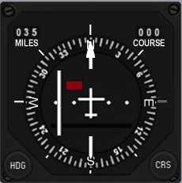 | 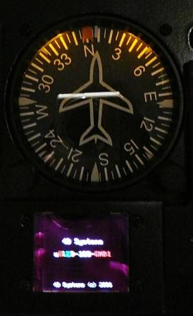
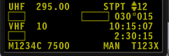 | 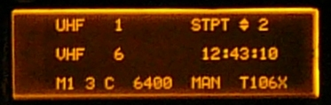
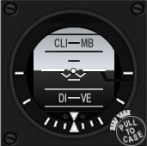
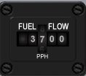 | 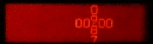
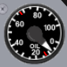
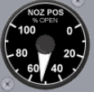
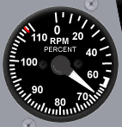
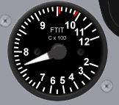
Fuel Gauge  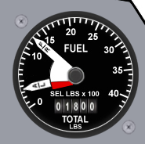 | 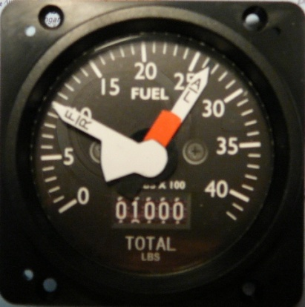  Simkit’s General Purpose Gauge with F16 Fuel Faceplate.  The Simkit’s gauges have dual needles and don't look to0 bad. (http://i198.photobucket.com/albums/aa273/bnepethomas/P1010206.jpg)
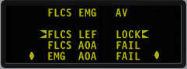
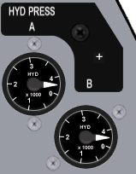
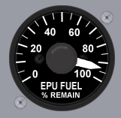
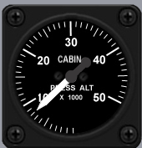
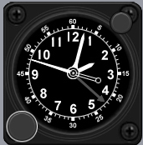
 | 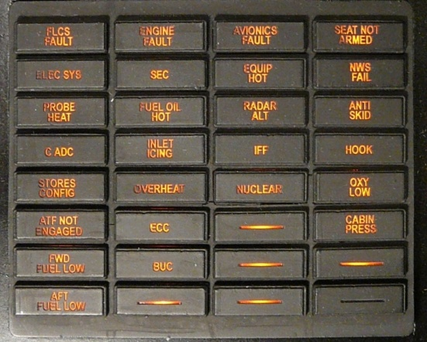

Centre Console Gauges

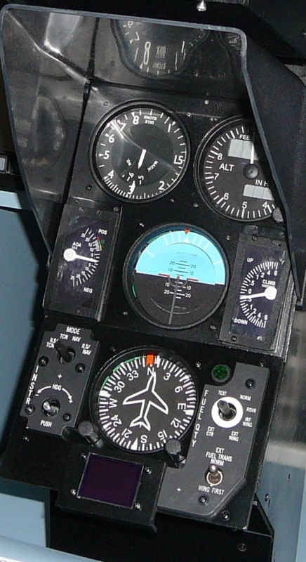 | 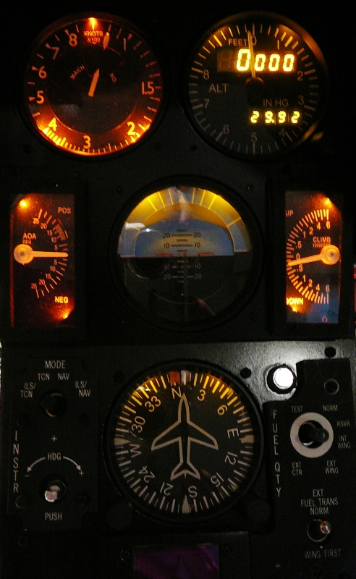

Both Flight Illusions and Parallax are interfaced using a Virtual Serial Port.

Controller | Com Port
GPS | Com1
Flight Illusions | Com6
Parallax | Com2

Parallax port manually set using the advanced settings

The Parallax Controller
The Parallax Controller is a 16 Port USB Servo Controller (first Port is Port 0). It needs an external 5V supply to drive the servos. You can configure and test the controller without the external supply, but the servos will not respond until power is applied.

Testing the Gauges

Flight Illusions driver includes test capabilities, current version in July 08 is G-Step 3.51.

Parallax supplies PSCI, which can also manage the speed at which servos move.

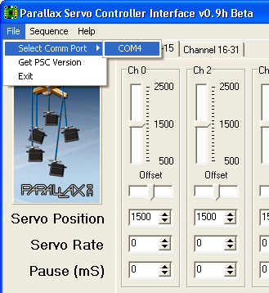

To open the Parallax controller you first need to select the Com Port (virtual) the device is attached to. Once the port is open the status box will change from blank to Comm Port Open.

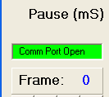

A number of devices use the FTDI USB to serial converters. PSCI will scan looking for the Parallax device. Another way to check which port the Parallax is attached to is to open Device Manager and check serial ports. Sometimes the board goes a little silly, i.e. it opens but doesn’t respond. Check sanity by requesting version, if it returns v1.4 its ok, if it returns ‘…’ then communications have been lost.
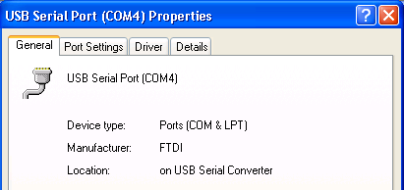

PSCI is a sequencer which can be used to exercise the gauges. Given you usually will want to slow or dampen the gauge movements, the servo rate should be set to a non-zero number. I’ve found 30 to be good for heavily dampened devices and 10 for more active gauges such as AOA and VSI.

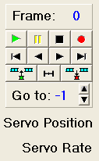

Once the servo rates have been set, position the gauges using the sliders, and then press the Record (red dot) button. The sequence can then be saved (Sequence – Save) Programming the Gauges

Programming the Gauges

Whilst the pit will primarily be driven by Falcon4, it’s desirable that it can be driven by other Sims.

Given Leo has already done the hard yards with F4IM, all devices driven by F4IM will continue to use the F4 shared memory. For the Parallax and flight Illusions gauges they’ll be driven by a separate shared memory file, this makes it easier to move between different devices in the future as the code to drive the device is abstracted from the code to read values from the simulator.

Simulator Value | Gauge | Gauge Item
Airspeed | Simkit’s Airspeed
Mach No | Simkit’s Airspeed
Altitude | FI Altitude
Air Pressure | FI Altitude
Air Pressure Adjust | FI Altitude
AOA | AOA
Roll | FI Attitude
Pitch | FI Attitude
VSI | VSI
Heading | FI Heading
Desired Heading | FI Heading
Fuel Internal | Simkit’s F16 Fuel (Fwd)
Fuel External | Simkit’s F16 Fuel (Aft)

Data Types for the Shared Memory File

Public Type Type_Parallax_Servo_F16
'Angle Of Attack -25 to +25
AOA As Single
'Vertical Speed -6000 to +6000
VSI As Single
'Internal Fuel -99 to 100, -99 Indicates Power off
Internal_Fuel As Single
'External Right Fuel -99 to 100, -99 Indicates Power off
External_Fuel As Single
Airspeed As Single
'MachNo multiplied by 100
MachNo As Single
PowerAvailable As Boolean
End Type

Public Type Type_FI_F16
'Common Backlight Control for FI Gauges
Backlight As Single
'Altitude 0 to 100000
Altitude As Single
'AirPressure 0 to 2000, 1013 normal
AirPressure As Single
'Roll
Roll As Single
'Pitch
Pitch As Single
'Heading
Heading As Single
'Drives HeadingBug
DesiredHeading As Single
PowerAvailable As Boolean
End Type

Falcon 4 Data Path’s
F4 Glass
2nd PC
1st PC
Shared Memory File
“PTLomacSharedMemoryArea”
Shared Memory File
“FalconSharedMemoryArea”
GPS
RS232 from COM5
"19200,N,8,1"
NEMA
UDP Data Link for Dual Engine Stack
(to 8081)
PTTRC
_Link
TCP Link to Simkits TRC Custom Link
(to 1972)
Shared Memory File
“TRCSharedMemoryArea”
Shared Memory File
“PTDualEngineSharedMemoryArea”
Shared Memory File
“FalconSharedMemoryArea”
Falcon4

Flight Illusion Gauges

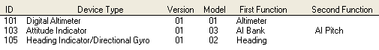

Note – when using GStep 3.5 – even if gauges are configured and responding the connection status can be reported as unknown.
I used the SysInternals (now owned by Microsoft) PortMon in hex mode to decode what is being sent to the gauges.

Using the Decoder Ring

00 Start of frame
65 Device ID 101 – 65 Hex

Data
0 01 02 = 0
3 f5 13 = 5109
2 31 4e = 20016

4 Set Attitude Command

FF End of Frame

0 01 02 = 0
3 f5 13 = 5109 – 13F5
2 31 4e = 20016 – 20017

MSB is +ve negative bit.
Commands for Flight Illusion Gauges

Byte 1: Flag byte:&h00
Byte 2: Address: 1-255; address zero forbidden!
Byte 3: Command byte: Bit 3 always "1": CCCC.1SHL
H & L are the data bits to "repair" the "forced to one bits" in
byte 4 & 5), S= sign bit of the integer value)
CCCC is the 4 bits command(0001-1111, so 1-15)
Byte 4: Data Low; &h00-&hFF; bit0 always 1 : XXXX.XXX1 -> XXXX.XXXL
Byte 5: Data Hight:&h00-&hFF: bit1 always 1 : XXXX.XX1X -> XXXX.XXHX
Byte 6: End byte:&hFF

Altimeter

Commands:
0= noop
1= Initialize
2= Set Instrument Address; Value 0-&hff (odd addr. only),second byte:&HAA
3= Set Scan frequency (Needle Speed)
4= Set Altitude (-9999 to + 50000)
5= Set AirPresure mode (byte1: 0= Inches HG, 1= Milibar), byte2:0=no connection, 1=connected to altitude)
6= Set Needle zero displacement; Number of steps between sensor and needle
7= Send info about instrument; Reply &h00, Address, Type, Model, Version, Airpressure
8= Switch lights: Low byte= DL00.0000; D=display on/off, L=light on/off
9= Set Instrument Model &Version, Low Byte=Model, High Byte=Version
10= Write an EEPROM byte (Blocked; is for debug only)
11= Direct Needle Control (0 to 1079); Sets needle independent from altitude
12= Set Airpressure value

Command 4 is the one you'll need mostly. Rest better using our ControlProgram.

Attitude Indicator

Commands:
0= noop
1= Initialize
2= Set Instrument Address; Value 0-&hff,second byte:&HAA
3= Set Instrument speed: If positive: Bank; If negative: Pitch
4= Set Bank position (0-3839)
5= Set Pitch position (0-1200)
6= not used
7= Send info about instrument; Reply &h00, Address, Type, Model, Version
8= Switch lights: Low byte= DL00.0000; D=display on/off, L=light on/off
9= Set Instrument Model &Version, Low Byte=Model, High Byte=Version
10= Move bank directly; used for calibration
11= Move pitch directly; used for calibration
12= Set calibration values for pitch and bank centres
13= Clear calibration values for pitch and bank
14= Set/Reset test mode: 0=off, 1=on, turn right, 2=on, turn left
'----------------------------------------------------------------
I advise just to use commands 4, 5 and 8 only. Calibration can best be done using our G-Step control program. It has to be done only once.

Engine Cluster
The engine cluster is connected to a virtual com port via 40 bytes long messages.
Port settings: 38400 bps, 8 bits, no parity, 2 stopbits

First byte is the command. Engine cluster will recognize more commands, but for gauge setting this must be character "F". Other commands are for diagnostics and program update, so use the "F" only!!
After the "F"a string of characters will set the needle. High and Low byte make an integer from 0-3800. Take care of gauge limits. In Visual Basic the characters to set ITT gauge are (as an example):

int1 = GaugeIttLeft
If GaugeIttLeft > 3800 Then GaugeIttLeft = 3800
If GaugeIttLeft < 0 Then GaugeIttLeft = 0
int2 = Int(int1 / 256)
Mid$(ComBufferXmit, 2, 1) = Chr$(int2 And &HFF)
Mid$(ComBufferXmit, 3, 1) = Chr$(int1 And &HFF)

Displays are driven using 4 bits per digit. Example for torque display:

If TorqueLeft < 100 Then
byte1 = Mid$(bTorqueLeft, 4, 1) And &HF
byte1 = (byte1 + 1) * 16
byte1 = byte1 Or &HB 'code for dot
Mid$(ComBufferXmit, 36, 1) = Chr$(byte1)
byte1 = Mid$(TorqueLeft, 2, 1) And &HF
Byte2 = Mid$(TorqueLeft, 1, 1) And &HF
byte1 = ((byte1 + 1) * 16) + Byte2 + 1
Mid$(ComBufferXmit, 37, 1) = Chr$(byte1)
Else
byte1 = Mid$(TorqueLeft, 1, 1) And &HF
Byte2 = Mid$(TorqueLeft, 2, 1) And &HF
byte1 = ((Byte2 + 1) * 16) + byte1 + 1
Mid$(ComBufferXmit, 37, 1) = Chr$(byte1)
byte1 = Mid$(TorqueLeft, 3, 1) And &HF
byte1 = byte1 + 1
byte1 = byte1 Or &HB0 'first digit = blank/space
Mid$(ComBufferXmit, 36, 1) = Chr$(byte1)
End If

The displays is capable to display the following characters:

&h0=character "0"
'
'
&h9=character "9"
&hA = "." 'dot
&hB = " " 'space
&hC = "+" 'plus
&HD = "-" 'minus
&HE = ':" 'semicolumn
&HF = '=" 'equal sign

Backlight and displays are switched on/off using bits in byte 38.

Last two bytes are checkbytes: &hAA.

Message layout:

Byte 1: command:F=update values
Byte 2: ITT Left Hight
Byte 3: ITT Left Low
Byte 4: Torque Left High
Byte 5: Torque Left Low
Byte 6: PropRPM Left High
Byte 7: PropRPM Left Low
Byte 8: Turbine Left High
Byte 9: Turbine Left Low
Byte10: FuelFlow Left High
Byte11: FuelFlow Left Low
Byte12: OilTemp Left High
Byte13: OilTemp Left Low
Byte14: OilPress Left High
Byte15: OilPress Left Low
Byte16: ITT Right Hight
Byte17: ITT Right Low
Byte18: Torque Right High
Byte19: Torque Right Low
Byte20: PropRPM Right High
Byte21: PropRPM Right Low
Byte22: Turbine Right High
Byte23: Turbine Right Low
Byte24: FuelFlow Right High
Byte25: FuelFlow Right Low
Byte26: OilTemp Right High
Byte27: OilTemp Right Low
Byte28: OilPress Right High
Byte29: OilPress Right Low
Byte30: Display1 Left High
Byte31: Display1 Left Low
Byte34: Display1 Right High
Byte35: Display1 Right Low
Byte32: Display2 Left High
Byte33: Display2 Left Low
Byte36: Display2 Right High
Byte37: Display2 Right Low
Byte38: Control byte
bit 7: Light control 0=off 1=on
bit 6: Blanking Diplays 0=off 1=on
Byte39: &hAA
Byte40: &hAA

After each message the Engine Cluster will send back a 16 byte message with first character &HFF. Rest of the message can be neglected. Contains status and some internal readings.

Working out the Mach-No

I’d initially tried to calculate the position of the Mach No relative to the position of the airspeed meter. Turns out that’s the hard way to do it. The Mach-No is proportional to the altitude, so find the Mach 1.0 speed for each of the altitudes and store that is a table.

Altitude | Mach 1.0 kts
0 | 661.4
5,000 | 649.9
10,000 | 638.2
15,000 | 626.3
20,000 | 614.2
25,000 | 601.8
30,000 | 589.2
35,000 | 576.3
40,000 | 573.2
45,000 | 573.5
50,000 | 573.5

Lighting the Pit.

Gauge Lighting

Beta Innovation Air Core

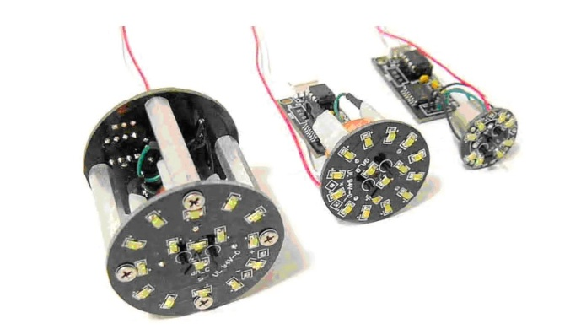
The Beta Innovation Air Core gauges are driven off a Digital to Analog Converter. The faceplates and needles are built by Mike Williams; the Gauge Tubes are built by Jarrod (Jarrod66 on Viperpit).

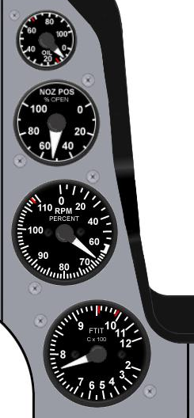
Figure 6 Centre Air Core Gauges

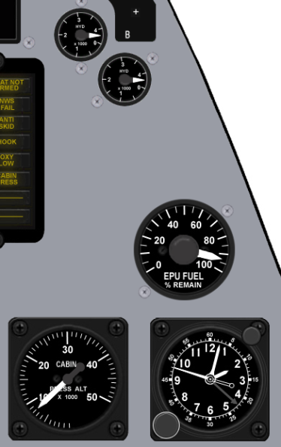
Figure 7 RH Air Core Gauges

These gauges come supplied with Led backlighting. A total of 520mA at 12V is needed to drive the backlighting for the eight gauges.

Guage Type | Backlight Current | Qty | Total
AC360A | 40 mA | 3 | 120mA
AC360B | 80 mA | 1 | 80mA
AC360C | 80 mA | 4 | 320mA
 |  |  | 520mA

LO-LED64 Led Output

The LO-LED64 is driven by the E-Flux. As the name suggests it can drive 64 Led outputs. As it is a passive device, F4IM must be manually configured to use this module. Each of the 64 channels can source 35mA at 5V. It supports PWM with a duty cycle range of 25% to 100% via software control.

Outputs using positive logic should be configured like
Figure 8 LOLED-64 driving a led
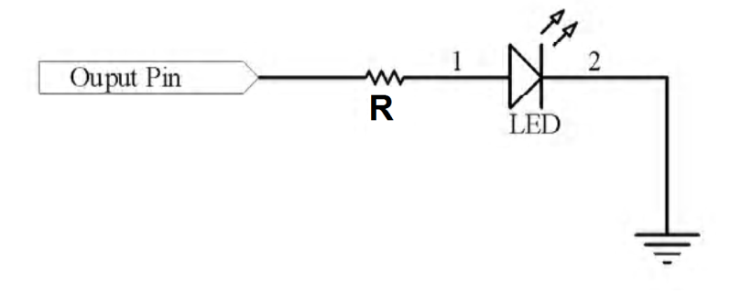
The card has the following connectors
Figure 9 LOLED-64 Ports
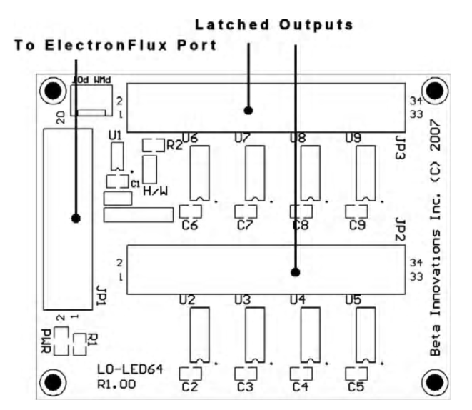

Figure 10 LOLED64 Port A
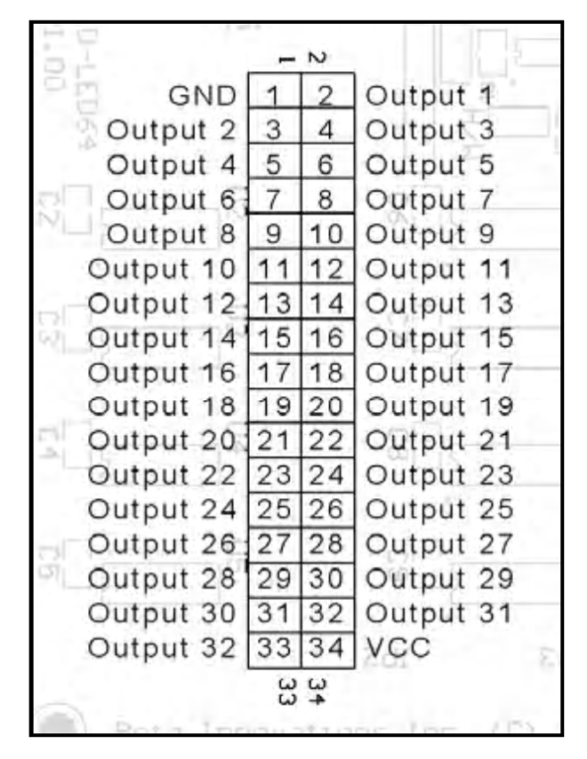
Figure 11 LOLED64 Port B
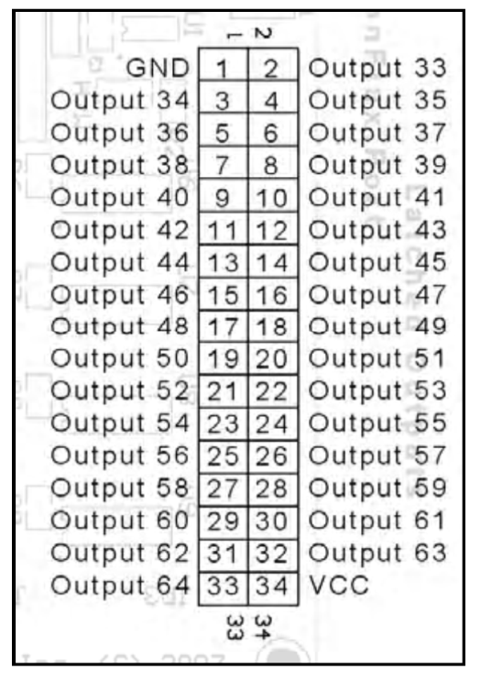

There is a PWM Pot port on the card but this is not functional. The datasheet specifies that the unit can also be S/W controlled, currently this is not configured in F4IM (plan is initially to have a slider in F4IM). The dimming setting applies to all ports. The ultimate plan is to allow you to dim with a pot connected to one of the BI input devices.

General Panel backlighting

Dimming the backlights

The Beta Innovation’s LBC-PWM will drive both the Air Core gauges and the General Panel EL Sheets. Consideration will also be given to driving the Simkit’s backlights. The Flight Illusions gauges cannot be dimmed, only supporting off/on for backlighting.

As each of the ten channels is capable of driving 500mA several channels have be used. Given the pit has three wiring zones, Left, Centre, and Right, the EL sheets will also be driven across three channels.

The Air Core gauges sit across the centre and right side of the pit. They will use different channels to the EL sheets to reduce the likelihood of interference and reduce the size of fault domains.

Figure 12 Backlighting of Misc Panel
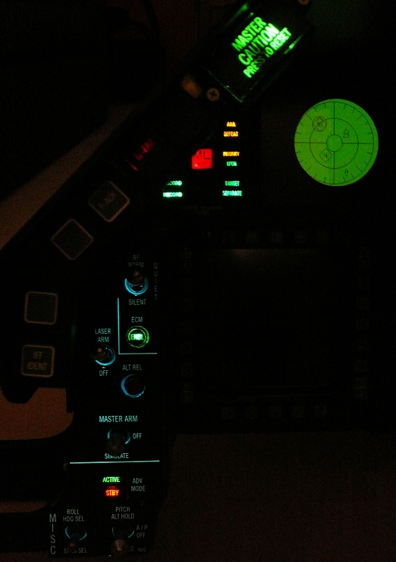

Air Core Backlighting

Centre | Gauge Size (inches) | Current Draw (mA)
Oil Pressure | 1 | 40
Nozzle Position | 1.5 | 80
RPM | 2 | 80
FTIT | 2 | 80
 |  | 280mA Total

Right | Gauge Size (inches) | Current Draw
Hyd Pressure A | 1 | 40
Hyd Pressure B | 1 | 40
EPU Fuel | 2 | 80
Cabin Pressure | 2 | 80
 |  | 240mA Total

EL Sheets

Left Hand Side EL
1 | Test
2 | Anti-G
3 | Flt control
4 | Manual Trim
5 | Fuel
6 | Aux Comm
7 | Ext Lighting
8 | EPU
9 | Elect
10 | AVTR
11 | ECM
12 | Jet Start
13 | Audio2
14 | Audio
15 | UHF
16 | Manual Pitch
17 | Threat Warn Aux
18 | CMDS
19 | Gear Panel
20 | MISC

Total Current Draw 20*25mA = 500mA

Right Hand Side EL

Right Hand Side EL
1 | Caution Panel
2 | Sensor Power
3 | HUD Control
4 | Nuclear consent
5 | Lighting
6 | Master Zeroize
7 | Air Cond
8 | Oxy Reg
9 | KY-58
10 | Avionics Power
11 | Anti-Ice
12 | DTU
13 | OBOGS Monitor

Total Current Draw 13*25mA = 325mA

ICP

Mike (Kabar03) and Jay (Crease-Guard) from Viperpit have put together a very nice ICP.

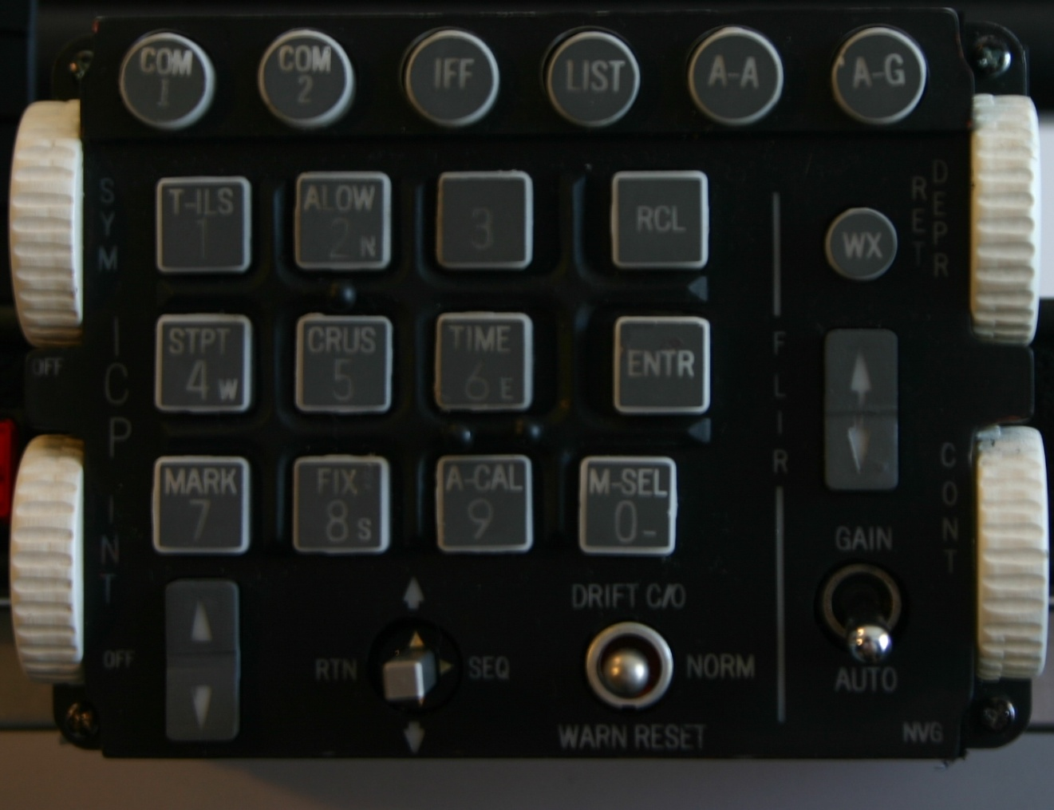

It also is backlit, does require 24V (later models use 12V), so I added an adjustable plug-pack from Dick Smith Electronics.

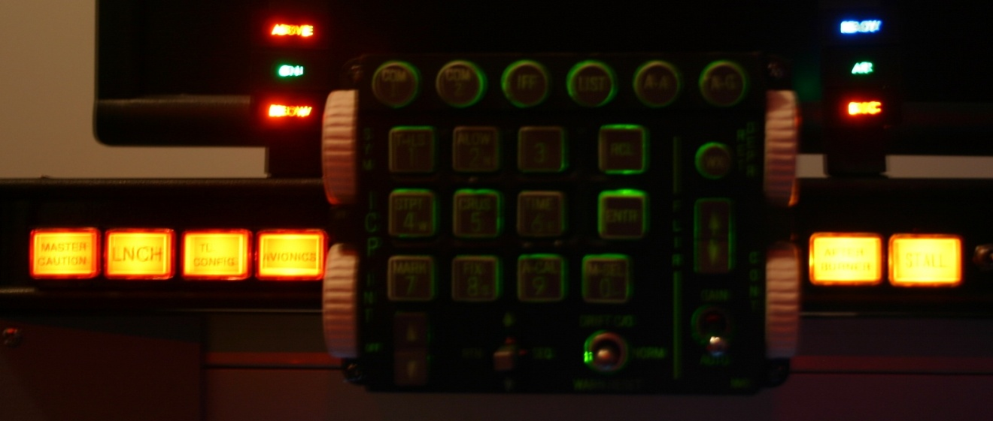

I had been searching for some toggle switches that didn’t look or feel cheap. These can be found at Allied Electronics (www.AlliedElec.com). The switch models I’m using include:
- 676-3240 7101TZQE
- 676-3245 7103TZQE
- 676-3250 7105TZQE

The Centre Console

The Centre console is the most complex part of the pit, largely due to the number of devices that are mounted in a small area.

Here’s an overview of the pieces that make up the centre console
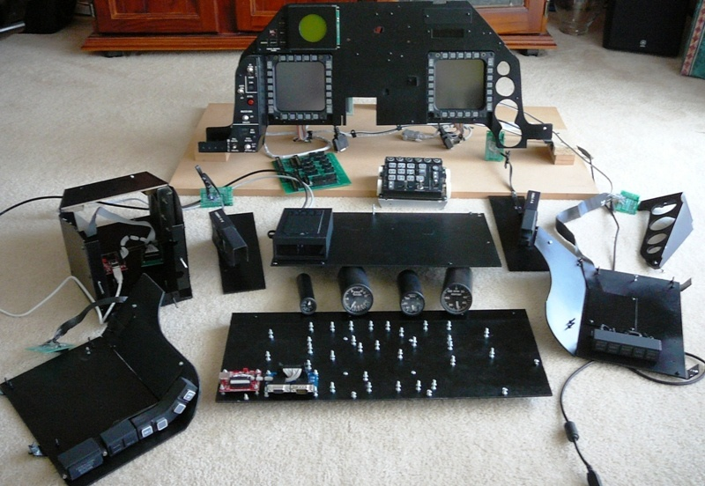
The MM2 and the adaptor PCB are now mounted on the inside of the back panel due to the connectors from the adaptor card intruding into the leg room area in the leg well.

On the back side of the panel we find the G15 display along with its USB interface mounted on the top right, above the MFD display and its electronics. The DB15 (VGA) connectors attached to ribbon cables are from the MFDs. The two stubs of wood in the centre hold the Centre distribution board. The MFD displays are driven off a 12V PC Power Connector.

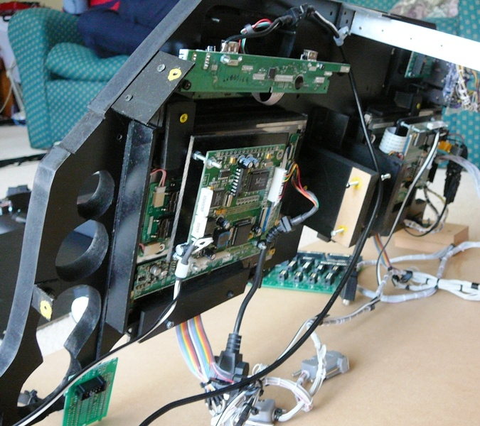
From the back right of the panel we find the PCBs for the MISC Panel, TWP. The white connector next to the TWP PCB is for the RWR.
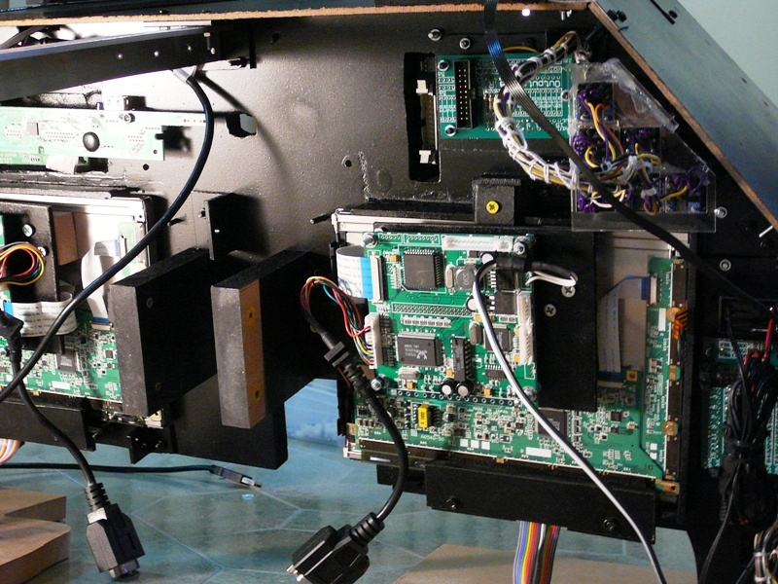
The electronics panel for the MFD display had to be relocated, so it is mounted on a board. The MFDs are touch screen aware, the flat brown cable connects to the touch controller, which is currently not installed. The Misc PCB is not directly connected to the Misc panel because of space challenges.
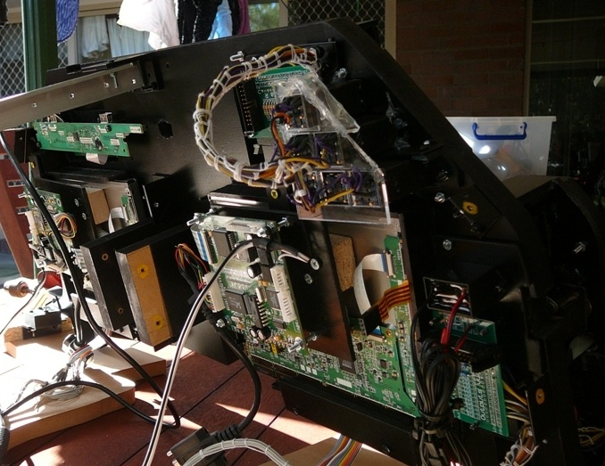
The MM2 and its adaptor card for the ICP are mounted in the ICP itself. I currently don’t have plans to build an HUD.

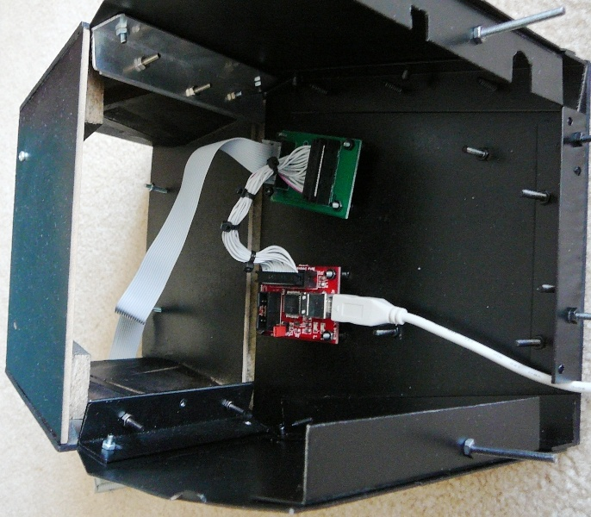

The Front right Eyebrow panel has its cables and holt melt glue (which holds the leds in place) painted black to stop light bleed through. The piece if sheet metal holds the cables up against the frame.
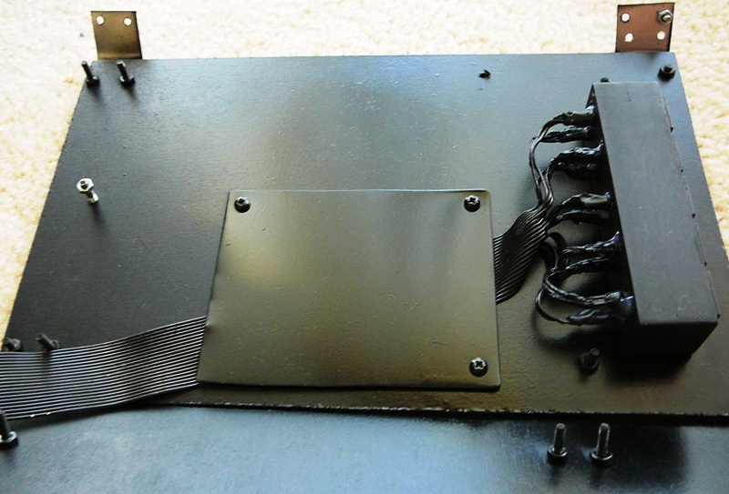
A similar thing is done with the front left Eyebrow panel.
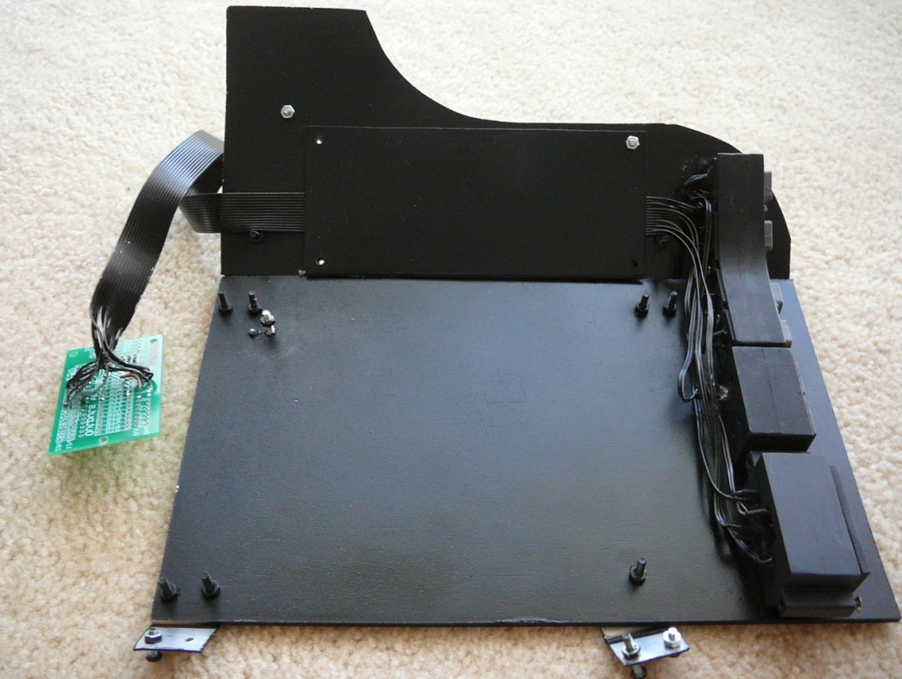

Here’s the back of the panel with the Centre distribution board mounted (note the MM2 and MFD adaptor card now sit on the inside of the distribution board).
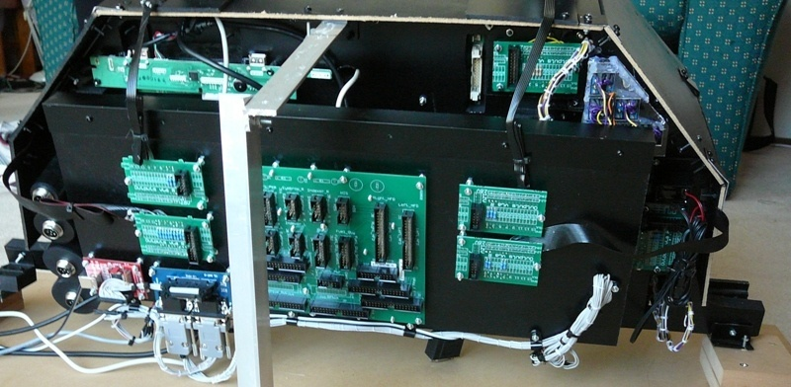

And from the front
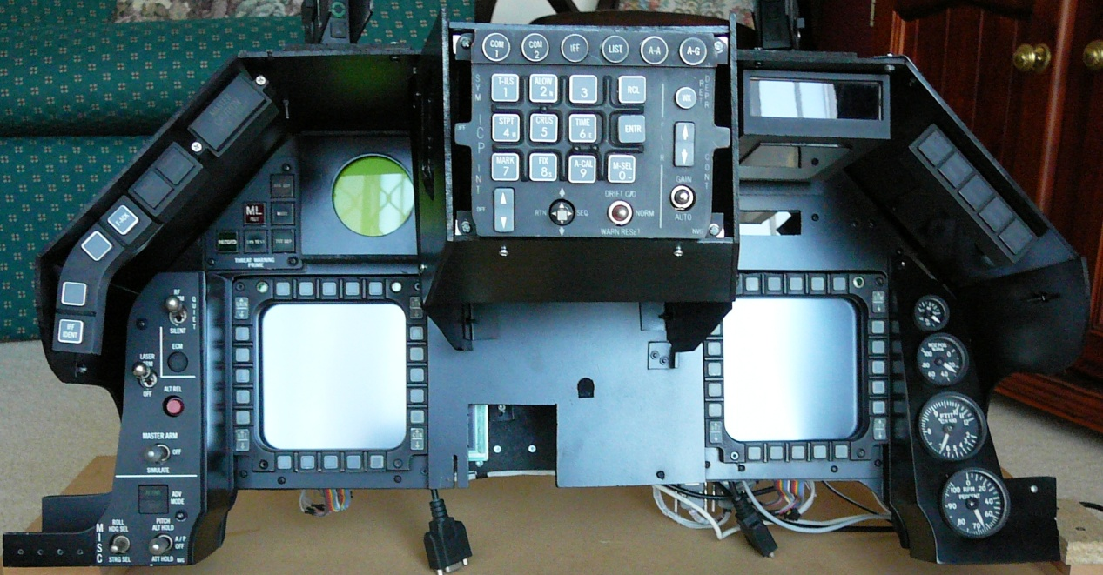
And from the side. The hole in the centre of the front board it to provide clearance for the top gauge in the CP.
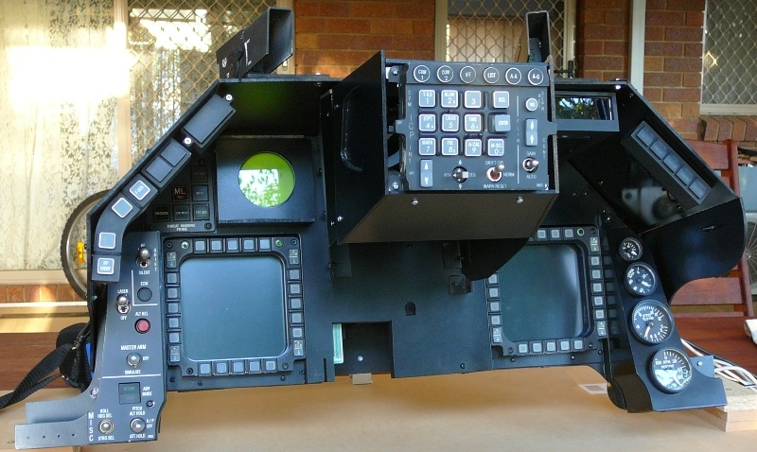

Figure 13 Front Right all lit up
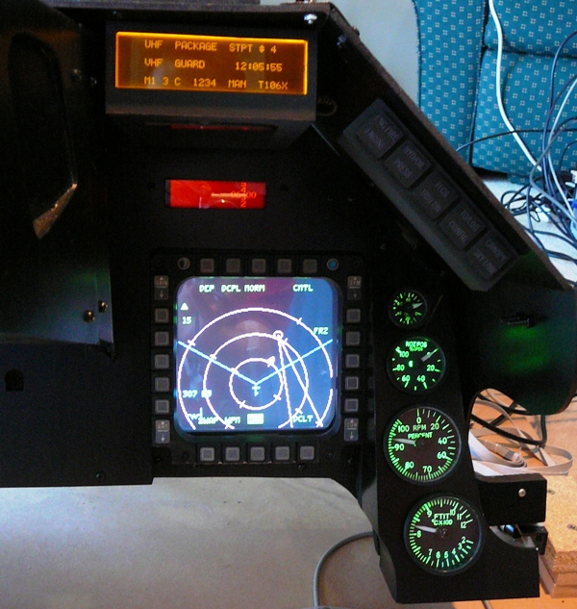

Centre Pedestal
Figure 14 Rear of CP

Figure 15 Rear of CP
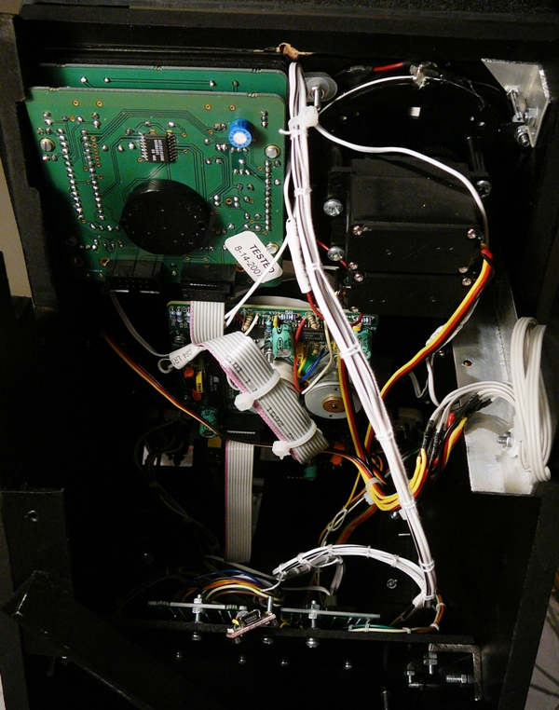
The Flight Illusions gauges are daisy-chained.

Figure 16 Rear of CP with oled USB
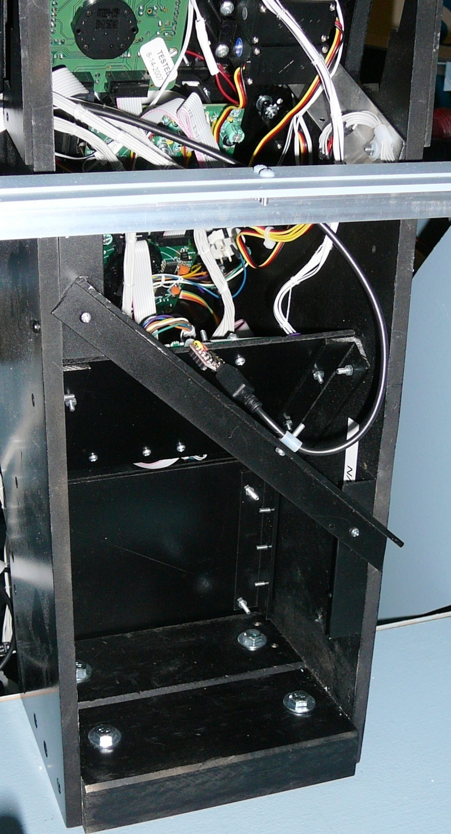
The OLED display has a small USB to serial converter, it is held in place by the USB lead. The four bolts in the bottom hold the CP in place.

Caution Panel
Figure 17 Caution Panel without gauges
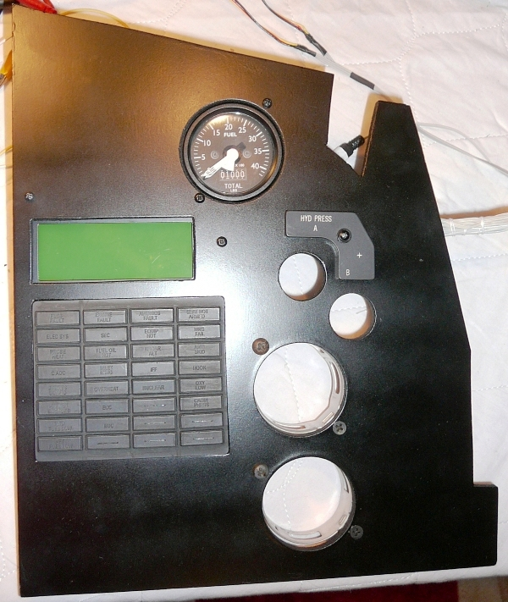

Figure 18 Back of Caution Panel
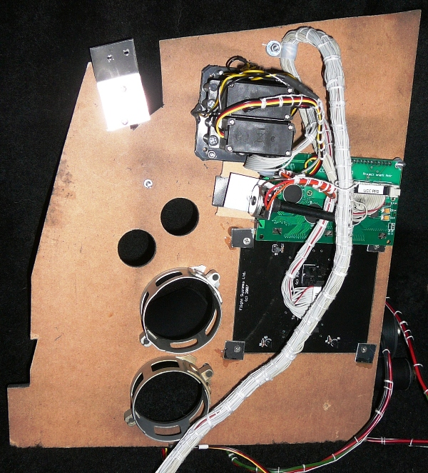
The potentiometer adjusts the contrast of the PFD LCD.

Figure 19 Caution Panel Installed
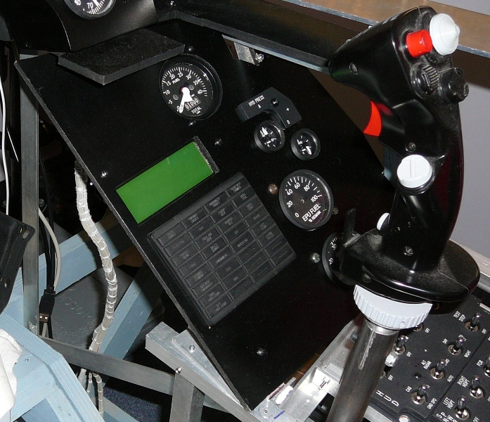

Gear Panel
The gear panel contains Dunk’s gear assembly. It has been slightly modified so that it now reports Gear lever position, as opposed to just transition.

Figure 20 Gear Assembly before modification
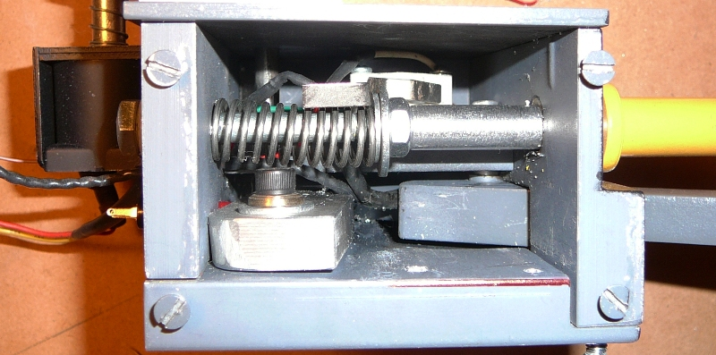

Figure 21 Additional Microswitch and backing plate
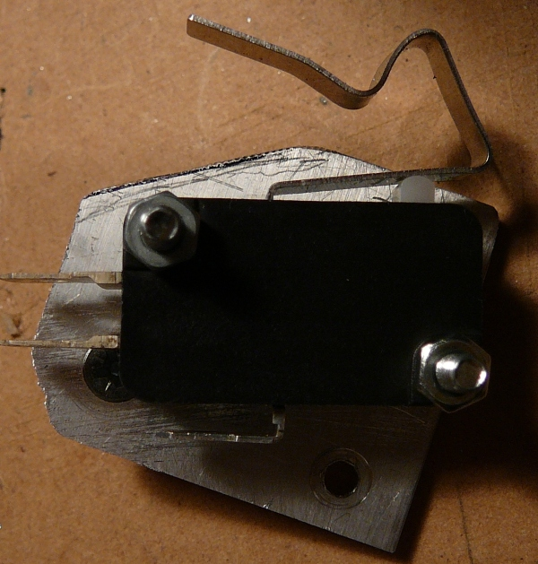
Figure 22 After installation of microswitch
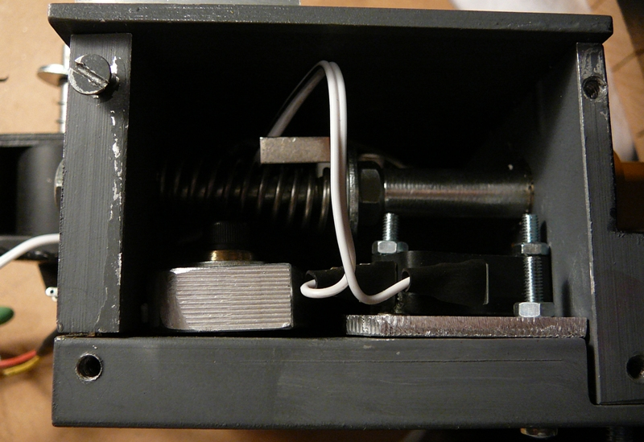
Figure 23 Back of Gear Panel
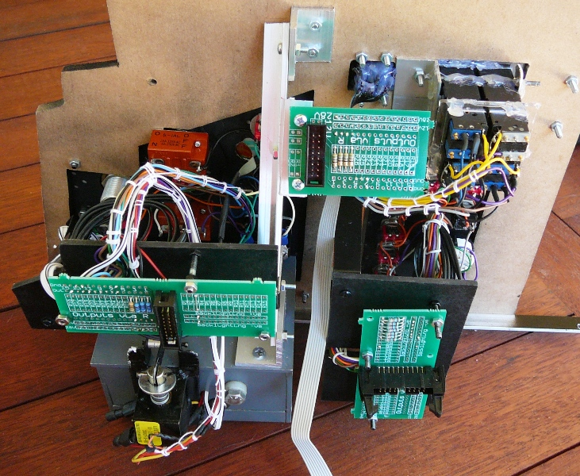
A right angle bracket is just to hold the gear assembly in place. It is also bolted directly to the bracket which supports the inner wall.
Figure 24 Rear of Gear Panel
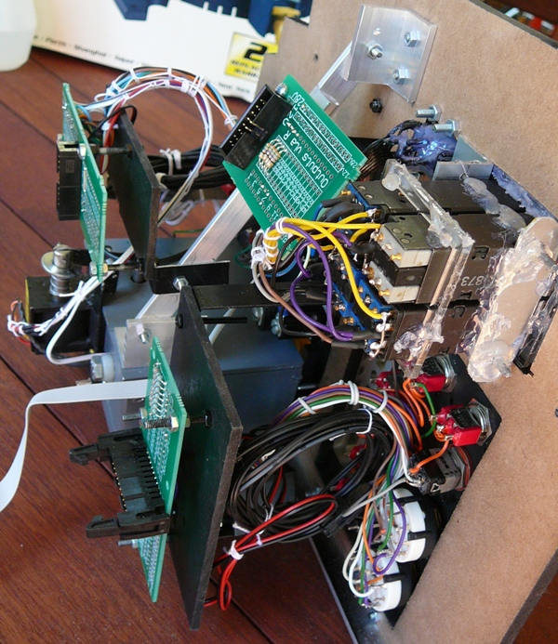

Figure 25 Gear Panel Installed
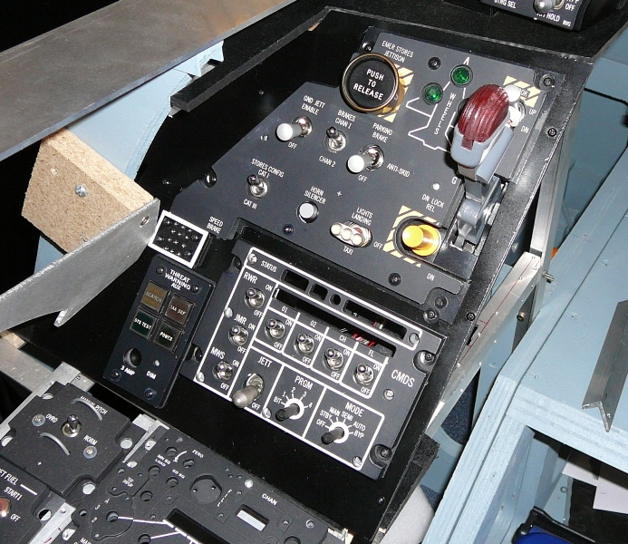

The Panels in the Pit

The section summarises the panels in the pit. It includes references to Mark Doran’s Callback worksheet and uses pictures cut from Martins F16 pit picture. The panels are in order from the back left of the pit in a clockwise direction.

An empty space in the callbacks section means that at the time of spreadsheet creation the switch was not function in Falcon4. Variants of Falon4 such as Open Falcon probably have callbacks not recorded in this document.

The callbacks are copied from the spreadsheet and pasted as a RTF object, which results in a word table. The font is reduced to 10 points. Macros where used pretty heavily when creating this document. Something I found useful was creating a new toolbar and then Assigning the Macro to the toolbar by Tools -> Customize -> Commands -> Selecting Macros in the left hand column and dragging the macros I needed to the new toolbar.

The Electronics Bays

There are three electronics ‘bays’. I’ve used some old terminal server boxes.
The three bays are:
- Primary Input output module
- Power Distribution, dimming
- Servo, Flight Illusion

Figure 26 Primary Input Output Module
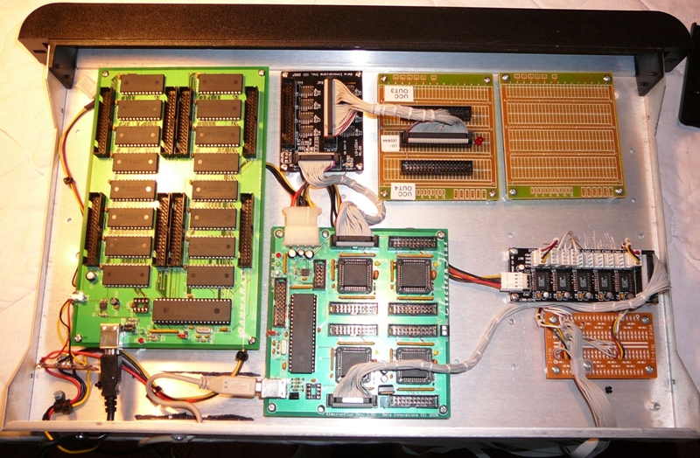
Figure 27 Power and Dimming Module
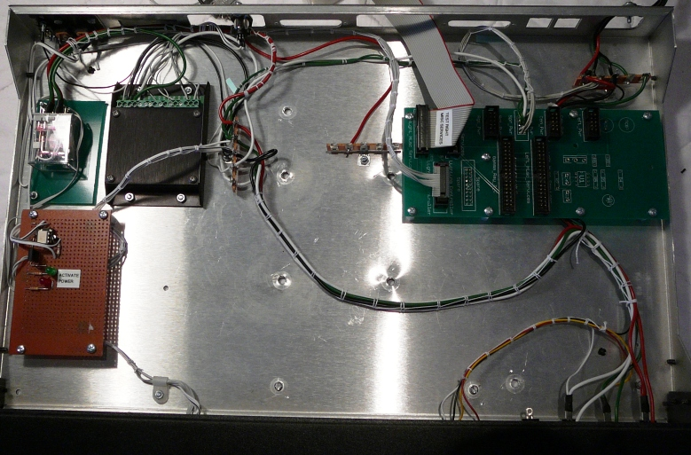

Falcon Modifications

Solid Background for MFDs in MFD view.
Useful gem from Lightning
For F4AF, you have to create a text file in your C:\Program Files\Lead Pursuit\Battlefield Operations folder called "BFops.cfg". In that file, make sure you have a line that reads as follows:
Code:
set g_fMfdTransparency 100
For OpenFalcon, the file is called "falconbms.cfg".
For RedViper, the file is called "redviper.cfg".

Build Status
Panel Purchased
Back Panel Purchased
Mounted in Pit
Backlighting | Ordered
Wired
Knobs mounted
Inputs Tested
Outputs Tested
Protective Coat Applied
Panel Summary

Test
Anti-G
Flt control
Manual Trim
Fuel
Aux Comm
Ext Lighting
EPU
Elect
AVTR
ECM
Jet Start
Audio2
Audio
UHF
Manual Pitch
Threat Warn Aux
CMDS
Gear Panel
MISC
Threat Warn Prim | Complete
Eyebrow Lights L | Complete
Eyebrow Lights R | Complete
Indexer L | Complete
Indexer R | Complete
ICP | Complete
INSTR
HIS
Fuel Qty Select
Caution Panel
Sensor Power
HUD Control
Nuclear consent
Lighting
Master Zeroize
Air Cond
KY-58
Avionics Power
Anti-Ice
Oxy Reg
DTU 2
Left MFD
Right MFD
Other
ACES-II
TQS
SSCG

Keystroke Modifications

F4AF – Using pt_cockpitbuilders key file (based on cockpitbuilders). Thought I’d be able to do some moving around of keystrokes, using direct DX assignments, but discovered the F4AF doesn’t understand multiple instances of the same controllers (Plasa-MM2s), so keystrokes have to continue to be used for the bulk of the functions.

Panel | Switch | Comments
MISC | RF Inhibit | RF Inhibit Shift-Alt-R SimRFSwitch. The default steps through the RF Quiet settings. Want absolute steps. There are three callbacks RF Norm – RF Quiet, and RF silent. The current toggle is to position so only RF Norm and RF silent are used.  Shift-Control N RF Norm  Shift-Control S RF Silent
MISC | Laser Arm | Shift-Control u Laser Arm On  Shift-Control y Laser Arm Off
MISC | Autopilot | Default is simply AP off/on. Need to map Shift-Alt-A Left AP Switch Up  Shift-Alt-S Left AP Switch Middle  Shift-Alt-D Left AP Switch Down  Shift-Alt-Z Right AP Switch Up  Shift-Alt-X Right AP Switch Middle  Shigt-Alt-C Right AP Switch Down
MISC | AVD Mode | Use Invert of TFR-Stdby for Active (BMS)
TWP | Priority | Use invert on Open led for Priority.

Test

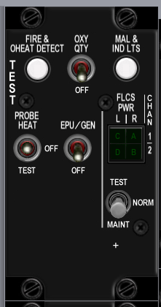
Build Status
Panel Purchased
Back Panel Purchased
Mounted in Pit
Backlighting | Ordered
Wired
Knobs mounted
Inputs Tested
Outputs Tested
Protective Coat Applied

 | Poles | Switch type | Positions | Postion names | Notes | Callback
EPU gen | 2 | toggle | off-on | off-epu gen
PROBE HEAT | 3 | toggle | on-off-on | test-off-probe heat
FIRE & OHEAT DETECT | 2 | push | off-(on) | n/a
OXY | 2 | toggle | off-on | off-QTY
MAL & IND LTS | 2 |  |  | n/a
A B C D | 0 | indicator light | none | C A D B quartered markings on legend tile
test maint | 3 | locking toggle | on-off-on | h

Notes:
Consider hard wiring indicators to on when power is available.

Anti-G

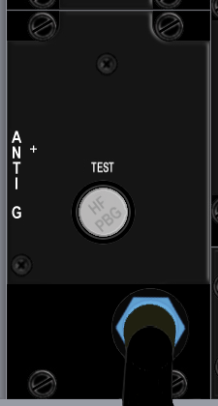
Build Status
Panel Purchased
Back Panel Purchased
Mounted in Pit
Wired
Knobs mounted
Inputs Tested
Outputs Tested

Switch Name | Poles | Switch type | Positions | Postion names | Notes | Callback
test | 2 | push | off-(on) | Test

Flt control
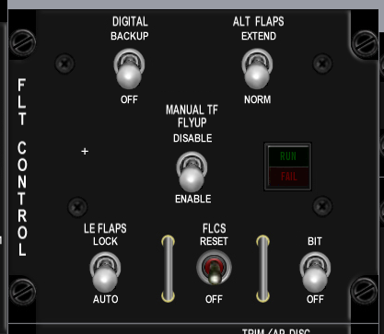
Build Status
Panel Purchased
Back Panel Purchased
Mounted in Pit
Wired
Knobs mounted
Inputs Tested
Outputs Tested

Switch Name | Poles | Call Back | Pole Totals | Switch type | Positions | Postion names | Notes | Callback
 |  |  | 2
DIGITAL | 2 | 0 | 0 | locking toggle | [off]-[on] | off-backup
ALT FALPS | 2 | 0 | 1 | locking toggle | [off]-[on] | norm-extend |  | SimAltFlapsNorm, SimAltFlapsExtend
MANUAL TF FLYUP | 2 | 0 | 0 | locking toggle | [off]-[on] | disable-enable
LE FLAPS | 2 | 0 | 1 | locking toggle | [off]-[on] | auto-lock |  | SimLEFAuto?, SimLEFLock
FLCS | 2 | 0 | 0 | momentary toggle | (on)-off | reset-off
BIT / OFF | 2 | 0 | 0 | locking toggle | [off]-[on] | OFF, BIT
RUN FAIL | 0 | 0 | 0 | indicator light | none | n/a, RUN FAIL legend lights when pressed

 | J4
1 | BKLGT-V
2 | BKLGT+V
3 | +12V LEFT
4 | +28V LEFT
5 | GND LEFT
6 | L_FLT
7 | FLP_EXT
8 | LEF_LCK
9 | 9 OPEN
10 | 10 OPEN

Manual Trim

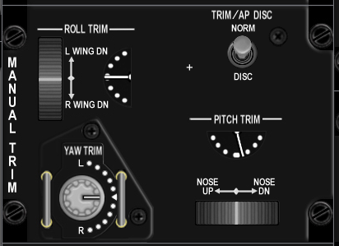
Build Status
Panel Purchased
Back Panel Purchased
Mounted in Pit
Wired
Knobs mounted
Inputs Tested
Outputs Tested

Switch Name | Poles | Call Back | Pole Totals | Switch type | Positions | Position names | Notes | Callback
 |  |  | 1
Pitch Trim | 1 | 0 | 0 | encoder with center detent | thumbwheel |  | light stripe showing position | BMS analog axis or SimTrimNoseUp, SimTrimNoseDown
Roll Trim | 1 | 0 | 0 | encoder with center detent | thumbwheel |  | light stripe showing position | BMS analog axis or SimTrimRollLeft, SimTrimRollRight
Yaw Trim | 1 | 0 | 0 | encoder with center detent | thumbwheel |  | light stripe showing position | BMS analog axis or SimTrimYawLeft, SimTrimYawRight
Trim /AP DISC | 2 | 1 | 1 | locking toggle | [off]-[on] | norm, disc |  | SimTrimAPNORM, SimTrimAPDISC

 | J30
1 | BKLGT-V
2 | BKLGT+V
3 | +12V LEFT
4 | +28V LEFT
5 | GND LEFT
6 | ROLL
7 | PITCH
8 | 8 OPEN,
9 | ANA_PWR
10 | ANA_GND
11 | APITCH
12 | AROLL
13 | AYAW
14 | YLEFT
15 | YRGHT
16 | RLEFT
17 | RRIGHT
18 | NSEUP
19 | NSEDWN
20 | AP_DISC

Fuel
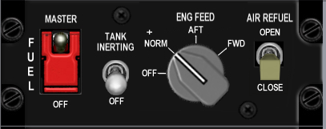
Build Status
Panel Purchased
Back Panel Purchased
Mounted in Pit
Wired
Knobs mounted
Inputs Tested
Outputs Tested

Switch Name | Poles | Switch type | Positions | Position names | Notes | Callback
MASTER | 2 | guarded toggle | off-on | OFF, MASTER | Guarded in MASTER | SimMasterFuelOff, SimMasterFuelOn
TANK INERTING | 2 | toggle | off-on | OFF-TANK INERTING ??????
ENG FEED | 4 | rotary knob | on-on-on-on | OFF, NORM, AFT, FWD | (4x45 deg) | SimFuelPumpOff, SimFuelPumpNorm, SimFuelPumpAft, SimFuelPumpFwd
AIR REFUEL | 2 | toggle | off-on | CLOSE, OPEN |  | SimFuelDoorOpen, SimFuelDoorClose?

 | J6
1 | BKLGT-V
2 | BKLGT+V
3 | +12V LEFT
4 | +28V LEFT
5 | GND LEFT
6 | FUEL_ON
7 | PMP_OFF
8 | PMP_NRM
9 | PMP_AFT
10 | PMP_FWD
11 | FUL_DOR
12 | 12 OPEN,
13 | 13 OPEN,
14 | 14 OPEN,
15 | 15 OPEN,
16 | 16 OPEN

Aux Comm

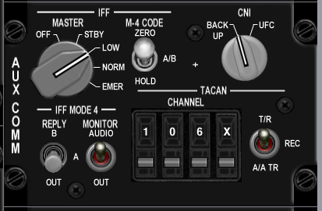
Build Status
Panel Purchased
Back Panel Purchased
Mounted in Pit
Wired
Knobs mounted
Inputs Tested
Outputs Tested

Switch Name | Poles | Switch type | Positions | Position names | Notes | Callback
MASTER | 5 | Rotary knob | on-on-on-on-on | off, STBY, LOW, NORM, EMER | (5x36 deg) | SimToggleAuxComMaster
M-4 CODE | 3 | locking toggle | [on]-[off]-[on] | hold, a/b, zero
CNI | 2 | Rotary knob | on-off | BACK UP, UFC | (2x36 deg) | SimAuxComBackup, SimAuxComUFC
REPLY | 3 | locking toggle | [off]-[on]-[on] | OUT, A, B
MONITOR | 2 | toggle | off-on | OUT, AUDIO
TACAN | 3 | toggle | on-off-on | A/A TR-REC-T/R |  | SimTACANAATR, SimTACANTR
CHANNEL 100's | 10 | encoder | cw/ccw | 0-9 inclusive |  | SimCycleLeftAuxComDigit, SimDecLeftAuxComDigit
CHANNEL 10's | 10 | encoder | cw/ccw | 0-9 inclusive |  | SimCycleCenterAuxComDigit, SimDecCenterAuxComDigit
CHANNEL 1's | 10 | encoder | cw/ccw | 0-9 inclusive |  | SimCycleRightAuxComDigit, SimDecRightAuxComDigit
channel x/y | 2 | encoder | cw/ccw | x, y |  | SimCycleBandAuxComDigit

 | J7
1 | BKLGT-V
2 | BKLGT+V
3 | +12V LEFT
4 | +28V LEFT
5 | GND LEFT
6 | COM_OFF
7 | COM_STB
8 | COM_LOW
9 | COM_NO
10 | COM_BCK
11 | COM_UFC
12 | TCN_ATR
13 | TCN_NTR
14 | 14 OPEN,
15 | 15 OPEN,
16 | 16 OPEN

 | J8
1 | BKLGT-V
2 | BKLGT+V
3 | +12V LEFT
4 | +28V LEFT
5 | GND LEFT
6 | R_GND
7 | INC_LFT
8 | DEC_LFT
9 | INC_CEN
10 | DEC_CEN
11 | INC_RGHT
12 | DEC_RGHT
13 | INC_BND
14 | DEC_BND
15 | 15 OPEN,
16 | 16 OPEN

Ext Lighting

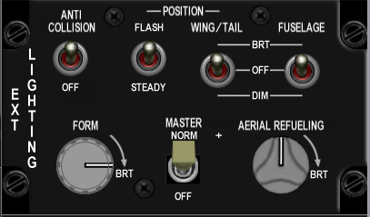
Build Status
Panel Purchased
Back Panel Purchased
Mounted in Pit
Wired
Knobs mounted
Inputs Tested
Outputs Tested

Switch Name | Poles | Switch type | Positions | Position names | Notes
Form | 0 | potentiometer | increase clockwise
Master | 2 | toggle | [off]-[on] | off, norm | SimExtlMasterOff, SimExtlMasterNorm
Aerial Refueling | 0 | potentiometer | increase clockwise
Anti Collision | 2 | toggle | off-on | off, anti collision | SimAntiCollOff, SimAntiCollOn
Flash Steady | 2 | toggle | on-off | flash, steady | SimLightsFlash, SimLightsSteady
Wing Trail | 3 | toggle | on-off-on | dim, off, brt | SimWingLightOff, SimWingLightBrt
Fuselage | 3 | toggle | on-off-on | dim, off, brt

 | J9
1 | BKLGT-V
2 | BKLGT+V
3 | +12V LEFT
4 | +28V LEFT
5 | GND LEFT
6 | EXTM_ON
7 | ACOL_ON
8 | FLSH_ON
9 | WNG_DM
10 | WNG_BRT
11 | P_MSTR
12 | P_DIM
13 | P_CMN
14 | 14 OPEN,
15 | 15 OPEN,
16 | 16 OPEN

EPU
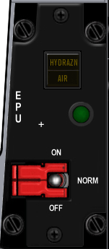
Build Status
Panel Purchased
Back Panel Purchased
Mounted in Pit
Wired
Knobs mounted
Inputs Tested
Outputs Tested

Switch Name | Poles | Switch type | Positions | Position names | Notes | Callback | Lightbits1 | Lightbits2
EPU | 3 | guarded toggle | off-on-on | OFF-NORMAL-ON | Center guard on NORMAL | SimEpuOff,SimEpuAuto,SimEpuOn
RUN light | 0 | indicator light | none | green light |  |  |  | EPUOn = $100000
HYDRAZN-AIR | 0 | indicator light | none | HYDRAZN-AIR |  |  |  | Hydrazine = $100,Air = $200

 | J10
1 | BKLGT-V
2 | BKLGT+V
3 | +12V LEFT
4 | +28V LEFT
5 | GND LEFT
6 | EPU_ON
7 | HYDRA
8 | AIR
9 | EPU_OF
10 | EPU_ON

Elect
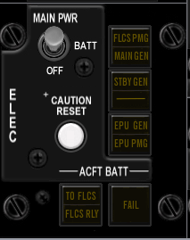
Build Status
Panel Purchased
Back Panel Purchased
Mounted in Pit
Wired
Knobs mounted
Inputs Tested
Outputs Tested

Switch Name | Poles | Switch type | Positions | Position names | Notes | Callback | Lightbits1 | Lightbits2
MAIN PWR | 3 | Locking toggle | [off]-[on]-[on] | OFF, BAT, MAIN PWR |  | SimMainPowerOff,SimMainPowerBatt,SimMainPowerMain
CAUTION RESET | 2 | push | off-(on) |  |  | SimWarnReset?
FLCS PMG-MAIN GEN | 0 | indicator light | none | FLCS PMG-MAIN GEN |  |  |  | FlcsPmg = $1,MainGen = $2
STBY GEN | 0 | indicator light | none | STBY GEN |  |  |  | StbyGen = $4
EPU GEN-EPU / PMG | 0 | indicator light | none | EPU GEN-EPU / PMG |  |  |  | EpuGen = $8,EpuPmg = $10
FAIL | 0 | indicator light | none | FAIL |  |  |  | BatFail = $80
TO FLCS-FLCS RLY | 0 | indicator light | none | TO FLCS-FLCS RLY |  |  |  | ToFlcs = $20,FlcsRly = $40
 | J17
1 | BKLGT-V
2 | BKLGT+V
3 | +12V LEFT
4 | +28V LEFT
5 | GND LEFT
6 | FLCSPMG
7 | MAINGEN
8 | STBYGEN
9 | EPUGEN
10 | EPUPMG
11 | BATFAIL
12 | TOFLCS
13 | FLCSRLY
14 | PWR_OFF
15 | PWRMAIN
16 | WRN_RST

AVTR

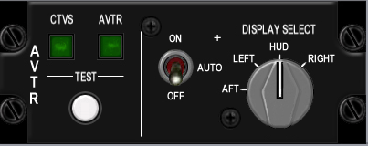
Build Status
Panel Purchased
Back Panel Purchased
Mounted in Pit
Wired
Knobs mounted
Inputs Tested
Outputs Tested

Switch Name | Poles | Switch type | Positions | Position names | Notes | Callback | Lightbits1 | Lightbits2 | Lightbits3 | HSIbits
AVTR | 3 | toggle | on-off-on | on, auto, off |  | SimAVTRSwitchOff, SimAVTRSwitchAuto, SimAVTRSwitchOn
 |  |  |  |  | (4x45 deg) |  |  |  |  | AVTR = $2000

 | J16
1 | BKLGT-V
2 | BKLGT+V
3 | +12V LEFT
4 | +28V LEFT
5 | GND LEFT
6 | AVTR
7 | AVT_OFF
8 | AVT_ON
9 | 9 OPEN
10 | 10 OPEN

ECM

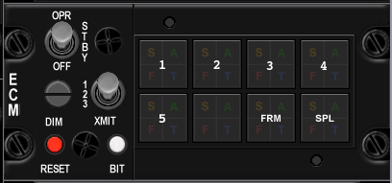
Build Status
Panel Purchased
Back Panel Purchased
Mounted in Pit
Wired
Knobs mounted
Inputs Tested
Outputs Tested

Switch Name | Poles | Switch type | Positions | Position names
OPR | 3 | toggle | off-on-on | OFF-STBY-OPR
DIM | 3 | rotary | on-on-on | 1, 2, 3
XMIT | 2 | locking toggle | [on]-[off] | xmit, blank
RESET | 2 | toggle | (on)-off | reset, blank
BIT | 2 | toggle | (on)-off | bit, blank
1 | 0 | indicator light | none | S, A, F, T light in corners
2 | 0 | indicator light | none | S, A, F, T light in corners
3 | 0 | indicator light | none | S, A, F, T light in corners
4 | 0 | indicator light | none | S, A, F, T light in corners
5 | 0 | indicator light | none | S, A, F, T light in corners
ALT | 0 | indicator light | none | S, A, F, T light in corners
FRM | 0 | indicator light | none | S, A, F, T light in corners
SPL | 0 | indicator light | none | S, A, F, T light in corners

Jet Start

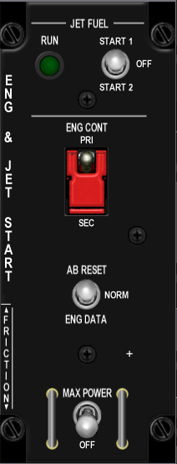
Build Status
Panel Purchased
Back Panel Purchased
Mounted in Pit
Wired
Knobs mounted
Inputs Tested
Outputs Tested

Switch Name | Poles | Switch type | Positions | Position names | Callback | Notes | Lightbits2
JET FUEL | 3 | locking toggle | [on]-[off]-[on] | START2-OFF-START1 | SimJFSStart | solenoid pulls to center after start ??
ENG CONT | 2 | guarded toggle | off-on | SEC-PRI |  | guarded up to PRI
AB RESET | 3 | toggle | (on)-off-(on) | ENG DATA-NORM-AB DATA
MAX POWER | 2 | locking toggle | [off]-(on) | OFF-MAX POWER
RUN | 0 | indicator light | none | green light |  |  | JFSOn = $200000

 | J13
1 | BKLGT-V
2 | BKLGT+V
3 | +12V LEFT
4 | +28V LEFT
5 | GND LEFT
6 | JFS_ON_LGHT
7 | JFS_ON_SOL
8 | JFS_ST
9 | 9 OPEN,
10 | 10 OPEN

Audio2

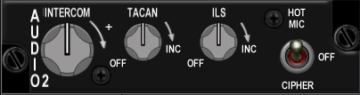
Build Status
Panel Purchased
Back Panel Purchased
Mounted in Pit
Wired
Knobs mounted
Inputs Tested
Outputs Tested

Switch Name | Poles | Switch type | Positions | Position names | Notes
INTERCOM | 0 | potentiometer | increase clockwise
TACAN | 2 | potentiometer 10k log | [off]-increase clockwise |  | rotary pot with off switch
ILS | 2 | potentiometer 10k log | [off]-increase clockwise |  | rotary pot with off switch
HOT MIC | 3 | toggle | on-off-on | CIPHER, OFF, HOT MIC

Audio

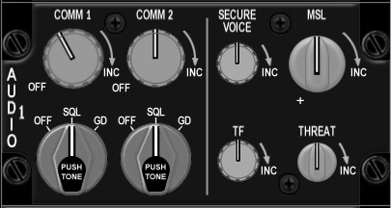
Build Status
Panel Purchased
Back Panel Purchased
Mounted in Pit
Wired
Knobs mounted
Inputs Tested
Outputs Tested

Switch Name | Poles | Switch type | Positions | Position names | Notes | Callback
COMM 1 volume | 2 | potetiometer | off-increase clockwise |  | rotary pot with off switch | BMS analog axis or SimStepComm1VolumeDown, SimStepComm1VolumeUp
COMM 1 selector | 3 | rotary knob | on-on-on | OFF-SQL-GD | PUSH FOR TONE,(3x45 deg)
COMM 2 volume | 2 | potetiometer | off-increase clockwise |  | rotary pot with off switch | BMS analog axis or SimStepComm2VolumeDown, SimStepComm2VolumeUp
COMM 2 selector | 3 | rotary knob | on-on-on | OFF-SQL-GD | PUSH FOR TONE,(3x45 deg)
SECURE VOICE | 0 | potetiometer | increase clockwise
TF | 0 | potetiometer | increase clockwise
MSL | 0 | potetiometer | increase clockwise |  |  | BMS analog axis or SimStepMissileVolumeDown, SimStepMissileVolumeUp
THREAT | 0 | potetiometer | increase clockwise |  |  | BMS analog axis or SimStepThreatVolumeDown, SimStepThreatVolumeUp

 | J31
1 | BKLGT-V
2 | BKLGT+V
3 | +12V LEFT
4 | +28V LEFT
5 | GND LEFT
6 | ANA_PWR
7 | ANA_GND
8 | ACM1_V
9 | ACM2_V
0 | AMSL_V
1 | ATHRT_V
2 | CM1_UP
3 | CM1_DWN
4 | CM2_UP
5 | CM2_DWN
6 | MSL_UP
7 | MSL_DWN
8 | THRT_UP
9 | THRT_DWN
20 | R_GND

UHF
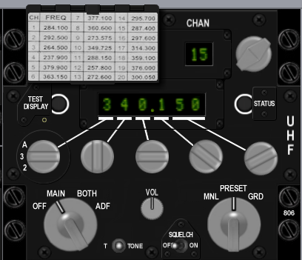
Build Status
Panel Purchased
Back Panel Purchased
Mounted in Pit
Wired
Knobs mounted
Inputs Tested
Outputs Tested

Switch Name | Poles | Switch type | Positions | Position names | Notes | Callback
UHF | 4 | rotary | on-on-on-on | OFF-MAIN-BOTH-ADF
TONE | 2 | push | off-(on) | tone
VOL | 0 | potentiometer | clockwise to increase
SQUELCH | 2 | toggle | off-on | OFF-ON
MANUAL | 3 | rotary | on-on-on | MANUAL-PRESET-GUARD
Freq 100's | 4 | encoder | cw-ccw | A, 3, 2, T
Freq 10's | 10 | encoder | cw-ccw | 0-9 inclusive
Freq 1's | 10 | encoder | cw-ccw | 0-9 inclusive
Freq 1/10's | 10 | encoder | cw-ccw | 0-9 inclusive
Freq 1/1000's | 4 | encoder | cw-ccw | 00, 25, 50, 75
CHAN | 20 | encoder | cw-ccw | 1-19 inclusive |  | SimCycleRadioChannel, SimDecRadioChannel
EMB | 2 | push | off-(on) | ??

Manual Pitch
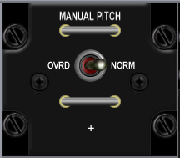
Build Status
Panel Purchased
Back Panel Purchased
Mounted in Pit
Wired
Knobs mounted
Inputs Tested
Outputs Tested

Switch Name | Poles | Switch type | Positions | Position names | Notes | Callback
MANUAL PITCH | 2 | toggle | off-on | OVRD-NORM | Horizontal wire guard loops above and below toggle | SimMPO

 | J3
1 | BKLGT-V
2 | BKLGT+V
3 | +12V LEFT
4 | +28V LEFT,
5 | GND LEFT
6 | MPTCHO NET49_1,
7 | 7 OPEN,
8 | 8 OPEN,
9 | 9 OPEN,
10 | 10 OPEN

Threat Warn Aux
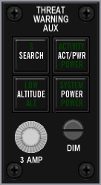
Build Status
Panel Purchased
Back Panel Purchased
Mounted in Pit
Wired
Knobs mounted
Inputs Tested
Outputs Tested

Switch Name | Poles | Switch type | Positions | Position names | Notes | Callback | Lightbits1 | Lightbits2
Search | 2 | on/off lighted push | off-on | search |  | SimRWRSetSearch |  | AuxSrch = $1000
activity power | 2 | on/off lighted push | off-on | activity power |  |  |  | AuxAct = $2000
Low priority | 2 | on/off lighted push | off-on | low |  | SimRWRSetGroundPriority? |  | AuxLow = $4000
system power | 2 | on/off lighted push | off-on | power |  | SimRwrPower |  | AuxPwr = $8000
fuse | 0 | fuse holder | none | n/a
Dimmer | 0 | potentiometer | rotary | n/a | no EPIC connection

 | J22
1 | BKLGT-V
2 | BKLGT+V
3 | +12V LEFT
4 | +28V LEFT
5 | GND LEFT
6 | AXSCH
7 | AXACT
8 | AXLOW
9 | AXPWR
10 | R_SRCH
11 | R_GND
12 | R_PWR
13 | 13 OPEN,
14 | 14 OPEN,
15 | 15 OPEN,
16 | 16 OPEN

CMDS
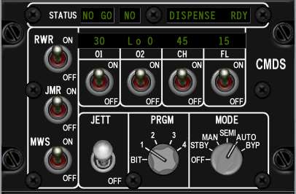
Build Status
Panel Purchased
Back Panel Purchased
Mounted in Pit
Wired
Knobs mounted
Inputs Tested
Outputs Tested

Switch Name | Poles | Switch type | Positions | Position names | Notes | Callback
RWR | 2 | toggle | off-on | off, on |  | SimEWSRWROn, SimEWSRWROff
JMR | 2 | toggle | off-on | off, on |  | SimEWSJammerOn, SimEWSJammerOff
MWS | 2 | toggle | off-on | off, on
01 | 2 | toggle | off-on | off, on
02 | 2 | toggle | off-on | off, on
CH | 2 | toggle | off-on | off, on |  | SimEWSChaffOff, SimEWSChaffOn
FL | 2 | toggle | off-on | off, on |  | SimEWSFlareOff, SimEWSFlareOn
JETT | 2 | locking toggle | off-on | off, JETT
PRGM | 5 | rotary | on-on-on-on-on | bit, 1, 2, 3, 4, 5 | (5x36 deg) | SimEWSProgOne, SimEWSProgTwo, SimEWSProgThree, SimEWSProgFour
MODE | 6 | rotary | on-on-on-on-on-on | off, stby, man, semi, auto, byp | (6x30 deg) | SimEWSModeOff, SimEWSModeStby, SimEWSModeMan, SimEWSModeSemi, SimEWSModeAuto,
STATUS NO GO | 0 | green indicator light | n/a | NO GO (green lit legend)
STATUS GO | 0 | green indicator light | n/a | GO (green lit legend)
STATUS READY | 0 | green indicator light | n/a | READY TO DISPENSE (green lit legend)

 | J21
1 | BKLGT-V
2 | BKLGT+V
3 | +12V LEFT
4 | +28V LEFT
5 | GND LEFT
6 | GO NET5_2,
7 | NO_GO
8 | RDY_DISP
9 | CHAFF_LO
10 | FLARE_LO

 | J23
1 | BKLGT-V
2 | BKLGT+V
3 | +12V LEFT
4 | +28V LEFT
5 | GND LEFT
6 | RWR_ON
7 | JMR_ON
8 | CHF_ON
9 | FLR_ON
10 | PRG_BIT
11 | PRG_1
12 | PRG_2
13 | PRG_3
14 | PRG_4
15 | MDEOFF
16 | MDESTBY
17 | MDEMAN
18 | MDESEMI
19 | MDEAUTO
20 | MDEBYP

Gear Panel
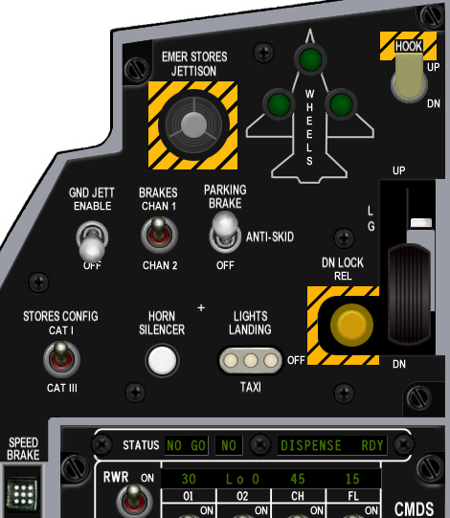
Build Status
Panel Purchased
Back Panel Purchased
Mounted in Pit
Wired
Knobs mounted
Inputs Tested
Outputs Tested

Switch Name | Poles | Switch type | Positions | Position names | Notes | Callback | Lightbits1 | Lightbits2 | Lightbits3
Emergency jettison | 2 | guarded push | off-(on) | n/a | breakable cover over | SimEmergencyJettison
wheel lights | 0 | 3 x green lights | none | n/a |  |  |  |  | NoseGearDown = $10000,LeftGearDown = $20000,RightGearDown = $40000
Hook | 2 | lever locking toggle | [off]-[on] | dn, up |  | SimHookUp,SimHookDown
Ground jettison | 2 | locking toggle | [off]-[on] | off, enable |  | SimGndJettOn, SimGndJettOff
Brakes | 2 | toggle | off-on | chan 2, chan 1
Parking brake | 3 | locking toggle | [off]-[on]-[on] | off, anti skid, brake |  | SimParkingBrakeOff, ,SimParkingBrakeOn
Stores | 2 | toggle | off-on | cat III, cat I |  | SimCATIII,SimCATI
Horn silencer | 2 | push | off-(on) | n/a |  | SimSilenceHorn
Landing lights | 3 | locking t handle toggle | [on]-[off]-[on] | taxi, off, landing |  | SimLandingLightOn, SimLandingLightOff
Down lock release | 2 | push | off-(on) | n/a
Gear down enable | 2 | push | off-(on) | n/a | mounted on the arm of the gear handle
Gear handle | 2 | lollipop lever | off-on | (down and up) |  | AFGeapUp, AFGearDown
Gear warning light | 0 | yellow light | none | n/a | mounted in lollipop end of the gear handle |  |  | GEARHANDLE = $40000000

 | J29
1 | BKLGT-V
2 | BKLGT+V
3 | +12V LEFT
4 | +28V LEFT
5 | GND LEFT
6 | N_GEAR
7 | L_GEAR
8 | R_GEAR
9 | G_HNDLE
10 | PK_SOLND
11 | HOOK
12 | GNDJETT
13 | PARKBRK
14 | EMG_JET
15 | CAT_III
16 | L_TAXI
17 | L_LAND
18 | L_GEAR
19 | HRN_SIL
20 | 20 OPEN

MISC
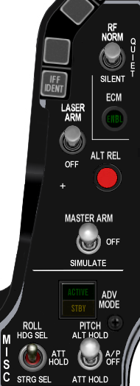
Build Status
Panel Purchased
Back Panel Purchased
Mounted in Pit
Wired
Knobs mounted
Inputs Tested
Outputs Tested

Switch Name | Poles | Switch type | Positions | Position names | Notes | Callback | Lightbits1 | Lightbits2
RF quiet | 3 | locking toggle | [on[-[off]-[on] | silent, rf norm |  | SimRFNorm, SimRFQuiet, SimRFSilent
ECM light | 0 | green light | none | n/a |  |  |  | EcmPwr = $10000?
Laser arm | 2 | locking toggle | [off]-[on] | off, arm |  | SimLaserArmOn, SimLaserArmOff
Alternate release | 2 | push | off-(on) | n/a |  | SimPickle
Master arm | 3 | locking toggle | [on]-[off]-[on] | simulate, off, arm |  | SimSimMasterArm, SimSafeMasterArm, SimArmMasterArm
ADV mode | 0 | indicator light tile | none | active/standby
Autopilot pitch | 3 | locking toggle | [on]-[off]-[on] | att hold, a-p off, alt hold |  | SimRightAPDown, SimRightAPMid, SimRightAPUp
Autopilot roll | 3 | toggle | on-off-on | strg sel, att hold, hdg sel |  | SimLeftAPDown, SimLeftAPMid, SimLeftAPUp

 | J17
1 | BKLGT-V
2 | BKLGT+V
3 | +12V
4 | +28V
5 | GND ,
6 | ECM_PWR
7 | AP_ON
8 | TFR_STDBY
9 | ECM_PWR
0 | TFR_ENGAGED
1 | RF_NRM
2 | RF_SILNT
3 | LSR_ON
4 | S_PICKLE
5 | MST_ARM
6 | MST_SIM
7 | RAP_DWN
8 | RAP_UP
9 | LAP_DWN
10 | LAP_UP

Threat Warn Prim
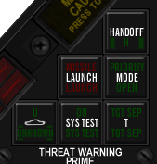
Build Status
Panel Purchased
Back Panel Purchased
Mounted in Pit
Wired
Knobs mounted
Inputs Tested
Outputs Tested

Switch Name | Poles | Switch type | Positions | Notes | Callback | Lightbits1 | Lightbits2
Handoff | 2 | push | off-(on) | Green illumination on push to select handoff mode | SimRWRHandoff |  | HandOff = $1
Priority | 2 | push | off-(on) | Green illumination on push to select priority threat mode | SimRWRSetPriority |  | PriMode = $4
Target separate | 2 | push | off-(on) | Green illumination on push to separate target symbols | SimRWRSetTargetSep |  | TgtSep = $20
Missile Launch | 0 | indicator light tile | none | Red light |  |  | Launch = $2
system test | 2 | push | off-(on) | Green light on push
Unknown/naval | 2 | push | off-(on) | Green light on push | SimRWRSetNaval, SimRWRSetUnknowns |  | Naval = $8,Unk = $10

 | 19
1 | BKLGT-V
2 | BKLGT+V
3 | +12V
4 | +28V
5 | GND ,
6 | HANDOFF
7 | PRIMODE
8 | TGTSEP
9 | LAUNCH
10 | NAVAL
11 | UKNOWN
12 | RHANDOFF
13 | RSETPRI
14 | RSETTGT
15 | RSETNVL
16 | RSETUN

Eyebrow Lights L
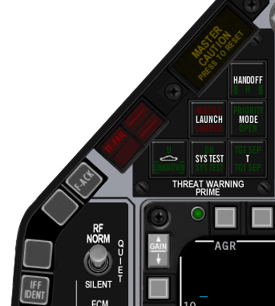
Build Status
Panel Purchased
Back Panel Purchased
Mounted in Pit
Wired
Knobs mounted
Inputs Tested
Outputs Tested

Switch Name | Poles | Switch type | Positions | Position names | Notes | Callback | Lightbits1
Left
IFF | 2 | push | off-(on) | IFF IDENT
Blank 1 | 2 | push | off-(on) | (directly above IFF button)
Blank 2 | 2 | push | off-(on) | (directly below TF-FAIL button)
TF fail | 0 | red indicator light | none | TF-FAIL | Red illumination, normally off |  | TF = $2
F-ACK | 2 | push | off-(on) | F-ACK |  | SimICPFAck
Master Caution | 2 | push | off-(on) | Master Caution push to reset |  | ExtinguishMasterCaution | MasterCaution = $1

 | J16
1 | BKLGT-V
2 | BKLGT+V
3 | +12V
4 | +28V
5 | GND ,
6 | TFF
7 | M_CAUT
8 | F_ACK
9 | EXT_CTN
10 | 10 OPEN

Eyebrow Lights R
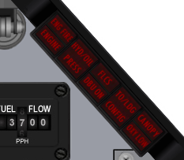
Build Status
Panel Purchased
Back Panel Purchased
Mounted in Pit
Wired
Knobs mounted
Inputs Tested
Outputs Tested

Switch Name | Poles | Switch type | Positions | Position names | Notes | Callback | Lightbits1
Right
Engine fire | 2 | push | off-(on) | ENGFIRE ENGINE | Red illumination, normally off |  | ENG_FIRE = $20, ENGINE=80000000
Fluid pressure warning | 2 | push | off-(on) | HYD/OIL PRESS | Red illumination, normally off |  | HYD = $80,  OIL = $100
Flight controls warning | 2 | push | off-(on) | FLCS DBU ON | Red illumination, normally off
Landing configuration | 2 | push | off-(on) | TO/LDG CONFIG | Red illumination, normally off |  | T_L_CFG = $800
Canopy seal warning | 2 | push | off-(on) | CANOPY | Red illumination, normally off |  | CAN = $400

 | J11
1 | BKLGT-V
2 | BKLGT+V
3 | +12V
4 | +28V
5 | GND ,
6 | E_FIRE
7 | ENGINE
8 | OIL
9 | TL_CFG
10 | CANOPY

A little challenge here as Leo provides support for more Light BITS, and Mike’s Right Eyebrow is different to what I’d been working off. Ended up using http://www.scribd.com/doc/903695/F16MLU-Checklist as a reference

 | Original | Mike | F4IM | F4IM Comments
Engine | 7 | Engine |  | ENG_FIRE | 6
E_Fire | 6 | Eng Fire |  | ENG_FIRE | 6
OIL | 8 | Press |  | OIL | 7
 |  | HYD/OIL |  | HYD | 8
 |  | FLCS |  | DUAL | 9
 |  | DBO ON |  | DUAL | 9
TL_CFG | 9 | TO/LDG |  | T_L_CFG | 10
 |  | CONFIG |  | CONFIG | 11
Canopy | 10 | CANOPY |  | CAN | 12
 |  | OXY LOW | N/A

As Wired
 |  | 1 | 2 | 3 | 4 | 5 | 6 | 7 | 8
ENG FIRE | 1 | X
ENGINE | 2 |  | X
PRESS | 3 |  |  | X
CONFIG | 4 |  |  |  | X
CANOPY | 5 |  |  |  |  | X
HYD/OIL | 6 |  |  | X
DBU ON | 7 |  |  |  |  |  | X
FLCS | 8 |  |  |  |  |  |  | X
TO/LDG | 9 |  |  |  | X
OXY LOW | 10 |  |  |  |  |  |  |  | X

ENG FIRE  1 | HYD/OIL  6 | FLCS  8 | TO/LDG  9 | CANOPY  5
ENGINE  2 | PRESS  3 | DBU ON  7 | CONFIG  4 | OXY LOE  10

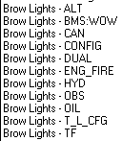

Final Wiring of Spare Connector
 | J32
1 | BKLGT-V
2 | BKLGT+V
3 | +12V
4 | +28V
5 | GND ,
6 | E_FIRE
7 | ENGINE
8 | OIL
9 | TL_CFG
10 | CANOPY
11 | FLCS
12 | DBU ON
13 | OXY LOW
Indexer L

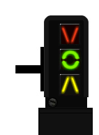
Build Status
Panel Purchased
Back Panel Purchased
Mounted in Pit
Wired
Knobs mounted
Inputs Tested
Outputs Tested

Switch Name | Poles | Switch type | Positions | Position names | Notes | Callback | Lightbits1
Left Indexer
 |  |  |  |  |  |  | AOAAbove = $1000
 |  |  |  |  |  |  | AOAOn = $2000
 |  |  |  |  |  |  | AOABelow = $4000

 | J8
1 | BKLGT-V
2 | BKLGT+V
3 | +12V
4 | +28V
5 | GND ,
6 | A_ABVE
7 | A_ON
8 | A_BLOW
9 | 9 OPEN,
10 | 10 OPEN

Indexer R

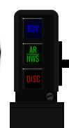
Build Status
Panel Purchased
Back Panel Purchased
Mounted in Pit
Wired
Knobs mounted
Inputs Tested
Outputs Tested

Switch Name | Poles | Switch type | Positions | Position names | Notes | Callback | Lightbits1
Right Indexer
 |  |  |  |  |  |  | RefuelRDY = $8000
 |  |  |  |  |  |  | RefuelAR = $10000
 |  |  |  |  |  |  | RefuelDSC = $20000

 | J9
1 | BKLGT-V
2 | BKLGT+V
3 | +12V
4 | +28V
5 | GND ,
6 | R_RDY NET41_2,
7 | R_AR NET40_2,
8 | R_DSC NET39_2,
9 | 9 OPEN,
10 | 10 OPEN

ICP

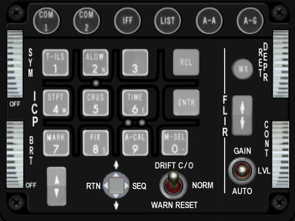
Build Status
Panel Purchased
Back Panel Purchased
Mounted in Pit
Wired
Knobs mounted
Inputs Tested
Outputs Tested

Switch Name | # of poles | Switch type | Positions | Position names | Notes | Callback
COM1 | 2 | push | off-(on) | n/a |  | SimICPCom1
COM2 | 2 | push | off-(on) | n/a |  | SimICPCom2
IFF | 2 | push | off-(on) | n/a |  | SimICPIFF
LIST | 2 | push | off-(on) | n/a |  | SimICPLIST
A-A | 2 | push | off-(on) | n/a |  | SimICPAA
A-G | 2 | push | off-(on) | n/a |  | SimICPAG
1 key | 2 | push tile | off-(on) | n/a |  | SimICPTILS
2 key | 2 | push tile | off-(on) | n/a |  | SimICPALOW
3 key | 2 | push tile | off-(on) | n/a |  | SimICPTHREE
Recall key | 2 | push tile | off-(on) | n/a |  | SimICPCLEAR
4 key | 2 | push tile | off-(on) | n/a |  | SimICPStpt
5 key | 2 | push tile | off-(on) | n/a |  | SimICPCrus
6 key | 2 | push tile | off-(on) | n/a |  | SimICPSIX
enter key | 2 | push tile | off-(on) | n/a |  | SimICPEnter
7 key | 2 | push tile | off-(on) | n/a |  | SimICPMark
8 key | 2 | push tile | off-(on) | n/a |  | SimICPEIGHT
9 key | 2 | push tile | off-(on) | n/a |  | SimICPNINE
0 key | 2 | push tile | off-(on) | n/a |  | SimICPZERO
WX | 2 | push | off-(on) | n/a
ICP inc/dec | 3 | rocker | (on)-off-(on) | down arrow, up arrow |  | SimICPNext, SimICPPrevious
display control switch | 4 | 4-way momentary bat | (on)-(on)-(on)-(on)-center off | down, rtn, up, seq (cw from bottom) | ? | SimICPDEDDOWN, SimICPResetDED ,SimICPDEDUP, SimICPDEDSEQ
Drift cutoff | 3 | toggle (momentary 1 side only) | (on)-off-on | warn reset, norm, drift c/o |  | SimDriftCOOff, SimDriftCOOn
FLIR up/down | 3 | rocker | (on)-off-(on) | down arrow, up arrow
FLIR gain | 3 | toggle | on-off-on | auto, lvl, gain
SYM | 2 | 10k linear pot | off-increase clockwise | off |  | BMS analog axis or SimSymWheelD <SimSymWheelUp
BRT | 0 | 10k linear pot | off-increase clockwise |  |  | BMS analog axis or SimHUDBrightnessDown, SimHUDBrightnessUp
 |  |  |  |  |  | SimHUDOn, SimHUDOff
RET DEPR | 0 | 10k linear pot | increase clockwise |  |  | BMS analog axis or SimRetDn,SimRetUp
CONT | 0 | 10k linear pot | increase clockwise

INSTR

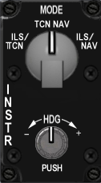
Build Status
Panel Purchased
Back Panel Purchased
Mounted in Pit
Wired
Knobs mounted
Inputs Tested
Outputs Tested

Switch Name | # of poles | Switch type | Positions | Postion names | Notes | Callback
mode | 4 | rotary | on-on-on-on | ils/tcn, tcn, nav, ils/nav | (4x30 deg) | SimHSIIlsTcn, SimHSITcn, SimHSINav, SimHSIIlsNav
heading | 0 | potentiometer | rotary | n/a | no EPIC connection

 | J4 | Implemented
1 | BKLGT-V | BKLGT-V
2 | BKLGT+V | BKLGT+V
3 | +12V | +12V
4 | +28V | +28V
5 | GND , | GND ,
6 | I_TCN | I_TCN
7 | TCN | TCN
8 | NAV | I_NAV
9 | I_NAV | OPEN
10 | 10 OPEN, | OPEN
11 | R_GND | R_GND
12 | R_CRSE_A | R_CRSE_HEAD_A
13 | R_CRSE_B | R_CRSE_HEAD_A
14 | R_HEAD_A | R_Pushed
15 | R_HEAD_B
16 | 16 OPEN

HIS – Not used

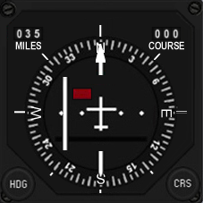
Build Status - not used
Panel Purchased
Back Panel Purchased
Mounted in Pit
Wired
Knobs mounted
Inputs Tested
Outputs Tested

Switch Name | # of poles | Switch type | Positions | Postion names | Notes | Callback
course | 360 | encoder | rotary | n/a |  | SimHsiCourseDec, SimHsiCourseInc
heading | 360 | encoder | rotary | n/a |  | SimHsiHeadingDec, SimHsiHeadingInc

The Course and Heading input is mapped to a single rotary on the INSTR panel, with the role changing if the rotary is pushed while rotating.

Fuel Qty Select

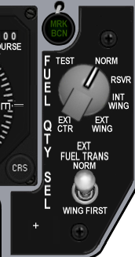
Build Status
Panel Purchased
Back Panel Purchased
Mounted in Pit
Wired
Knobs mounted
Inputs Tested
Outputs Tested

Switch Name | # of poles | Switch type | Positions | Postion names | Notes | Callback
source | 6 | rotary | on-on-on-on-on-on | ext ctr, ext wing, int wing, rsvr, norm, test | (6x45 deg) | SimFuelSwitchCenterExt, SimFuelSwitchWingExt, SimFuelSwitchWingInt, SimFuelSwitchResv, SimFuelSwitchNorm, SimFuelSwitchTest
Fuel transfer | 2 | locking toggle | [off]-[on] | wing first, norm |  | SimFuelTransWing,SimFuelTransNorm

 | J12
1 | BKLGT-V
2 | BKLGT+V
3 | +12V
4 | +28V
5 | GND ,
6 | MARKER
7 | EXT_WNG
8 | INT_WNG
9 | RVSR
10 | NORM
11 | TEST
12 | TRNSFR
13 | EXT_CTR
14 | INST_FLG1
15 | INST_FLG2
16 | INST_FLG3

Caution Panel

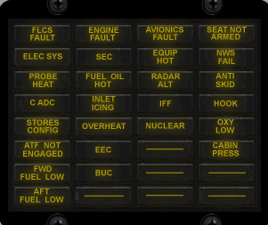
Build Status
Panel Purchased
Back Panel Purchased
Mounted in Pit
Wired
Knobs mounted
Inputs Tested
Outputs Tested

Lightbits1 | Lightbits2 | Lightbits3
CONFIG = $40
DUAL = $200;
FltControlSys = $40000
LEFlaps = $80000
EngineFault = $100000
Overheat = $200000
FuelLow = $400000
Avionics = $800000
RadarAlt = $1000000
IFF = $2000000
ECM = $4000000
Hook = $8000000
NWSFail = $10000000
CabinPress = $20000000
 | FwdFuelLow = $40000
 | AftFuelLow = $80000
 | SEC = $400000
 | OXY_LOW = $800000
 | PROBEHEAT = $1000000
 | SEAT_ARM = $2000000
 | BUC = $4000000
 | FUEL_OIL_HOT = $8000000
 | ANTI_SKID = $10000000
 |  | Elec_Fault = $400

Sensor Power

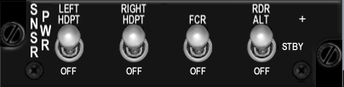
Build Status
Panel Purchased
Back Panel Purchased
Mounted in Pit
Wired
Knobs mounted
Inputs Tested
Outputs Tested

Switch Name | # of poles | Switch type | Positions | Postion names | Notes
Left hardpoint | 2 | toggle | off-on | off, left hdpt | SimLeftHptOff, SimLeftHptOn
Right hardpoint | 2 | toggle | off-on | off, right hdpt | SimRightHptOff, SimRightHptOn
Fire control radar | 2 | toggle | off-on | off, fcr | SimFCROff, SimFCROn
Radar altimeter | 3 | toggle | off-on-on | off, stby, rdr alt | SimRALTOFF, SimRALTSTDBY, SimRALTOFF

 | J23
1 | BKLGT-V
2 | BKLGT+V
3 | +12V
4 | +28V
5 | GND ,
6 | L_HPT
7 | R_HPT
8 | FCR
9 | RA_STD
10 | RA_ON

HUD Control

Build Status
Panel Purchased
Back Panel Purchased
Mounted in Pit
Wired
Knobs mounted
Inputs Tested
Outputs Tested
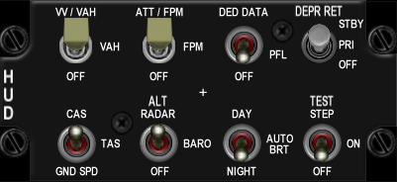

Switch Name | # of poles | Switch type | Positions | Postion names | Notes | Callback
Velocity scales | 3 | toggle | off-on-on | off, vah, vv/vah |  | SimScalesOff, SimScalesVAH, SimScalesVVVAH
Attitude scales | 3 | toggle | off-on-on | off, fpm, att/fpm |  | SimPitchLadderOff, SimPitchLadderFPM, SimPitchLadderATTFPM
Data Entry | 3 | toggle | off-on-on | off, pfl, ded data |  | SimHUDDEDOff, SimHUDDEDPFL, SimHUDDEDDED
DEPR reticle | 3 | toggle | [off]-[on]-[on] | off, pri, stby |  | SimReticleOff, SimReticlePri, SimReticleStby
Velocity | 3 | toggle | off-on-on | gnd spd, tas, cas |  | SimHUDVelocityGND, SimHUDVelocityTAS, SimHUDVelocityCAS
Altitude | 3 | toggle | off-on-on | auto, baro, alt radar |  | SimHUDAltAuto, SimHUDAltBaro, SimHUDAltRadar
Brightness | 3 | toggle | off-on-on | night, auto, day |  | SimHUDBrtNight, SimHUDBrtAuto, SimHUDBrtDay
Test | 3 | toggle | off-on-on | off, on, test step

1 | BKLGT-V
2 | BKLGT+V
3 | +12V
4 | +28V
5 | GND ,
6 | S_VA
7 | S_VV
8 | FPM
9 | AT_FPM
10 | PFL
11 | DED
12 | R_PRI
13 | R_STD
14 | A_BARO
15 | A_RDR
16 | NIGHT
17 | DAY
18 | CAS
19 | GNDSPD
20 | 20 OPEN

Nuclear consent

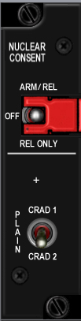
Build Status
Panel Purchased
Back Panel Purchased
Mounted in Pit
Wired
Knobs mounted
Inputs Tested
Outputs Tested

Switch Name | # of poles | Switch type | Positions | Postion names
plain | 2 | toggle | off-on | crad1, crad 2
arm | 3 | guarded toggle | on-off-on | rel only, off, arm rel

Lighting

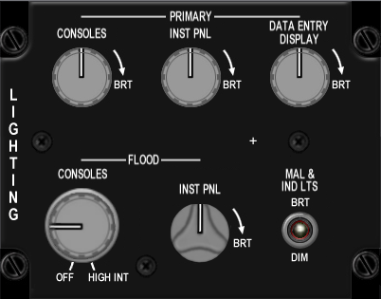
Build Status
Panel Purchased
Back Panel Purchased
Mounted in Pit
Wired
Knobs mounted
Inputs Tested
Outputs Tested

Switch Name | # of poles | Switch type | Positions | Postion names
Consoles (primary) | 0 | potentiometer | increase clockwise
instrument panel (primary) | 0 | potentiometer | increase clockwise
Data entry display (primary) | 0 | potentiometer | increase clockwise
Consoles (flood) | 2 | off-potentiometer | increase clockwise
instrument panel (flood) | 0 | potentiometer | increase clockwise
malfunction lights | 2 | toggle | off-on | dim, brt

 | J27
1 | BKLGT-V
2 | BKLGT+V
3 | +12V
4 | +28V
5 | GND ,
6 | POT_GND POT_GROUND_4,
7 | POT_+V POT_+V_4,
8 | POT_1 POT_1_4,
9 | POT_2 POT_2_4,
10 | POT_3 POT_3_4,
11 | POT_4 POT_4_4,
12 | DIM_BRIGHT DIM_BRIGHT_4,
13 | 13 OPEN,
14 | 14 OPEN,
15 | 15 OPEN,
16 | 16 OPEN

Master Zeroize
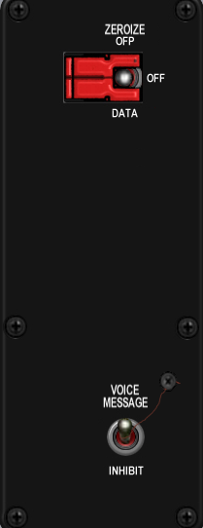
Build Status
Panel Purchased
Back Panel Purchased
Mounted in Pit
Wired
Knobs mounted
Inputs Tested
Outputs Tested

Switch Name | # of poles | Switch type | Positions | Postion names | Notes | Callback
voice message | 2 | toggle | off-on | inhibit, voice message |  | SimVMSOFF, SimVMSOn
zeroize | 3 | guarded toggle | on-off-on | data zeroize, blank, master zeroize | guarded in center off position

 | J33
1 | BKLGT-V
2 | BKLGT+V
3 | +12V
4 | +28V
5 | GND ,
6 | V_INHB NET5_5,
7 | 7 OPEN,
8 | 8 OPEN,
9 | 9 OPEN,
10 | 10 OPEN

Air Cond

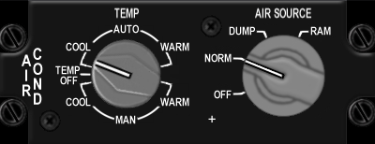
Build Status
Panel Purchased
Back Panel Purchased
Mounted in Pit
Wired
Knobs mounted
Inputs Tested
Outputs Tested

Switch Name | # of poles | Switch type | Positions | Postion names | Notes | Callback
air source | 4 | rotary | on-on-on-on | off, norm, dump, ram | (4x45 deg) | SimAirSourceOff, SimAirSourceNorm, SimAirSourceDump, SimAirSourceRam
temp | 7 | rotary | on-on-on-off-on-on-on |  | No EPIC connection

 | J34
1 | BKLGT-V
2 | BKLGT+V
3 | +12V
4 | +28V
5 | GND ,
6 | OFF
7 | NORM
8 | DUMP
9 | RAM
10 | 10 OPEN

KY-58

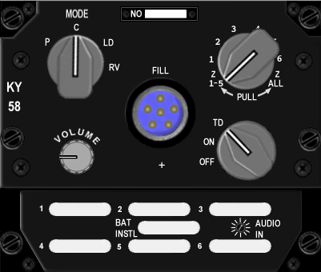
Build Status
Panel Purchased
Back Panel Purchased
Mounted in Pit
Wired
Knobs mounted
Inputs Tested
Outputs Tested

Switch Name | # of poles | Switch type | Positions | Postion names | Notes
mode | 4 | rotary knob | on-on-on-on | p, c, ld, rv | (4x45 deg)
volume | 0 | 10k log potentiometer | clockwise to increase |  | no EPIC connection
number rotary | 8 | rotary knob | {on}-on-on-on-on-on-on-{on} | 215, 1, 2, 3, 4, 5, 6, 7 all | (8x30 deg)
on/off rotary | 3 | rotary knob | on-on-on | off, on, TD | (3x30 deg)

Avionics Power

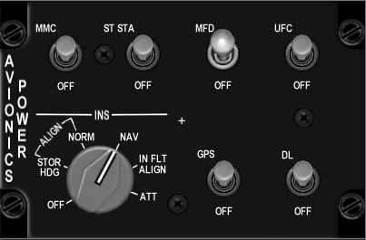
Build Status
Panel Purchased
Back Panel Purchased
Mounted in Pit
Wired
Knobs mounted
Inputs Tested
Outputs Tested

Switch Name | # of poles | Switch type | Positions | Postion names | Notes | Callback
FCC | 2 | Locking toggle | [off]-[on] | off, FCC |  | SimFCCOff, SimFCCOn
SMS | 2 | Locking toggle | [off]-[on] | off, SMS |  | SimSMSOff, SimSMSOn
MFD | 2 | Locking toggle | [off]-[on] | off, MFD |  | SimMFDOff, SimMFDOn
UFC | 2 | Locking toggle | [off]-[on] | off, UFC |  | SimUFCOff, SimUFCOn
INS | 7 | Rotary knob | on-on-on-on-on-on-on | off, stor hdg, norm, nav, cal, in flt align, att | (7x45deg) | SimINSOff, SimINSNorm, SimINSNav, SimINSInFlt
GPS | 2 | Locking toggle | [off]-[on] | off, GPS |  | SimGPSOff, SimGPSOn
DL | 2 | Locking toggle | [off]-[on] | off, DL |  | SimDLOff, SimDLOn
MAP | 2 | Locking toggle | [off]-[on] | off, MAP |  | SimMAPOff, SimMAPOn

 | J24
1 | BKLGT-V
2 | BKLGT+V
3 | +12V
4 | +28V
5 | GND ,
6 | FCC
7 | SMS
8 | MFD
9 | UFC
10 | I_OFF
11 | I_HDG
12 | I_NRM
13 | I_NAV
14 | I_CAL
15 | I_ATT
16 | GPS
17 | TISL
18 | MAP
19 | P_GND PHY_MFD_PWR_4,
20 | P_MFD_PWR PHY_GND_4

Anti-Ice

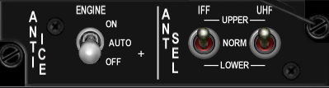
Build Status
Panel Purchased
Back Panel Purchased
Mounted in Pit
Wired
Knobs mounted
Inputs Tested
Outputs Tested

Switch Name | # of poles | Switch type | Positions | Postion names | Notes | Callback
engine anti ice | 3 | locking toggle | [off]-[on]-[on] | off, auto, on
IFF antenna select | 3 | toggle | on-off-on | lower, norm, upper
UHF antenna select | 3 | toggle | on-off-on | lower, norm, upper

Oxy Reg

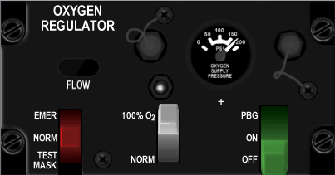
Build Status
Panel Purchased
Back Panel Purchased
Mounted in Pit
Wired
Knobs mounted
Inputs Tested
Outputs Tested

Switch Name | # of poles | Switch type | Positions | Postion names
Flow control (red) | 3 | lever | on-on-on | Test mask, norm, Emer
Oxygen content (green) | 2 | lever | on-on | Norm, 100% O2
Pressure control (grey) | 3 | lever | off-on-on | off, on, PBG

DTU

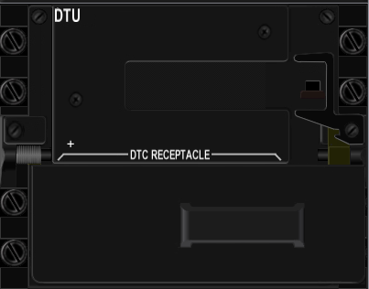
Build Status
Panel Purchased
Back Panel Purchased
Mounted in Pit
Wired
Knobs mounted
Inputs Tested
Outputs Tested

Switch Name | # of poles | Switch type | Positions
DTU | 2 | toggle | off-on

Left MFD

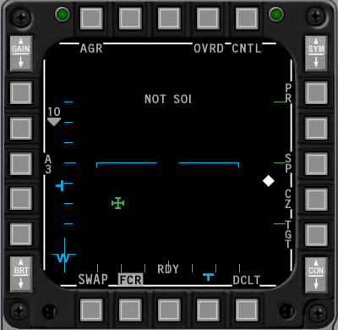
Build Status
Panel Purchased
Back Panel Purchased
Mounted in Pit
Wired
Knobs mounted
Inputs Tested
Outputs Tested

Switch Name | # of poles | Switch type | Positions | Notes | Callback
OSB1 | 2 | push | off-(on) |  | SimCBEOSB_1L
OSB2 | 2 | push | off-(on) |  | SimCBEOSB_2L
OSB3 | 2 | push | off-(on) |  | SimCBEOSB_3L
OSB4 | 2 | push | off-(on) |  | SimCBEOSB_4L
OSB5 | 2 | push | off-(on) |  | SimCBEOSB_5L
OSB6 | 2 | push | off-(on) |  | SimCBEOSB_6L
OSB7 | 2 | push | off-(on) |  | SimCBEOSB_7L
OSB8 | 2 | push | off-(on) |  | SimCBEOSB_8L
OSB9 | 2 | push | off-(on) |  | SimCBEOSB_9L
OSB10 | 2 | push | off-(on) |  | SimCBEOSB_10L
OSB11 | 2 | push | off-(on) |  | SimCBEOSB_11L
OSB12 | 2 | push | off-(on) |  | SimCBEOSB_12L
OSB13 | 2 | push | off-(on) |  | SimCBEOSB_13L
OSB14 | 2 | push | off-(on) |  | SimCBEOSB_14L
OSB15 | 2 | push | off-(on) |  | SimCBEOSB_15L
OSB16 | 2 | push | off-(on) |  | SimCBEOSB_16L
OSB17 | 2 | push | off-(on) |  | SimCBEOSB_17L
OSB18 | 2 | push | off-(on) |  | SimCBEOSB_18L
OSB19 | 2 | push | off-(on) |  | SimCBEOSB_19L
OSB20 | 2 | push | off-(on) |  | SimCBEOSB_20L
 |  |  |  |  | SimCBEOSB_GAINUP_L
30 |  |  |  |  | SimCBEOSB_GAINDOWN_L

Right MFD

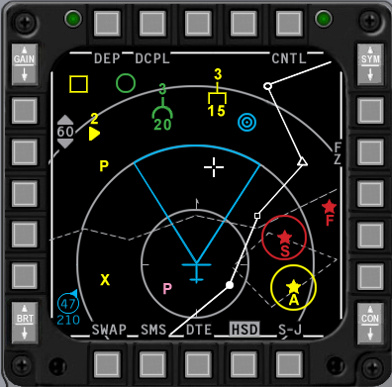
Build Status
Panel Purchased
Back Panel Purchased
Mounted in Pit
Wired
Knobs mounted
Inputs Tested
Outputs Tested

Switch Name | # of poles | Switch type | Positions | Notes | Callback
OSB1 | 2 | push | off-(on) |  | SimCBEOSB_1R
OSB2 | 2 | push | off-(on) |  | SimCBEOSB_2R
OSB3 | 2 | push | off-(on) |  | SimCBEOSB_3R
OSB4 | 2 | push | off-(on) |  | SimCBEOSB_4R
OSB5 | 2 | push | off-(on) |  | SimCBEOSB_5R
OSB6 | 2 | push | off-(on) |  | SimCBEOSB_6R
OSB7 | 2 | push | off-(on) |  | SimCBEOSB_7R
OSB8 | 2 | push | off-(on) |  | SimCBEOSB_8R
OSB9 | 2 | push | off-(on) |  | SimCBEOSB_9R
OSB10 | 2 | push | off-(on) |  | SimCBEOSB_10R
OSB11 | 2 | push | off-(on) |  | SimCBEOSB_11R
OSB12 | 2 | push | off-(on) |  | SimCBEOSB_12R
OSB13 | 2 | push | off-(on) |  | SimCBEOSB_13R
OSB14 | 2 | push | off-(on) |  | SimCBEOSB_14R
OSB15 | 2 | push | off-(on) |  | SimCBEOSB_15R
OSB16 | 2 | push | off-(on) |  | SimCBEOSB_16R
OSB17 | 2 | push | off-(on) |  | SimCBEOSB_17R
OSB18 | 2 | push | off-(on) |  | SimCBEOSB_18R
OSB19 | 2 | push | off-(on) |  | SimCBEOSB_19R
OSB20 | 2 | push | off-(on) |  | SimCBEOSB_20R
 |  |  |  |  | SimCBEOSB_GAINUP_R
 |  |  |  |  | SimCBEOSB_GAINDOWN_R

Other
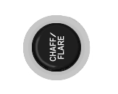
Build Status
Panel Purchased
Back Panel Purchased
Mounted in Pit
Wired
Knobs mounted
Inputs Tested
Outputs Tested

Switch Name | # of poles | Switch type | Positions | Postion names | Notes | Callback
Chaff/flare button
Alt gear | 2 |  |  |  | ? | AFAlternateGear, AFAlternateGearReset
Canopy switch | 2 |  |  |  |  | AFCanopyToggle
pedal adj | 0 | T handle | mechanical | none
Mark beacon | 0 | green indicator light | none | mrk bcn

ACES-II

Build Status
Panel Purchased
Back Panel Purchased
Mounted in Pit
Wired
Knobs mounted
Inputs Tested
Outputs Tested

Switch Name | # of poles | Positions | Postion names | Notes | Callback
Eject grip | 2 |  |  |  | SimEject
Safety Lever | 2 |  |  |  | SimSeatOff, SimSeatOn
Manual release

 | J15
1 | BKLGT-V
2 | BKLGT+V
3 | +12V LEFT
4 | +28V LEFT
5 | GND LEFT
6 | EJECT
7 | SEAT_ON
8 | 8 OPEN,
9 | 9 OPEN,
10 | 10 OPEN

TQS

Switch Name | # of poles | Switch type | Positions | Postion names | Notes | Callback
DOGFIGHT | 3 |  | on-off-on | DDOGFIGHT, , |  | SimSelectMRMOverride, SimDeselectOverride, SimSelectSRMOverride
MAN RNG/UNCAGE |  | Rotary knob |  | MAN RNG/UNCAGE |  | BMS alanog axis or SimRangeKnobDown, SimRangeKnobUp
ANT ELEV |  | Rotary knob | Detented center |  |  | BMS alanog axis or SimRadarElevationDown, SimRadarElevationCenter, SimRadarElevationUp
CURSOR |  | Joystick |  |  |  | BMS alanog axes or SimCursorDown ,SimCursorLeft ,SimCursorRight , SimCursorUp
ENABLE | 2 | push | off-(on) |  |  | SimCursorEnable
Speed Brake | 2 |  |  |  |  | AFBrakesIn, AFBrakesOut
PTT | 4 |  |  | VHF,UHF,IFF IN,IFF OUT |  | SimTransmitCom2,SimTransmitCom1
Black-Out Switch | 2

SSCG

Switch Name | # of poles | Switch type | Positions | Postion names | Notes | Callback
NWS-A/R DISC-MSL STEP | 2 |  | off,(on) |  |  | SimMissileStep
Trim | 5 |  |  | Off,Fwd,Aft,Left,Right |  | AFElevatorTrimUp, AFElevatorTrimDown ,AFAileronTrimLeft, AFAileronTrimRight
Display Manag | 5 |  |  | Off,Fwd,Aft,Left,Right |  | SimDMSUp, SimDMSDown, SimDMSLeft,SimDMSRight
Weapon Release | 2 |  | off,(on) |  |  | SimPickle
Paddle Switch | 2 |  |  |  |  | SimAPOverride
Trigger | 3 |  |  | Off,Detent1,Detent2 |  | SimTriggerFirstDetent, SimTriggerSecondDetent
Pinky Switch | 2 |  |  |  |  | SimPinkySwitch
TMS | 5 |  |  | Off,Fwd,Aft,Left,Right |  | SimTMSUp,SimTMSDown, SimTMSLeft,SimTMSRight
CMS | 5 |  |  | Off,Fwd,Aft,Left,Right |  | SimDropProgrammed, SimECMConsent, ,SimECMStandby

Switch Mapping for non-Falcon

Test
 | Lomac | Postion names | Keystroke
EPU gen |  | off-epu gen
PROBE HEAT |  | test-off-probe heat
FIRE & OHEAT DETECT |  | n/a
OXY |  | off-QTY
MAL & IND LTS |  | n/a
A B C D
test maint |  | h

Anti-G
Switch Name | Lomac | Postion names | Keystroke
Test |  | Test

Flt control
Switch Name | Lomac | Postion names | Keystroke
DIGITAL |  | off-backup
ALT FALPS | Flaps Up | norm | LCtrl-F
 | Flaps Landing Position | extend | LShift-F
MANUAL TF FLYUP |  | disable-enable
LE FLAPS |  | auto-lock
FLCS |  | reset-off
BIT / OFF |  | OFF, BIT
RUN FAIL

Manual Trim
Switch Name | Lomac | Position names | Keystroke
Pitch Trim
Roll Trim
Yaw Trim
Trim /AP DISC |  | norm, disc

Fuel
Switch Name | Lomac | Position names | Key Strokes
MASTER | Engines Stop | OFF | RShift-End
 |  | MASTER
TANK INERTING | Fuel Dump | OFF-TANK INERTING | R
ENG FEED |  | OFF, NORM, AFT, FWD
AIR REFUEL | Refueling Bay | CLOSE, | LCtrl-R
 |  | OPEN | LCtrl-R

Aux Comm
Switch Name | Lomac | Position names | Keystroke
MASTER |  | off, STBY, LOW, NORM, EMER
M-4 CODE |  | hold, a/b, zero
CNI |  | BACK UP, UFC
REPLY |  | OUT, A, B
MONITOR |  | OUT, AUDIO
TACAN |  | A/A TR-REC-T/R
CHANNEL 100's |  | 0-9 inclusive
CHANNEL 10's |  | 0-9 inclusive
CHANNEL 1's |  | 0-9 inclusive
channel x/y |  | x, y

Ext Lighting
Switch Name | Lomac | Position names | Keystrokes
Form
Master | Illumination Cockpit | off | L
 |  | norm | L
Aerial Refueling
Anti Collision | Navigation lights | Off | RCtrl-L
 |  | anti collision | RCtrl-L
Flash Steady |  | flash, steady
Wing Trail | Smoke | dim, off, brt | T
 |  | off | T
 |  | brt | T
Fuselage |  | dim, off, brt

EPU
Switch Name | Lomac | Position names | Keystroke
EPU | 3 | OFF-NORMAL-ON | Center guard on NORMAL
RUN light | 0 | green light
HYDRAZN-AIR | 0 | HYDRAZN-AIR

Elect
Switch Name | Lomac | Position names | Keystrokes
MAIN PWR | Power Switch | OFF | Shift-P
 |  | BAT | Shift-P
 |  | MAIN PWR | Shift-P
CAUTION RESET
FLCS PMG-MAIN GEN |  | FLCS PMG-MAIN GEN
STBY GEN |  | STBY GEN
EPU GEN-EPU / PMG |  | EPU GEN-EPU / PMG
FAIL |  | FAIL
TO FLCS-FLCS RLY |  | TO FLCS-FLCS RLY

AVTR
Switch Name | Lomac | Position names | Keystroke
AVTR |  | on, auto, off

ECM
Switch Name | Lomac | Position names | Keystroke
OPR |  | OFF-STBY-OPR
DIM |  | 1, 2, 3
XMIT |  | xmit, blank
RESET |  | reset, blank
BIT |  | bit, blank
1 |  | S, A, F, T light in corners
2 |  | S, A, F, T light in corners
3 |  | S, A, F, T light in corners
4 |  | S, A, F, T light in corners
5 |  | S, A, F, T light in corners
ALT |  | S, A, F, T light in corners
FRM |  | S, A, F, T light in corners
SPL |  | S, A, F, T light in corners

Jet Start
Switch Name | Lomac | Position names | Keystroke
JET FUEL | Engines Start | START2-OFF-START1 | RShift-Home
ENG CONT |  | SEC-PRI
AB RESET |  | ENG DATA-NORM-AB DATA
MAX POWER |  | OFF-MAX POWER
RUN |  | green light

Audio2
Switch Name | Lomac | Position names | Keystroke
INTERCOM
TACAN
ILS
HOT MIC |  | CIPHER, OFF, HOT MIC

Audio
Switch Name | Lomac | Position names | Keystroke
COMM 1 volume
COMM 1 selector |  | OFF-SQL-GD
COMM 2 volume
COMM 2 selector |  | OFF-SQL-GD
SECURE VOICE
TF
MSL | 0
THREAT | 0

UHF
Switch Name | Lomac | Position names | Keystroke
UHF |  | OFF-MAIN-BOTH-ADF
TONE |  | tone
VOL
SQUELCH |  | OFF-ON
MANUAL |  | MANUAL-PRESET-GUARD
Freq 100's |  | A, 3, 2, T
Freq 10's |  | 0-9 inclusive
Freq 1's |  | 0-9 inclusive
Freq 1/10's |  | 0-9 inclusive
Freq 1/1000's |  | 00, 25, 50, 75
CHAN |  | 1-19 inclusive
EMB |  | ??

Manual Pitch
Switch Name | Lomac | Position names | Keystroke
MANUAL PITCH |  | OVRD-NORM

Threat Warn Aux
Switch Name | Lomac | Position names | Keystroke
Search |  | search
activity power |  | activity power
Low priority |  | low
system power |  | power
fuse |  | n/a
Dimmer |  | n/a

CMDS
Switch Name | Lomac | Position names | Keystroke
RWR |  | off, on
JMR |  | off, on
MWS |  | off, on
01 |  | off, on
02 |  | off, on
CH |  | off, on
FL |  | off, on
JETT |  | off, JETT
PRGM |  | bit, 1, 2, 3, 4, 5
MODE |  | off, stby, man, semi, auto, byp
STATUS NO GO |  | NO GO (green lit legend)
STATUS GO | 0 | GO (green lit legend)
STATUS READY | 0

Gear Panel
Switch Name | Lomac | Position names | Keystrokes
Emergency jettison | Weapons Jettison |  | LCtrl-W
wheel lights
Hook | Toggle Arrestor Hook |  | Ctl-G
Ground jettison
Brakes
Parking brake |  | off
 | Wheel Brake on | anti skid | W
 | Wheel Brake on | brake | W
Stores |  | cat III, cat I
Horn silencer | Audible Warning Reset | n/a | RShift-N
Landing lights | Gear Light Near/Far/Off | taxi | RAlt-L
 | Gear Light Near/Far/Off | off | RAlt-L
 | Gear Light Near/Far/Off | landing | RAlt-L
Down lock release |  | n/a
Gear down enable |  | n/a
Gear handle | Landing Gear Down | Down | LShift-G
 | Landing Gear Up | Up | LCtrl-G
Gear warning light |  | n/a

MISC
Switch Name | Lomac | Position names | Keystrokes
RF quiet | Radar On/Off | silent | I
 |  | rf norm | I
ECM light |  | n/a
Laser arm |  | off, arm
Alternate release | Weapon Fire | n/a | Space
Master arm |  | simulate, off, arm
ADV mode |  | active/standby
Autopilot pitch |  | att hold, a-p off, alt hold
Autopilot roll |  | strg sel, att hold, hdg sel

Threat Warn Prime
Switch Name | Lomac | Positions | Notes
Handoff |  | off-(on)
Priority |  | off-(on)
Target separate |  | off-(on)
Missile Launch |  | none
system test |  | off-(on)
Unknown/naval |  | off-(on)

Eyebrow Lights L
Switch Name | Lomac | Position names | Keystrokes
IFF |  | IFF IDENT
Blank 1 |  | (directly above IFF button)
Blank 2 |  | (directly below TF-FAIL button)
TF fail |  | TF-FAIL
F-ACK |  | F-ACK | RShift-N
Master Caution |  | Master Caution push to reset | RShift-N

Eyebrow Lights R
Switch Name | Lomac | Position names | Keystroke
Right
Engine fire |  | ENGFIRE ENGINE
Fluid pressure warning |  | HYD/OIL PRESS
Flight controls warning |  | FLCS DBU ON
Landing configuration |  | TO/LDG CONFIG
Canopy seal warning |  | CANOPY

Indexer L

Switch Name | Lomac | Position names | Keystrok
Left Indexer

Indexer R

Switch Name | Lomac | Position names | Keystroke
Right Indexer

ICP
Switch Name | Lomac | Position names | Keystroke
COM1 |  | n/a
COM2 |  | n/a
IFF |  | n/a
LIST |  | n/a
A-A |  | n/a
A-G |  | n/a
1 key |  | n/a
2 key |  | n/a
3 key |  | n/a
Recall key |  | n/a
4 key |  | n/a
5 key |  | n/a
6 key |  | n/a
enter key |  | n/a
7 key |  | n/a
8 key |  | n/a
9 key |  | n/a
0 key |  | n/a
WX |  | n/a
ICP inc/dec |  | down arrow, up arrow
display control switch |  | down, rtn, up, seq (cw from bottom) | ?
Drift cutoff |  | warn reset, norm, drift c/o
FLIR up/down |  | down arrow, up arrow
FLIR gain |  | auto, lvl, gain
SYM |  | off
BRT
RET DEPR
CONT

INSTR

Switch Name | Lomac | Postion names | Keystroke
mode |  | ils/tcn, tcn, nav, ils/nav
heading |  | n/a

HIS – Not used
Switch Name | Lomac | Postion names | Keystroke
course |  | n/a
heading |  | n/a

Fuel Qty Select
Switch Name | Lomac | Postion names | Keystroke
source |  | ext ctr, ext wing, int wing, rsvr, norm, test
Fuel transfer |  | wing first, norm

Sensor Power
Switch Name | Lomac | Postion names | Keystroke
Left hardpoint |  | off, left hdpt
Right hardpoint |  | off, right hdpt
Fire control radar |  | off, fcr
Radar altimeter |  | off, stby, rdr alt

HUD Control
Switch Name | Lomac | Postion names | Keystrokes
Velocity scales |  | off, vah, vv/vah
Attitude scales |  | off, fpm, att/fpm
Data Entry |  | off, pfl, ded data
DEPR reticle |  | off, pri, stby
Velocity |  | gnd spd, tas, cas
Altitude |  | auto, baro, alt radar
Brightness | HUD Colour | night | RCtrl-H
 |  | auto | RCtrl-H
 |  | day | RCtrl-H
Test |  | off, on, test step

Nuclear consent
Switch Name | Lomac | Positions | Keystroke
plain |  | off-on
arm |  | on-off-on

Lighting
Switch Name | Lomac | Positions | Keystroke
Consoles (primary) |  | increase clockwise
instrument panel (primary) |  | increase clockwise
Data entry display (primary) |  | increase clockwise
Consoles (flood) |  | increase clockwise
instrument panel (flood) |  | increase clockwise
malfunction lights |  | off-on

Master Zeroize

Switch Name | Lomac | Postion names | Keystroke
voice message |  | inhibit, voice message
zeroize |  | data zeroize, blank, master zeroize

Air Cond
Switch Name | Lomac | Postion names | Keystroke
air source |  | off, norm, dump, ram
temp

KY-58
Switch Name | Lomac | Postion names | Keystroke
mode |  | p, c, ld, rv
volume
number rotary |  | 215, 1, 2, 3, 4, 5, 6, 7 all
on/off rotary |  | off, on, TD

Avionics Power
Switch Name | Lomac | Postion names | Keystroke
FCC |  | off, FCC
SMS |  | off, SMS
MFD |  | off, MFD
UFC |  | off, UFC
INS |  | off, stor hdg, norm, nav, cal, in flt align, att
GPS |  | off, GPS
DL |  | off, DL
MAP |  | off, MAP

Anti-Ice
Switch Name | Lomac | Postion names | Keystroke
engine anti ice |  | off, auto, on
IFF antenna select |  | lower, norm, upper
UHF antenna select |  | lower, norm, upper

Oxy Reg
Switch Name | Lomac | Postion names | Keystroke
Flow control (red) | 3 | Test mask, norm, Emer
Oxygen content (green) | 2 | Norm, 100% O2
Pressure control (grey) | 3 | off, on, PBG

DTU
Switch Name | Lomac | Positions | Keystroke
DTU |  | off-on

Left MFD
Switch Name | Lomac | Positions | Keystroke
OSB1 |  | off-(on)
OSB2 |  | off-(on)
OSB3 |  | off-(on)
OSB4 |  | off-(on)
OSB5 |  | off-(on)
OSB6 |  | off-(on)
OSB7 |  | off-(on)
OSB8 |  | off-(on)
OSB9 |  | off-(on)
OSB10 |  | off-(on)
OSB11 |  | off-(on)
OSB12 |  | off-(on)
OSB13 |  | off-(on)
OSB14 |  | off-(on)
OSB15 |  | off-(on)
OSB16 |  | off-(on)
OSB17 |  | off-(on)
OSB18 |  | off-(on)
OSB19 |  | off-(on)
OSB20 |  | off-(on)

Right MFD
Switch Name | Lomac | Positions | Keystroke
OSB1 |  | off-(on)
OSB2 |  | off-(on)
OSB3 |  | off-(on)
OSB4 |  | off-(on)
OSB5 |  | off-(on)
OSB6 |  | off-(on)
OSB7 |  | off-(on)
OSB8 |  | off-(on)
OSB9 |  | off-(on)
OSB10 |  | off-(on)
OSB11 |  | off-(on)
OSB12 |  | off-(on)
OSB13 |  | off-(on)
OSB14 |  | off-(on)
OSB15 |  | off-(on)
OSB16 |  | off-(on)
OSB17 |  | off-(on)
OSB18 |  | off-(on)
OSB19 |  | off-(on)
OSB20 |  | off-(on)

Other
Switch Name | Lomac | Positions | Keystrokes
Chaff/flare button
Alt gear
Canopy switch | Canopy Open/Close | Open | LCtrl-C
 | Canopy Open/Close | Close | LCtrl-C
pedal adj
Mark beacon

ACES-II
Switch Name | Lomac | Positions | Keystrokes
Eject grip | Eject |  | LCtrl-E (3 times)
Safety Lever
Manual release

TQS

Switch Name | Lomac | Postion names | Keystroke
DOGFIGHT |  | DDOGFIGHT, ,
MAN RNG/UNCAGE |  | MAN RNG/UNCAGE
ANT ELEV
CURSOR
ENABLE
Speed Brake
PTT |  | VHF,UHF,IFF IN,IFF OUT
Black-Out Switch

SSCG
Switch Name | Lomac | Postion names | Keystroke
NWS-A/R DISC-MSL STEP
Trim |  | Off,Fwd,Aft,Left,Right
Display Manag |  | Off,Fwd,Aft,Left,Right
Weapon Release
Paddle Switch
Trigger |  | Off,Detent1,Detent2
Pinky Switch
TMS |  | Off,Fwd,Aft,Left,Right
CMS |  | Off,Fwd,Aft,Left,Right

Centre Console Maintenance

The centre console has a number of devices in a very compact space. Broadly speaking there is the base and the horizontal support.

Component | Maintenance instructions
Entire CP | Removal - Remove Ejection Seat. Remove 4 bolts holding the base in place. Lift straight up
Entire CP | Installation - Carefully drop straight down, ensuring the LHS panel sits against support, and the RHS gauges support drops into its slot.
CP Back Panel | CP Back Panel can be removed only if CP Centre is firmly bolted to pit.  Assembly CP Rig to receive CP panel  Remove Ejection Seat as it is much easier to remove CP Back Panel from the front as opposed to the side.  Disconnect all leads from CP Back Panel  Remove RH Gauges.  Remove Top support bracket by removing bolt on CP end Fully disconnect top support bracket and reattach to front canopy support.  Unscrew bolt on top RH of centre console  Unscrew bolt on bottom RH of centre console  Check if screws are holding LH Misc Panel.
Glareshield
MFD Displays | MUST DISASSEMBLE CP, the screens are slotted in place and cannot be installed once CP is assembled.
Fuel Flow Display | Installation – Remove ICP assembly if installed. Install bolt and fix with nut. Slide LCD PCB in place and hold with nylon washer and nut. Once loosely tightened position such that tape on the base is just visible. Attach controller PCB, and affix using large spacers.
ICP | Unscrew two nuts holding the ICP assembly in place.
Threat Warn Prime | One of the switches if currently not wired, so care must be taken when disassembling. Push switches from the front.  Unscrew bezel.  Can be removed at any time.
RWR | Remove the two nuts from the rear, pull assembly from the front.  Can be removed at any time.
MFD Bezels | MUST REMOVE MFD DISPLAYS. MUST DISASSEMBLE CP.  Due to the tight clearance for the cable at the base of the display the displays have to be removed.  Use only suitable length countersunk bolts to hold Bezel as long bolts will damage display.
MISC Panel | Loosen 4 bolts holding panel in place. Carefully slide EL lead and panel cabling through the horizontal panel.
RH Gauges Support | Remove screw at top of panel, lift panel with gauges out and up. Careful as lower gauge faceplate sometimes falls off.
Upper Instruments | Removal – Ensure the rail attached to the back of the CP is bolted in place. Remove lower instrument Panel, and then lift Upper instrument panel outwards from the base.
Lower Instruments | Removal – Check upper panel is bolted in place. Unscrew 2 screws on RHS and 1 screw on LHS.
DED Case | Remove 4 countersunk screws attaching DED to glareshield. Remove 4 pan head screws from top panel, this allows the ld of the DED box to be removed.

Centre Console Base Maintenance

The base centre console can only be removed after the top centre console has been removed.
The centre console is held in place with 4 bolts attaching it ot the pit floor.

Heading Indicator panel | Lay the Centre console base on its back  Remove the three screw to the left (one screw) and right (two screws). These are threaded into the rail.
Main Instrument Panel | Remove the heading indicator panel  Remove the LH bolt holding the front-back rail.  Lift the base of the main panel and slide the panel up and out towards you.
Assembly | Install Glareshield
 | Lay console on its back
 | Remove top left glareshield support bolt
 | Lay unit on its side (check surface is clear of debris)
 | Insert the top gauge panel
 | Sit console upright while supporting panel
 | Note the console now becomes top heavy. Take care not to knock it over.
 | Attach the top gauges panel using one bolt on the LHS, and the extended bracket at the back
 | Connect the flight illusions cable to the heading indicator on the bottom gauge panel
 | Drag the PCBs and coloured ribbon cable to the back. Check the coloured ribbon cable is sitting in the middle slot in the front. While lifting the RH side of the bottom gauge panel place a bolt in the bottom RHS. The unit is now very top heavy. A roll of solder helps keep it balanced.
 | Cable clamp the coloured USB lead in position
 | Mount the RHS PCB, only a single nut at the top is needed
 | Connect the three backlighting connectors to the LHS PCB. Note one of the connectors is green.
 | Install the top RHS bolt of the bottom gauge panel.

PFD Console Maintenance

Unplug cables
- Warning panel to EFlux
- Fuel gauge servo and backlight
- PFD to UCC
- Air core gauges
Remove right Hand Sill
Remove all Air-core gauges. This reduces the likelihood of a tragedy occurring and also makes it easier to get to the bottom nut.
Remove bolt on bottom LHS. Access to nut from outside pit
Remove two bolts on the top right hand side. Note, theare are four bolts holding a wooden rest, two of the bolts reamin (the front two), the other two are removed.
The bolts to be removed are on the inner sill, not the panel itself. The bracket on the TRHS (top right hand side) remains attached to the panel.
The panel lifts up from the bottom, around 2 cm, and then slides towards the seat.

When reinstalling the panel note there is a kayed slot to help position against the rib.

Landing Gear Console Maintenance

Remove Seat and frame holding seat
Remove nuts and bolt in:
Mod-left on front of panel
Support bar the the base
Support bar at the top (may have to remove CP)
Place the panel on its side, landing gear towards the bottom
Remove the CMDs panel
Remove the Speedbrake Indicator
Unblot PCB support
Slide the Landing Gear Panel down towards the slot of the CMD panel
Unbolt landing gear panel itself.
Remove the bolts holding the angle support
Remove the two bolts holding the landing gear lever to the rail.

If the Front panel needs to be remove:
Unbolt the Push to Release button
Remove the Jewel from the Landing gear switch – careful not to loose the bolt holding it in place.

Gear-box maintenance – if the microswitch inside the gearbox needs replacing,:
Put the gear lever in the down position
Unscrew the 4 bolts in the base
Unscrew the one bolt holding the micro-switch plate in
Slide the plate towards the centre of the gearbox until the key-bolt clears the side

High Level Module Assembly

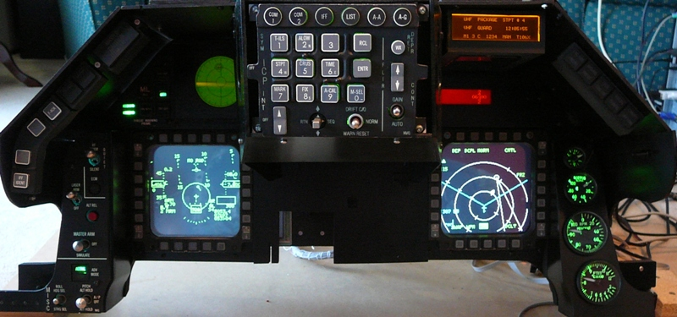

This instruction covers the assembly of the front sections of the pit. It includes the CP and Front panel as well as cables from the PFL and Gear Panel. It assumes the footwell panels are installed.

- Remove the seat and front right canopy support to improve access to the back section of the pit
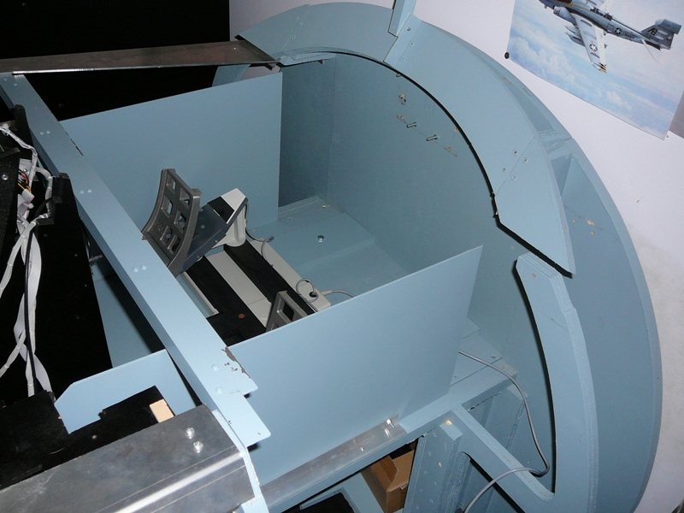
- Install the CP with 4 bolts through the pit floor. Lay the cables towards the rear of the pit so they don’t tangle with the upper part of the front panel.
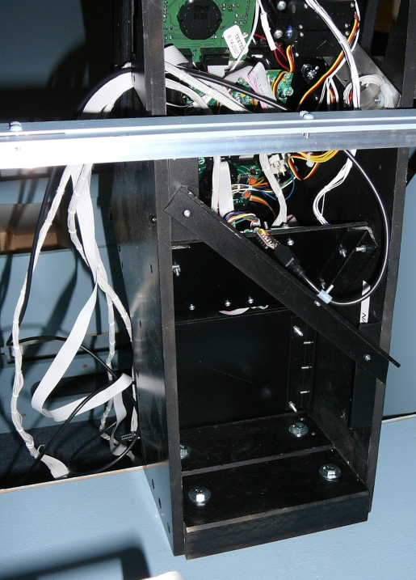
- Install the floor that supports electronics bay. Bring the power distribution input to the top of the floor. Thread through the cables from the bottom section up to the electronics floor. Cables include:
  - Instr (plug into Centre Distribution PCB)
  - Fuel Qty Select (plug into Centre Distribution PCB)
  - USB for OLED
  - Servo Cables
  - Flight Illusions
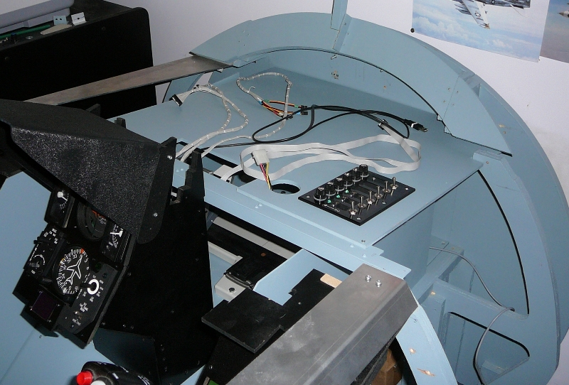
- Install the top part of the console. This is a tight fit, and may require of rocking from the left and right. There is a guide on the RH of the CP that the top section slots into. As the LH of the top section holds the switches it needs to be strongly supported. This may mean the RH of the panel sits a couple of mm above the RH support, this doesn’t present a problem as there are no switches on the RH side. Attach the back top support to the top panel. 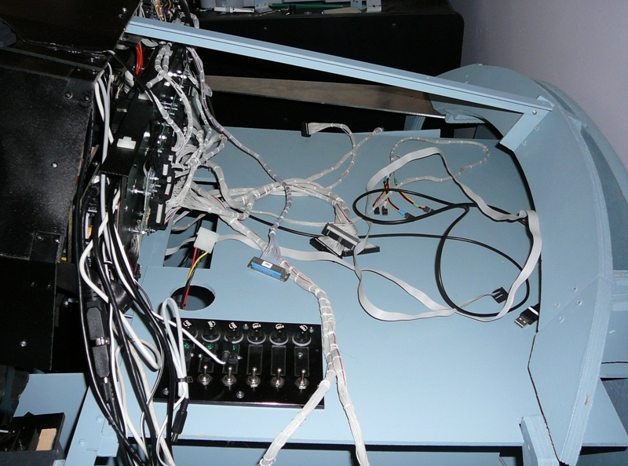
- Connect the Inst and Fuel Qty Select leads from the Centre bottom panel to the Centre Distribution Panel. Note that Left and Right MFD and HIS connections are not used. The MFDs are now driven by a MM2 through Jays Matrix adaptor PCB. The INST lead connects to the Left, and Fuel Qty to the right when looking from the back.
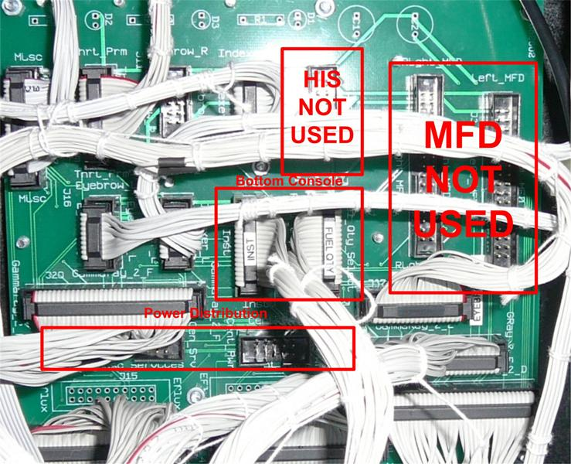
- Thread the cables from the PFD panel through the Electronics bay floor. Cables include:
  - PFD to UCC controller
  - Servo lead
  - Caution Panel to EFlux

Test Server as Built Documentation

Update 26/1/09
Operating Systems Windows XP SP2
1 * ATI PCI-Express Dual Head Card (Catalystr 8.12 8-12_xp32_dd_ccc_wdm_enu_72271.exe)
1 * NVidia PCI Video Card FX 5200 128MB RAM (Geforce 175.19 175.19_geforce_winxp_32bit_english_whql.exe)
Beta Innovations Device Manager 1.4.0.0
Beta Innovations F4IM 2.2.0.0
Beta Innovations Toolkit 1.4.0
PPJOY 0.83 (needed for Lightning’s S/W)
Parallax PSCI 0.9h Beta
Parallax Driver ?
UCC 1.8a
Flight Illusions G-Step Control 5.3
Logitech Game Panel Manager 2.02
MFD Extractor 2.0.3 (dependencies DX 9.0C, DotNet Framework 3.5)
G15 Viper 1.4.4.25
Touchbuddy 1.3.0.18-20070614-full

Falcon4 AF Patch 13, F4AF Hitiles
Open Falcon 4.5

Display Configuration

The screen resolutions are set for
Primary Screen 1024 * 768
MFDs 800 * 600
Note the colour depth is set to 16Bit, can’t remember whether it was MFD Extractor or Falcon 4 that failed to launch in windowed mode that forced me to change from32 bit colour depth to 16 bit.
The largest screen is positioned to the left, and assigned as the Primary screen as it makes co-ordinate position calculations easier.

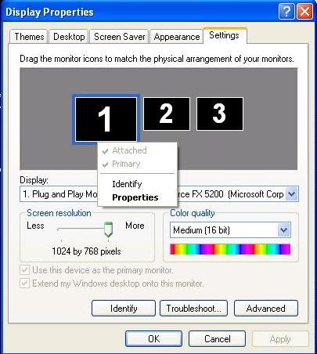

A print screen captures the whole view.
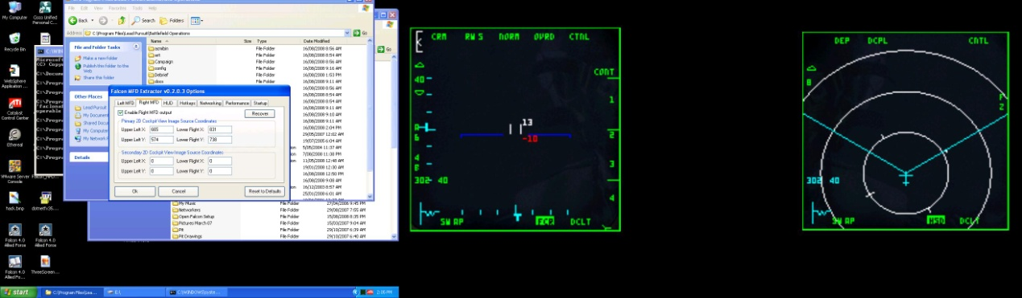

The co-ordinates for MFD Extractor are
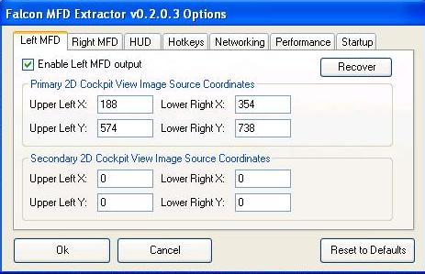

Right MFD

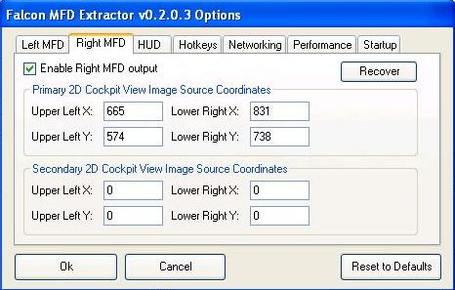

Com Port Allocation

Flight Illusion
UCC
Parallax

Beta Innovation Serial Numbers

Plasma-MM2 200 MFD (on back panel)
Plasma-MM2 201 ICP (in ICP assembly)

Electron-Flux DAC Outputs (Port A)

EF Port
1 | Nozzle Position
2 | FTIT
3 | Engine RPM
4 | Oil Pressure
5
6
7
8

Electron-Flux Latched Output Port Usage (Port D)

EF Port | Port Role
1
2 | TF-Fail (LH Eyebrow)
3
4 | Master Caution (LH Eyebrow)
5
6 | AA Defeat (TWP)
7
8 | Naval/Unknown (currently labeled Record) (TWP)
9
10 | Target Separate (TWP)
11
12 | Missile Launch (TWP)
13 | Engine Fire (RH Eyebrow)
14 | Priority (TWP)
15 | Engine (RH Eyebrow)
16 | Open (TWP)
17 | Hyd/Oil Pressure (RH Eyebrow)
18 | ECM Enable (Misc)
19 | TO/LDG Config (RH Eyebrow)
20
21 | Canopy (RH Eyebrow)
22 | Stand-by Adv Mode (Misc)
23 | AOA High (LH Indexer)
24
25 | AOA On (LH Indexer)
26 | Active Adv Mode (Misc)
27 | AOA Low (LH Indexer)
28 | FLCS (RH Eyebrow)
29 | Ready (RH Indexer)
30 | Oxy Low (RH Eyebrow)
31 | AR NWS (RH Indexer)
32 | Disc (RH Indexer) | Refuel/NWS/ -RefuelDSC
33
34
35
36
37
38
39
40
41
42
43
44
45
46
47
48
49
50
51
52
53
54
55
56
57
58
59
60
61
62
63
64

PC Build Instructions

Install Software from As-built CDROM (note the Parallax servo driver is .rar’d, so need to extract using something other than WinZip. Using jZipV1c.exe
- Start install with minimum hardware, just using PCI Video card, no USB expansion cards.
- Install Windows XP Pro – No Service Pack
- Install Visual Studio 6.0
  - Installs Java VM – reboots
  - Custom Install
  - Select all and then unselect FoxPro, Interdev, SourceSafe
  - Register Environment Variables for Visual C
  - Ok re debug files, another reload
  - Install MSDN – custom select all – clear FoxPro and Interdev
  - Install Install-shield (back to disk 1
  - Extract Visual Studio SP 6 flies to folder and run SetupSP6 Restart windows)
  - Save Point VSInstall
  - Install XP SP1 (required for XP SP3 to install)
  - Install XP SP3 (after restart discovers audio devices but doesn’t have drivers, now knows about FX 5200 video card)
  - Increase screen resolution to 1024*768
  - Directx 9C Redist – to c:\dx9c.
  - C:\DX9C\DXSETUP
  - Install DotNet Framework 3.5 SP1 (Needs XP SP2)
  - DotNetfx35 (using full redistributable). It displays that is downloading, but it is getting files locally. Then displays msg that you can disconnect from the internet, looks like it is hung, but CPUs are busy in background.
  - Save Point XP3
  - Installed Acrobat Reader 5.0
  - Install Beta Innovations Device Manager 1.4.0.0
  - Install Beta Innovations F4IM 2.2.0.0
  - Install Beta Innovations Toolkit 1.4.0
  - Install PPJOY 0.83 (PPJoySetup)
  - Install Parallax PSCI 0.9h Beta (387962_SetupPSCI.rar, extract, setupPSCI.exe)
  - Install Parallax Driver (CDM_Setup, installs FTDI CDM Drivers)
  - Copy UCC directory from install to Program_Files
  - Install Flight Illusions G-Step Control 5.3 (from Full Install G-Step Control V5.3)
  - Install Logitech Game Panel Manager 2.02 (lgps202.exe)
  - Install MFD Extractor 2.0.3 (dependencies DX 9.0C, DotNet Framework 3.5), from Falcon_MFD_Extractor_v0_2_0_3__x86
  - Install G15 Viper 1.4.4.25. Extract files from zip to Program_files\g15Viper
  - Install Touch Screen drivers install\touchDrivers\4.3.0.2412. Need to extract to temp directory. (should have screen plugged in, if not plugged in don’t attempt calibration)
  - Install Touchbuddy 1.3.0.18-20070614-full. Extract files to program_files\ Touchbuddy
  - Install cougar 2007 CDROM
  - SavePoint Utilities Installed
  - Install Falcon4 AF
  - Install Falcon4 AF Patch 13
  - Install Falcon4
  - Install AF Hitiles
  - SavePoint F4
  - Installed FS2004 and FSX. Added Aircraft, and Locations
  - Savepoint F4 FS2004
  - Now have 4 unknown devices in Device Manager
  - Installed Drivers from Gigabyte installation CDROM
  - After reboots No unknown devices in Device Manager.
  - Installed 2 * 4 Port USB Cards
  - No unknown devise in Device Manager
  - Installed ATI Video Card and Drivers – No unknown devices in Device Manager – although ATI Manager is complaining as there are no monitors attached to the ATI card.
  - Installed NVIDA drivers (to replace existing Native MS Drivers)

- Install all drivers from CDROM,
- copied UCC files to UCC folder off the root directory,
- Copied the G15 Viper files to a folder in Program Files
Connected USB Ports individually, waiting for ‘your new hardware is installed and ready for use message to appear.
Checks:
- Z10 display may need to be touched underneath to light up
- G15 Display starts without prompting
- Launched UCC, changed RWR to not be reversed, play test display
- Launched Beta Innovations Device Manager. Should see Gamma-Ray256, Plasma-MM2 (two of), Electron Flux, Gammatron

Beta Innovation Device Configuration
- Both Plasmsa-MM2s Digital Inputs are configured in Scan Matrix Mode
- Port D of the Electron Flux is Latched Output

Launch UCC and test RWR (don’t forget the contrast may need to be adjusted)

Launch F4 Interface Manager
- The Configuration File (bif4.f4c) should be stored in C:\FSSERVER\DataFiles)
- If the configuration file is not available,
  - go to Port D Latched Outputs, Set Ports to invert for initial testing to light all lamps.
  - Go to Port A DAC Outputs, Set Ports to F4 Shared Memory outputs, Add a section and press Test. Press the Cal button and set max position if needed.
  - As the gauges as not all linear you’ll need to add sections. (currently a a little weirdness with the FTIT not displaying below 750 degrees.

Launch G15 Viper, create shortcut on desktop.
Launch Logitech Game Panel Manager, both the Z10 and G15 devices should be displayed in the LH panel. G15 Viper should have registered itself.
Clear all programs that are allowed to run on the Z10 and the G15 aside from G15 Viper. G15 Viper LCD1 for the Z10, and G15 Viper LCD2 for the Z10. These settings need to be matched on G15 Viper Logitech Game Panel Manager.
One the displays have been correctly set, run G15 and set the Fuel Flow to LCD 2, the X offset to 104, the Y offset to 16. Interesting Falcon 4 Allied forced now recognises the displays. Needed to clear them from Logitech Game Panel Manager.

Falcon4 setup
As there are a number of devices with analog inputs, F4 will probably select one of the MM2’s for throttle and control input, a bad thing. Go to F4 controllers and setup the joystick.

Checking MFD Extractor and output Values
- Start Falcon4 in windowed mode
  - Cd \program files\lead pursuit\battlefield operations
  - Falconaf –window

Miscellaneous Tidbits

Falcon Keystroke decoder

Source
http://forums.frugalsworld.com/vbb/showthread.php?t=99484

Well...
it has been quite some time since somebody explained the inner working of the Falcon keyfiles to us. With the introduction of FalconAF and espacially the multi-controller-capability, the format has changed again (or at least it has been extended). So I thought it might be a good idea going through that file, its format and structure again. Perhaps somebody finds that information helpful.
1st Disclaimer:
I am not the 1st one who's posting about the keyfile format, so the credit for finding out hardly belongs to me. Nevertheless, I'd like to make a summary that is valid for the current FalconAF version (patch 1.05).
2nd Disclaimer:
The name "secret decoder update" was choosen because 'Gorny asked me a long time ago what is the "secret decoder ring" for those keyfiles. Well, I was unable to answer that question satisfactorily.
So here we go...
Part 1: Where to find the file
Ok, as you all know, the FalconAF keyfiles define the binding between the functionallity you can trigger within the sim and the different input devices like keyboard and joysticks that you have available. You find your keyfiles in the "config" subfolder of your FalconAF installation directory, so the default location would be:
"C:\Program Files\Lead Pursuit\Battlefield Operations\config\"
The keyfiles available to the sim all end with ".key", LP provided backup copies of those files (in case you screw them up), ending in ".orig" for your reference.
Let's have a look at the file - simply open it with a text editor. What you'll find are multiple lines, each line describing one particular binding. Let's pick out one line as an example...
SimToggleAutopilot 1076 0 0X1E 0 0 0 1 "Ckpit-Autopilot"
Basically, all lines look like this example line (well, more or less, details will follow). First part names an internal function name in the sim that is described by that line, then some code to which key/input device it is bound, and last not least (if we're lucky) some human-readable description of what that function really does. Let's get into the details...
Part 2: Keyboard bindings
The example line that we picked describes a keyboard binding. So let's have a deeper look (I use color coding to better distinguish between the different parts):
SimToggleAutopilot 1076 0 0X1E 0 0 0 1 "Ckpit-Autopilot"
The 1st part (SimToggleAutopilot) describes the sim function that is defined here. This is something what is defined by FalconAF and can not arbitrarily choosen by you. The most complete list of possible functions can be found in the cockpitbuilders.key file.
The 2nd part (1076) defines an ID within the 2D cockpit that you see within the sim. Those IDs are basically used within the cockpit definitions (somewhere in the art/ckptart folders) and are NOT related to the keyboard binding that is done here. So why does it show up? It simply means that the same sim function described by the current line can be toggled when you click on the cockpit graphic (button or switch) that has that particular ID. Long speech, short sense: You should NOT adjust that number. Always leave it as it is, otherwise you may loose cockpit mouse functionality.
If that number is "-1", it simply means that there is no 2D cockpit button/switch assigned to that function.
Edit: because if some confusion regarding the cockpit mappings, I added the explanation that I gave in another post:
the "-1" in the keystroke file does not mean that there is no clickable area in the cockpit available, it just means that the keystroke and the (possibly available) clickable area/button/whatever in the cockpit have not been mapped.
So if you *have* a button that can change position, it has a control number assigned in the cockpit file that basically defines what has to happen with the cockpit graphics if you click on something. What the actual control number really does with the sim is hardcoded somewhere into Falcon.
Now if that very control number shows up (instead the "-1") in the keystroke file next to a function entry, it simply means that if you press the key assigned to the function, the graphic change defined by the cockpit file will happen as well in the cockpit. However, there is no *need* that every clickable area in the cockpit has to be mapped to corresponding keystrokes.
For buttons or lights that *change* status permanently, it makes of course sense that the keystroke changes the button position in the cockpit as well. But for things that are only "triggered" instantaniously and do not show a permanent change in the cockpit graphics, the mapping is not really needed (although it would be nice to have *if* there is a cockpit function available )
And now for idle detent:
In terms of the description above, the idle detent keystroke does *not* trigger the "finger"-graphic in the cockpit. However, it *does* trigger the idle detent function in Falcon.
So for the idle detent to be effective, you need to have your RPM at 20% already and increased throttle...
Of course you can click on the detent in the cockpit with the mouse and because of the cockpit file definition, you will see the finger move, but that does not guarantee that Falcon decides to actually execute the idle detent function.
The 3rd part (0) seems not to be used anymore and is always "0" for keyboard bindings. Again, just leave it alone... (In the "old" Falcon days, here could have been used a "1" as well, which meant that ONLY the mouse cockpit input (2nd part) could be used to trigger the function and the keyboard binding was not used. Never saw this in FalconAF).
With the 4th part (0X1E 0), the interesting things start to happen. Basically you see 2 numbers: "0X1E", which describes the keyboard button that is assigned, and "0", which describes the modifier that needs to be applied (Alt, Shift, Ctrl or combinations).
Let's start with the modifier. This entry can have 8 different values:
"0" = (no modifier)
"1" = Shift
"2" = Ctrl
"3" = Shift+Ctrl
"4" = Alt
"5" = Shift+Alt
"6" = Ctrl+Alt
"7" = Shift+Ctrl+Alt
So this is the key combination that you need to press together with the button defined before to trigger the function.
Ok, so here's the big list of possible keys - for a US keybard layout (for those of you who *really* want to know it: those are costmized XT keycodes, not AT!):
Edit: The "modifier keys" mentioned above (Shift, Ctrl, Alt) are NOT reckognized as individual keys in FalconAF. That's why they do not show up in that following list. And that's why you cannot distinguish between left Shift/Ctrl/Alt and right Shift/Ctrl/Alt.
"0X1E" = "A"
"0X30" = "B"
"0X2E" = "C"
"0X20" = "D"
"0X12" = "E"
"0X21" = "F"
"0X22" = "G"
"0X23" = "H"
"0X17" = "I"
"0X24" = "J"
"0X25" = "K"
"0X26" = "L"
"0X32" = "M"
"0X31" = "N"
"0X18" = "O"
"0X19" = "P"
"0X10" = "Q"
"0X13" = "R"
"0X1F" = "S"
"0X14" = "T"
"0X16" = "U"
"0X2F" = "V"
"0X11" = "W"
"0X2D" = "X"
"0X15" = "Y"
"0X2C" = "Z"
"0X1" = "Escape"
"0X3B" = "F1"
"0X3C" = "F2"
"0X3D" = "F3"
"0X3E" = "F4"
"0X3F" = "F5"
"0X40" = "F6"
"0X41" = "F7"
"0X42" = "F8"
"0X43" = "F9"
"0X44" = "F10"
"0X57" = "F11"
"0X58" = "F12"
"0XB7" = "PrintScreen"
"0X46" = "ScrollLock"
"0X29" = " ~ "
"0X2" = "1"
"0X3" = "2"
"0X4" = "3"
"0X5" = "4"
"0X6" = "5"
"0X7" = "6"
"0X8" = "7"
"0X9" = "8"
"0XA" = "9"
"0XB" = "0"
"0XC" = " - "
"0XD" = " = "
"0XE" = "Backspace"
"0XF" = "Tabulator"
"0X1A" = " [ "
"0X1B" = " ] "
"0X2B" = " \ "
"0X3A" = "CapsLock"
"0X27" = " ; "
"0X28" = " ' "
"0X1C" = "Enter"
"0X33" = " , "
"0X34" = " . "
"0X35" = " / "
"0XDB" = "Win(left)"
"0X39" = "Space"
"0XDC" = "Win(right)"
"0XDD" = "Menu"
"0XD2" = "Insert"
"0XD3" = "Delete"
"0XC7" = "Home"
"0XCF" = "End"
"0XC9" = "PageUp"
"0XD1" = "PageDown"
"0XC8" = "CursorUp"
"0XD0" = "CursorDown"
"0XCB" = "CursorLeft"
"0XCD" = "CursorRight"
"0X45" = "NumLock"
"0XB5" = "Num/"
"0X37" = "Num*"
"0X4A" = "Num-"
"0X4E" = "Num+"
"0X52" = "Num0"
"0X4F" = "Num1"
"0X50" = "Num2"
"0X51" = "Num3"
"0X4B" = "Num4"
"0X4C" = "Num5"
"0X4D" = "Num6"
"0X47" = "Num7"
"0X48" = "Num8"
"0X49" = "Num9"
"0X53" = "NumDel"
"0X9C" = "NumEnter"
"0XFFFFFFFF" = "(Not assigned)"
As you can see, a non-assignment (0XFFFFFFFF) is possible.
Sorry for that looong list, I just wanted to be sure...
Ok, the 5th part (0 0) basically works exactly the same as the 4th part. 1st number is a key, 2nd number is a modifier. So what's the deal here?
Well, this is a key combination that you have to press before the key combination of defined in the 4th part. Huh? Let's pick an example, because the one we have used uses "0 0", which basically means there is no need for a 2nd keycombo... Alright, here's a better example (only highlighting the important things now):
SaveCockpitDefaults -1 0 0X1F 0 0X2E 4 -1 "Sim-cockpit setup save"
The first keycombo is "0X1F 0", which we can translate now to "no modifier" and "key S". Or simply "S". The second keycombo is "0X2E 4" which we can translate to "Alt" and "key C".
So this means that for triggering the function, you have to press
first ALT+C then S
OK? Good.
However, there is a restriction for this double-keycombo. You can not choose everything you want for that 5th part (ALT+C in our example). The available keycombos need to be defined as normal functions in the keyfile in order to use them. Here are the lines that are defined by default:
CommandsSetKeyCombo -1 0 0X2C 2 0 0 -1 "Key-Combination Ctrl-Z"
CommandsSetKeyCombo -1 0 0X2D 2 0 0 -1 "Key-Combination Ctrl-X"
CommandsSetKeyCombo -1 0 0X2E 4 0 0 -1 "Key-Combination Alt-C"
So that means that you can use those three combos (0X2C 2, 0X2D 2, 0X2E 4) as 5th part in your other function lines. I never tried defining different combos, but I guess it should be no problem
The 6th part (1) defines wheter you can see and assign the function within the setup screen of FalconAF. The possible values are:
"1" = You can see and change the assignment
"-1" = You can see it, but not change it
"-2" = You can neither see nor change it
Have a look at the cockpitbuilders.key file, you'll see there are quite a bunch of "hidden" functions...
And last not least, the 7th part ("Ckpit-Autopilot") simply holds the description that you see in the FalconAF setup screen for that function.
That's it for the keyboard...
Part 3: DirectX bindings
Right, you do not need to use keyboard bindings only, you can also use DirectX button assignments to toggle a function. As you might have guessed already, the binding lines for DirectX look different then the ones that we have described so far. So let's pick two examples. Why two? Well, because there is a (minor) difference whether you have only one DirectX device connected to yout PC or multiple DirectX devices.
First example line, only one DirectX device:
SimTrigger 0 -1 -2 0 0x0 0
Second example line, multiple DirectX devices:
SimTrigger 0 -1 -2 0 0x0 0 {46D7A990-DCF4-11D9-8001-444553540000}
As you can see, the only difference is a looooong identifier string in the end. Let's start with that identifier, because the rest of the line is the same for both examples. The long identifier simply identifies the DirectX device that is used to generate the input. Oh, you guessed already? Well, that's all there is to it...
Now the question "How the hell do I know wich device is decribed with that identifier?" Honestly, I don't know where to find a definition. I've searched the registry as well as I made a dxdiag, msinfo... No luck. However, I only have TWO devices connected, so I just tried. The identifier above {46D7A990-DCF4-11D9-8001-444553540000} seems to be my Cougar. Just try, assign a function in the FalconAF setup screen with different controllers and take note for your individual controllers yourself.
Edit: No need to search the registry or something else to get the controller ID. Just assign a DX button within the FalconAF setup screen, and FalconAF writes the ID to the keyfile. Open the file, look for the new entry, there you go!
Before we explain the DirectX lines in detail, I want you make aware of the following:
If you assign a DirectX button to a sim function that has already a keyboard input assigned, you will NOT overwrite thw keyboard input! Instead, both the keyboard input AND the DirectX input are functional now. And yes, that means that you may have two lines in your keyfile beginning with the same sim function name. That is completely OK!
Now back to the details. I'll take the line without the identifier in the end for simplification:
SimTrigger 0 -1 -2 0 0x0 0
The 1st part ("SimTrigger") is the sim function that should be triggered. Nothing new here.
Let me just jump to the 3rd part ("-1"), because we know this already as well. Like the 2nd part of the keyboard bindings, this 3rd part describes the 2D cockpit ID that can trigger the same function as well when clicked with the mouse. In our example, the "-1" simply means that there is no cokpit ID assigned.
The 2nd part ("0") is the DirectX button of the device that is assigned to that function. Be aware that FalconAF starts to count the buttons up from "0", whereas most joystick start to count from "1". So if your stick has four buttons 1 2 3 4, FalconAF will identify them as 0 1 2 3.
Edit: If you use more then one controller, every controller starts with the DX buttons from 0 again. FalconAF distinguished between different controllers just by the identifier/GUID at the end of the line mentioned above.
However, this 2nd part ("0") is only relevant if the 4th part ("-2") is "-2", which means that the normal DirectX buttons of the device shoud be used. If the 4th part is not "-2", the 2nd part seems to be always "0". If the 4th part is "-2", the 5th part ("0") is always "0".
The only only other value I have noticed for that 4th part is "-3". This means that your input device should NOT use the normal DirectX buttons, but directions of the POV/FieldOfView Hat switch. If that is the case, the 2nd part is not used and always "0", however, now the 5th part ("0") is used to determine the hat direction:
"0" = Hat UP
"2" = Hat RIGHT
"4" = Hat DOWN
"6" = Hat LEFT
I assume that a value of "1" would lead to "Hat UP-RIGHT", a value of "3" would lead to "Hat RIGHT-DOWN" etc., but I haven't verified that yet.
The 6th part ("0x0 0") seems to be always "0x0 0", I've never seen anything else.
And last not least, if you have a 7th part, it is the identifier of your joystick.
Confused? Well, it's not so hard if you see a complete example. Here's what my oooold Wingman is capable of (please ignore the actual sim functions that I have used, they make no sense at all, I just wanted to assign *something*):
"Wingman Trigger (Button 1)"
SimLeftHptOff 0 -1 -2 0 0x0 0 {CB7F0BB0-8F1F-11DA-8001-444553540000}
"Wingman Button2"
SimLeftHptOn 1 -1 -2 0 0x0 0 {CB7F0BB0-8F1F-11DA-8001-444553540000}
"Wingman Button3"
SimMAPOff 2 -1 -2 0 0x0 0 {CB7F0BB0-8F1F-11DA-8001-444553540000}
"Wingman Button4"
SimMAPOn 3 -1 -2 0 0x0 0 {CB7F0BB0-8F1F-11DA-8001-444553540000}
"Wingman Button5"
SimDLOff 4 -1 -2 0 0x0 0 {CB7F0BB0-8F1F-11DA-8001-444553540000}
"Wingman Button6"
SimDLOn 5 -1 -2 0 0x0 0 {CB7F0BB0-8F1F-11DA-8001-444553540000}
"Wingman Button7"
SimGPSOff 6 -1 -2 0 0x0 0 {CB7F0BB0-8F1F-11DA-8001-444553540000}
"Wingman HatUP"
SimUFCOff 0 -1 -3 0 0x0 0 {CB7F0BB0-8F1F-11DA-8001-444553540000}
"Wingman HatRIGHT"
SimMFDOn 0 -1 -3 2 0x0 0 {CB7F0BB0-8F1F-11DA-8001-444553540000}
"Wingman HatDOWN"
SimUFCOn 0 -1 -3 4 0x0 0 {CB7F0BB0-8F1F-11DA-8001-444553540000}
"Wingman HatLEFT"
SimMFDOff 0 -1 -3 6 0x0 0 {CB7F0BB0-8F1F-11DA-8001-444553540000}
Part 4: The best thing about multi-controller support
With the addition of the device identifier to the DirectX bindings, FalconAF is now capable of using 32 DirectX buttons for every DirectX device! So if you have 3 devices connected, you could assign up to 3x32 = 96 DirectX functions! This means a complete DirectX cockpit implementation is possible no

Working with PICs

There are a couple of things not yet available ‘off the shelf’. After having a read of Mike Powell’s Building Simulated Aircraft Instrumentation it looked like building some custom instruments is a very doable thing. It was time to dig out some very old programming books and take a look at PICs.

First thing you’ll notice is the PIC architecture a different to the traditional microprocessor in the data and program space is not shared. Also it is RISC based, meaning you have only a small number of programming steps to learn (around 35).

I purchased a development board and programmer from Futurlec. Didn’t have a very happy experience with the parallel port programmer, so went and purchased a PIC programmer from Jaycar Electronics. Had another unhappy moment when the Jaycar PIC programmer refused to play nice. It is serial connected and would not recogise the programmer when using a USB-Serial adaptor. Fortunately I also had a docking station for the laptop which worked first time with the programmer.

The VELLEMAN Pic Programmer/Checker programmer costs around $120. It includes a PIC16F627A PIC with some demo code to verify the PIC is all well.

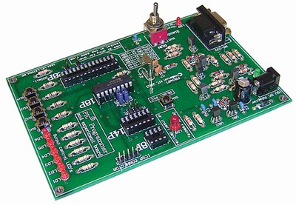

The controller board (PIC16F628CONT) from Futurlec (www.futurlec.com) is good value around $20.
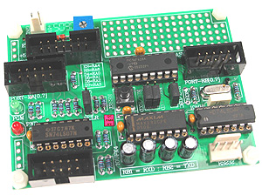

Paint for Panels

String, go by the local model shop (not the hobby lobby, but a real dedicated model shop). Ask for Tamiya model paints and get XF-1 (flat black) and XF-54 (Dark Sea Grey) paints. These are a perfect match to the paint Mike uses. I use them for touch up work when I'm building ICPs as they always get knicked. They are acrylic based paints and clean up with water. Very user friendly.

Modifying a Logitech Z10 into a F16 DED.
From http://www.eaglevision.nu/z10_ded.php

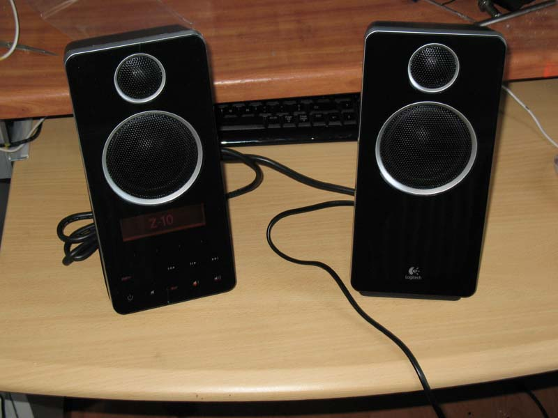 | 1. This is the z10 speakerset in its unmodified state. Please notice that turning it into a DED will make it absolutely worthless as a sound output device and that I accept no responsibility in any form for any damage caused by the modification.
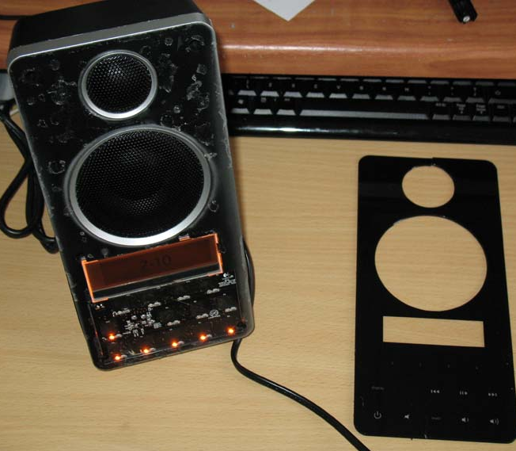 | 2. The most difficult part, removing the front-plate. The front-plate is mounted with double-sided tape. To remove the front, carefully place a fingernail between the front ant the frame. Now try to make a small opening by pulling on the front. When you have a small opening you can try to place more of your finger between the front and the housing. Keep pulling slowly and you will notice the front coming of. Be careful not to break the plastic, since you will need the buttons for the DED.
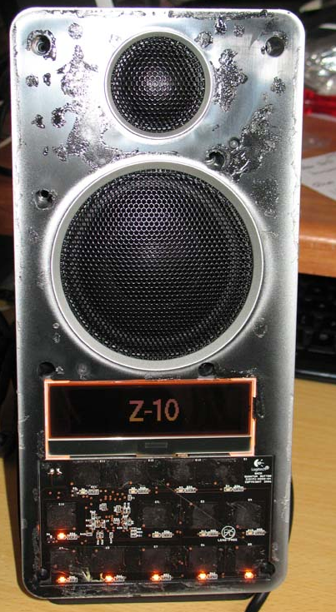 | 3. Now remove the screws and remove the front bezel. You can cut the wires to the speakers. Please pay attention to the cable going from the LCD screen to the pcb. You can remove the cable by carefully pushing the brown locking plate on the pcb connector 1mm upwards. The LCD cable will then come free from its socket. Now you have to remove the LCD display and the keyboard by first removing the hotmelt.
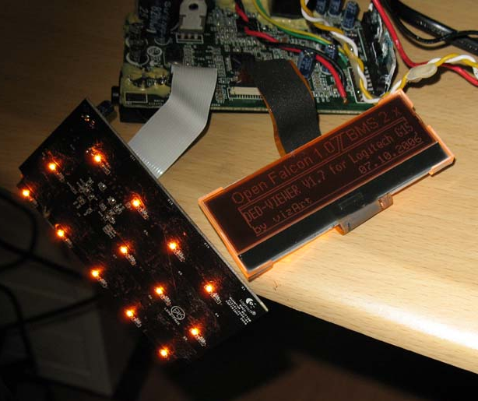 | 4. After removing the z10's guts this is what you need for the DED. The pcb, the LCD display and the touch-keyboard. Please make sure you do all the work with the mains disconnected. On my pictures I have the power connected for testing purposes.
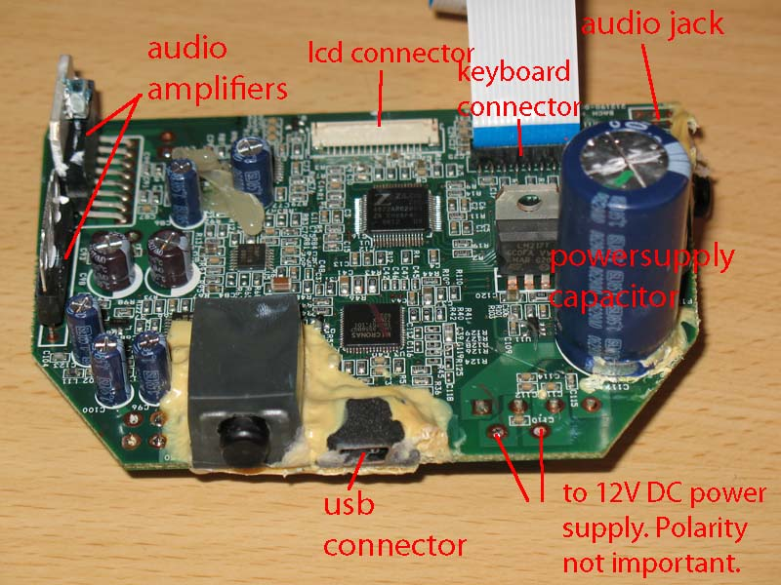 | 5. This is the main pcb. You can remove the amplifiers, the power-supply capacitor and the audio jack. Since you can best supply the DED with a separate 12V DC power-supply the capacitor can be safely removed. It is too high to fit the DED in its new housing.
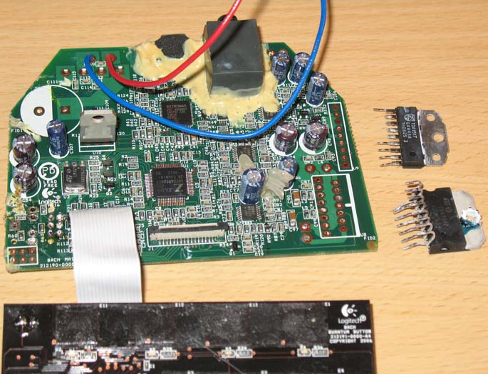 | 6. Here you see the pcb with the parts removed. The red and bleu wire go to the 12V DC power-supply connector, mounted in the DED box.
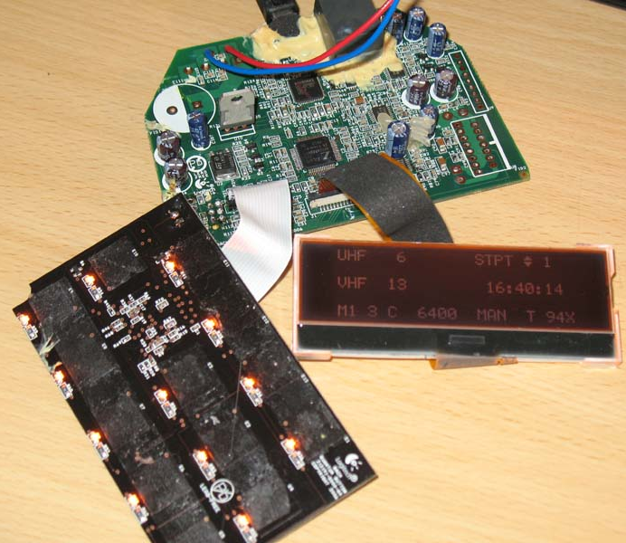 | 7.
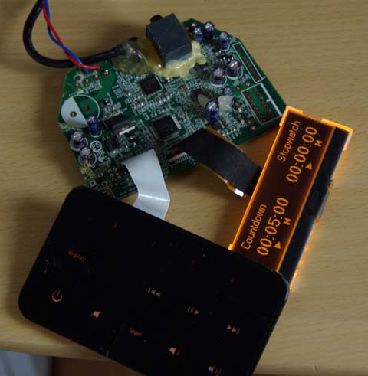 | 8. Here all parts are connected for a final test. I have soldered a piece of USB wire (4 leads + shield) behind the USB connector on the pcb. The other side is connected to a USB-B pcb connector which is also mounted in the DED box. The cable is covered with hotmelt. Before you can solder the USB cable, you first have to remove the original sealing by pealing it of the pcb.  The touch-key keyboard is covered with the original keypad, which has been cut out of the frontpanel.
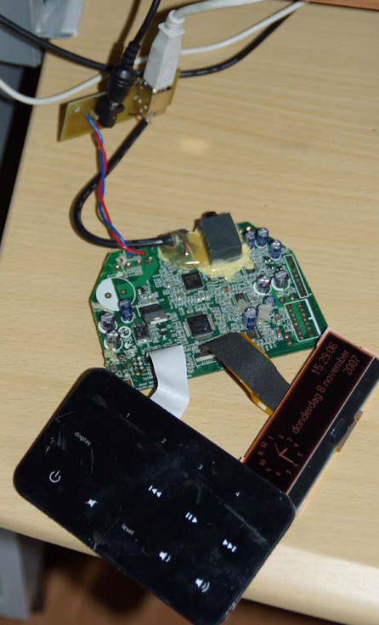 | 9. This is the complete assembly that goes into the DED box. You can see the little pcb with DC- and USB connector.
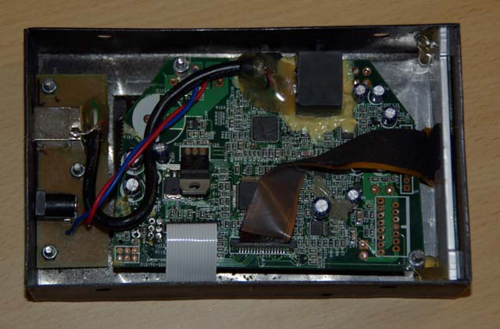 | 10. Here you can see everything mounted in the DED box. They keypad is mounted on the underside as the cover of an opening in the bottom of the box.  If everything still works this should be the result.  The layout of the DED box can be downloaded from this website in .dwg format.
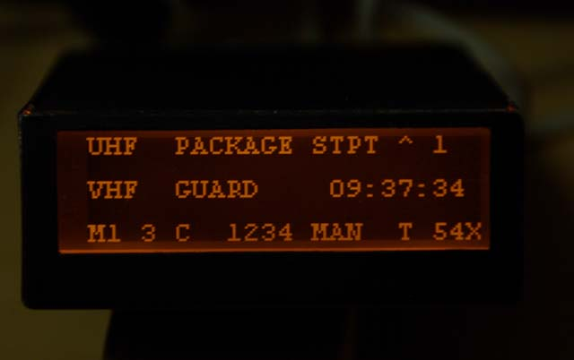 | 11. And here is your working DED.

At the moment i am building the casing from 1mm aluminum
You can use the speakers, if you have an amplifier, because the audio IC's are on the PCB that drives the display. You even need to remove those IC's otherwise the PCB is too high. I also removed the condenser on the PCB, and now use a 12VDC power supply. Taking the speakers apart, and prepare the PCB for use as a DED was quite a job. You need to take great care removing the display and not damaging the flat-cable from the display and the flat-cable from the buttons.

Other Mods
Jason (aka Kill’n)

DED and PFLs

Copy all of the files to a directory otherwise the fonts will not fit properly on the LCD screen.
*** How to install ***
- download the latest GamePanel software from Logitech (you can get the 2.0+ version here: http://www.logitech.com/index.cfm/434/3498&cl=gb,en?osid=1&file=) and install it. Reboot your PC if needed.
- Start the Logitech GamePanel Manager (Start -> Programs -> Logitech GamePanel Manager).
- Once there, click on the Programs icon. This is more or less what you'll see:
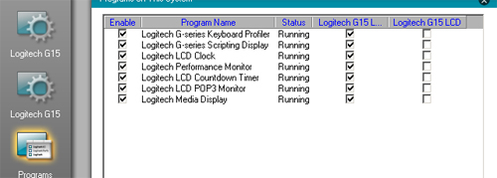
- Next, start the G15viper.exe application by double clicking it. It should appear and it should also appear in the GamePanel Manager, like so:
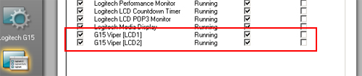
- Now, correct the checkboxes so they look like this (VERY important !):
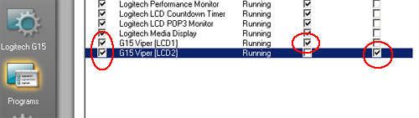
- Finally, disable all the other programs in the list by unchecking the boxes:
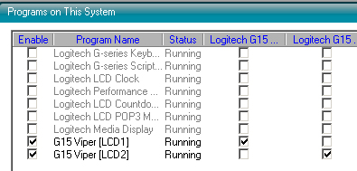
Now start up Open Falcon or Falcon AF and get tinkering ! Click the DED and PFL previews in G15 Viper to identify your LCD displays, or click on 'About' to show a cool logo graphic on both screens. Play around with everything and get your feedback to me !

Opening the z10
Use an exacto knife to pry up a corner of the black face plate. It's glued down with some crazy sticky glue. Once you get it started, use a small screw driver to finish the job. The hardest part is getting the lcd out. You'll have to pick away at some at some adhesive in order to get the ribbon cable to move. Just be careful and have patience, it will eventually come loose. It's also a pain in the ass to get the circuit board out. Again, you'll have to pick at some adhesive. I also used pliers to break the plastic of the speaker housing to get to where I could get at the board.

Watch-out that the lcd cable lock doesn’t disappear.

Double sided tap holding keyboard and display down. Remove keyboard first. The hot melt glue seeps all the way through. Remove heat sink gunk.,

Ribbstick Installation

This is pretty much straight copy of Dave’s Document.

IMPORTANT: GROUND THE STICK MOUNTING PLATE PRIOR TO OPERATION! FAILURE TO DO SO MAY RESULT IN STATIC DISCHARGE THAT CAN DAMAGE THE COUGAR ELECTRONICS!

WARNING: THE SENSOR TUBE PORTS ON THE PLASTIC TRANSDUCERS ARE VERY FRAGILE! AVOID EXERTING ANY UNDUE SIDE FORCES, EITHER DIRECTLY OR THROUGH THE SENSOR TUBES, AT THESE POINTS. THIS SHOULDN’T BE A PROBLEM UNDER NORMAL OPERATION, BUT CARE MUST BE TAKEN IF THE STICK IS PARTIALLY DISASSEMBLED FOR INSTALLATION.

Installation Considerations

The design of the Ribbstick places the stick in the precise location of the real side-stick when the mounting plate is mounted on the inboard side of the interior right console wall (visible on the wall between the ACESII and right console). If you choose this installation, you will need to cut openings for the upper sensor housing and lower stick mount to pass through the interior console wall. You will also need to temporarily remove the stick shaft and possibly the upper sensor housing assembly as well. With any disassembly and reassembly, it is critical that the stick shaft be once again centered between all four tubes in the upper sensor assembly - more on this procedure later.

It is important to note that if your interior console wall is over ½” thick, you will need to remove additional material from the outboard side of the wall to provide clearance for the sensor tubes with the installation method described. If this is the case, you may seriously wish to consider the right- hand mounting plate option described below.

If you can live with a stick centerline that is 7/8” outboard of the real stick’s location (assuming you used a ½” thick console wall), you may wish to consider mounting the plate on the outboard side of the right console sidewall. This will result in a somewhat easier installation, as the need for cutting additional openings in the sidewall and partial disassembly of the stick can all be avoided.

Another option is to request at time of order that your stick be assembled with a right-hand mounting plate configuration. With a right-hand plate design you will mount the stick on a secondary sub-wall, or septum wall, located under the right console. With this design, the stick centerline can still be located at the precise location of the real side-stick without the need for stick disassembly or the need to modify the inside console wall.

If you already have a faux side-stick transducer housing and nose piece (the piece that attaches the transducer housing to the aux panel), preinstall these first, as an aid in locating the stick mounting plate.
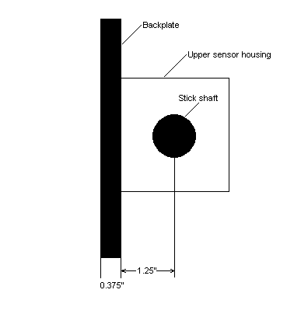  Figure 1, Plan View of Ribbstick (not to scale) | The plate must be located at the proper height and fore/aft position, plus have the proper tilt, or inclination backwards, to properly position the stick shaft through the center of a faux transducer housing. Having the transducer housing prior to installation takes all the guesswork out of locating the plate!  If you are using a real right auxiliary panel and dimensionally correct faux transducer housing, you may also need to remove a small amount of material from the back of the aux panel pocket opening to provide enough operating clearance for the stick shaft.  With any of the installations described above, remember that the stick forces are transferred to the structure through the mounting plate and therefore the structure must be robust enough to accept these without deflecting.  A template is provided to assist you in preparing the mounting wall to accept the stick mounting plate. You will use the same template for all types of installation.

Design Concept

The stick shaft of the Ribbstick is rigidly mounted to the mounting plate assembly via a plate. When stick input forces are applied, the plate deforms, resulting in a stick displacement. The thickness of the plate determines the force vs. displacement characteristics of the Ribbstick. The Ribbstick currently ships with a 1/8” thick aluminum deflection plate. This plate results in a full-unmodified stick input (as seen by the PC) at approximately 20 lbs of force, and a resultant displacement of .235”. The exception to this is ‘nose down’, which is modified to require additional force, mimicking the F-16’s design. Through the use of the Cougar Control Panel applet (described later), the user can reduce the maximum required forces.

It is worth noting that force and displacement values referred to in this document are referring to forces and displacements applied or measured at the stick grip’s reference point – a point located where the middle of the user’s palm contacts the grip in normal use.

With stick displacement, the sensor tubes are compressed. The increase in internal tube pressure is sensed by the pressure transducer, which varies the input signal to the PC accordingly. The stick is designed with slight pre-loading on all tubes. This insures that any movement of the stick will result in a change of the input signal. It also means that the design’s very slight mechanical hysteresis (inability to repeatedly return to the exact same center resting point) is seen as an input change by software. If you see this hysteresis in your application, simply add enough software center ‘dead zone’ to negate it.

Installation

Prior to disassembling your Cougar for conversion over to the Ribbstick installation, confirm that your Cougar is functioning properly.

Depending on the installation method you choose, you may need to partially disassemble the stick. If you do so, make certain that the stick shaft is re-centered between the sensor tubes – more on this below. Avoid removing or loosening the four screws holding the 1/8” thick aluminum plate to the mounting plate gussets (this is the most difficult point to realign). At worst, you should only need to remove the stick shaft and upper sensor housing.

Once you have secured the mounting plate in the cockpit and reassembled the stick components (if necessary), find a suitable location within reach of the Ribbstick’s cables to mount the Cougar’s printed circuit board (PCB). You may wish to leave the PCB in the Cougar base. While it may be more difficult to secure the Cougar base than the bare PCB, the advantage is that strain relief is provided for the USB cable, rudder, and throttle connectors.

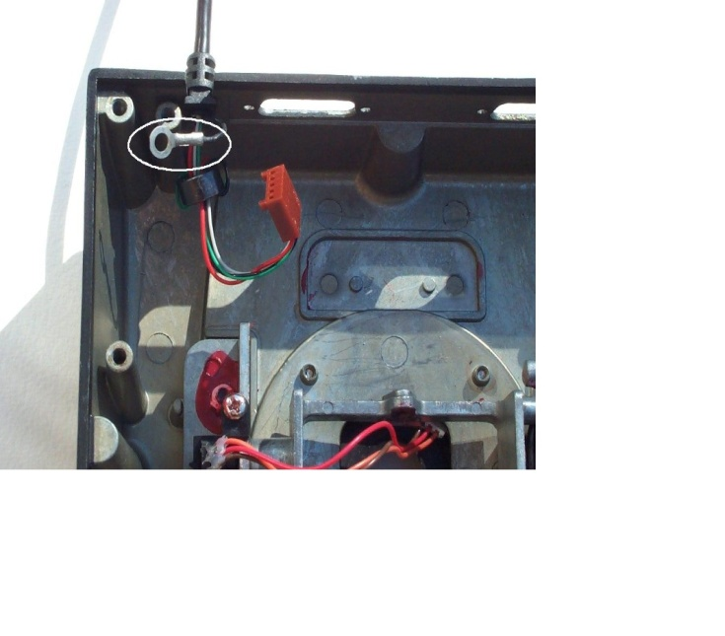  Figure 2, USB Cable Grounding Strap In Cougar Base (PCB removed) | Next, ground the mounting plate. This is an important step to reduce the chances of static discharge damaging the Cougar’s electronics. To do this, run a grounding wire from the stick mounting plate to the Cougar PCB or directly to the PC case. Most Cougars have a separate ground wire coming from the USB cable that terminates under one of the four screws holding the PCB in the Cougar base. Look under the screw closest to where the cable penetrates the casing to determine if you have a cable ground (see Figure 2). If your Cougar has this feature, run a ground wire from the stick mounting plate to the USB cable ground termination point. If you have an early version of the Cougar that lacks the USB cable ground wire, you must run the stick mounting plate ground wire back to the PC! Or even better, run the grounding wire to both the PC and one of the PCB mounting screws. Termination at the PC can be made using an alligator clip or similar fastener.

You are now ready to make the cable connections to the PCB with the two 3-pin and the 5-pin female connectors coming from the Ribbstick. These connectors are polarized so you will only be able to seat them with the proper orientation. Also, you will note that one of the 3-pin connectors is tied to the 5-pin connector so there will be no confusing which of the 3-pin male headers to connect it to. Next, install your Cougar grip on the Ribbstick and make the final connections to the throttle and rudder.

Finally, plug the Cougar USB cord into the PC and confirm that the Cougar is again recognized by the Cougar Control Panel applet. Calibrate the stick as normal using the Cougar Control Panel.

Force Adjustment

Using the Cougar Control Panel (CCP) applet, you are able to reduce the input forces required to produce maximum output (as seen by the software).
Open the CCP and click on the ‘Axis Shaping’ tab. Under ‘Axis Settings – Dead Zones’ you will note that you can adjust the upper and lower dead zones from a value of 0% to 100%. This is the setting you will change to adjust the maximum input force required. With a 0% dead zone setting, the full design force of 20 lbs (with 1/8” aluminum deflection plate) is required to generate a maximum output signal. At a 100% dead zone setting, the full design force is reduced by approximately 35%, to a value of 13 lbs. Worth noting, force and displacement are fixed in their relationship (In fact, this is close to a linear relationship and can be plotted as such). Therefore, lowering the force required to generate a maximum output signal also reduces the maximum displacement. You are in affect increasing the sensitivity of the stick.

As mentioned under DESIGN CONCEPT above, the Ribbstick is designed with a slight preloading of the sensor tubes to insure a change in output with any stick movement. You may wish to introduce a small amount of center dead zone if you are witnessing a slight hysteresis, or non-repeatability, at the center point.

Additionally, use the curve settings to customize the response of the stick for personal preference.

Technical Issues

Shortly after initial use, and periodically thereafter, you will notice slight slop in the base of the Cougar grip. The higher forces of the Ribbstick work to loosen the threaded bottom adapter within the Cougar grip over time. When necessary, carefully open the Cougar grip and tighten the one remaining screw holding the adapter in the grip.

If you notice unbalanced operation in the roll axis, that is, the stick requires dissimilar forces in opposing directions to generate the same output signal; look for the following two issues.

- Distorting force on sensor tubes; check to make sure that there is nothing coming in contact with the tubes that would distort them, generating a false input.
- Misalignment of stick; this is most likely a result of partial disassembly during installation. Visually inspect the contact that the stick shaft makes with the sensor tubes. Do this by looking into the square sensor housing from above or below. The stick shaft should be making very slight but equal contact with all four sensor tubes. If this is not the case, follow the realignment procedure described below.

You may also notice that a slight left roll is induced during a hard ‘nose-up’ maneuver. Pulling your arm slightly towards your body, in addition to the intended backwards pull causes this. The installation of an elbow rest changes your arm mechanics and stops this unintended input.

Realignment Of Stick

If your stick requires realignment, adjustment can be made in three places. (1) Four screws holding upper sensor housing to mounting plate adjusts the pitch axis only. (2) Four screws holding deflection plate to gussets adjust both pitch and roll axes. (3) Single bolt holding stick shaft to deflection plate adjusts to adjust both pitch and roll axes.

Realignment can be tedious, especially with the Ribbstick installed, and patience is required! If adjustment is needed in the pitch axis only, try making it with the upper sensor housing first. For small roll axis corrections, or a combination of roll axis and pitch axis corrections, try the single stick shaft bolt next.

The deflection plate is the most difficult point of adjustment and should be avoided. Anyway, you shouldn’t need to make changes here, as you wouldn’t normally be required to disassemble the deflection plate during stick installation.

RWR

The RWR is driven by the UCC driver.

The UCC is driven by a 5V regulated supply. A challenge for my pit is the 5V connector on the UCC is the same connector that I standardized on for the rest of the pit. For that reason the adaptor lead will be hot-glued in place.

A second thing I’d forgotten about was the Contrast potentiometer. Without this potentiometer the RWR just glows bright green with nothing displayed. The potentiometer needs to be set to approximately 200 degrees.

Another piece of good luck is the backlight of UCC displays are controller by a switch off the back of the UCC. Given there is a spare pole on the Backlight Relay in the primary power module, its be use to control backlighting on the LCDs.

Aircore Gauges

Assembling the Tubes

Acknowledgement - this is pretty much a cut and paste from
http://www.viperpits.org/smf/index.php?topic=2698.15

When the tubes arrive from Jarrod they are partially assembled. They fit together exceptionally well, Initially I thought the end caps where a single unit, needless to say thet aren’t. Remove both end caps to start.

I know the tubes are pretty self explanatory, but I thought I would just put a little guide on here as to the order of some of the pieces.
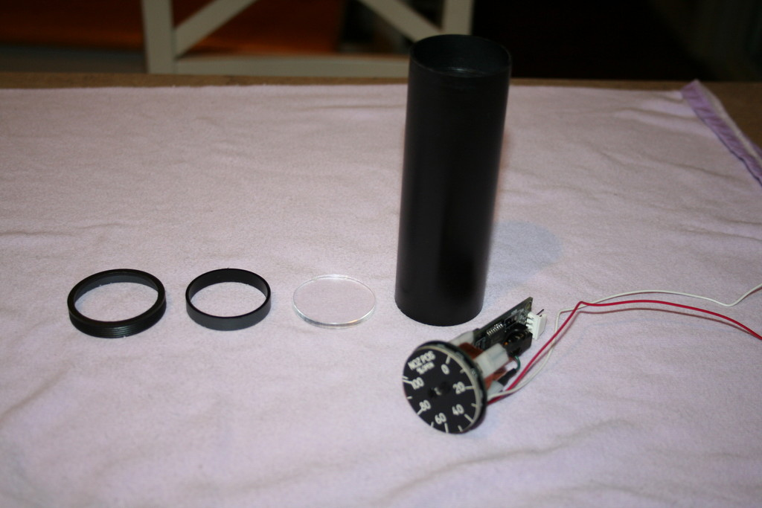
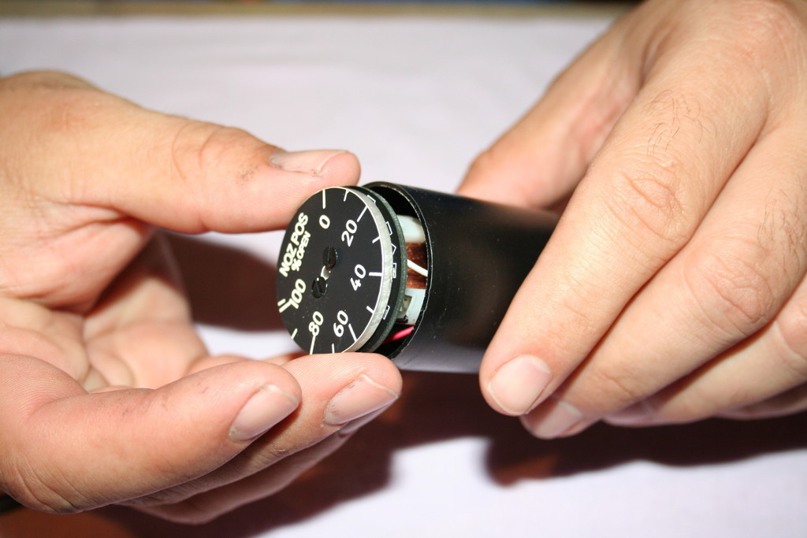
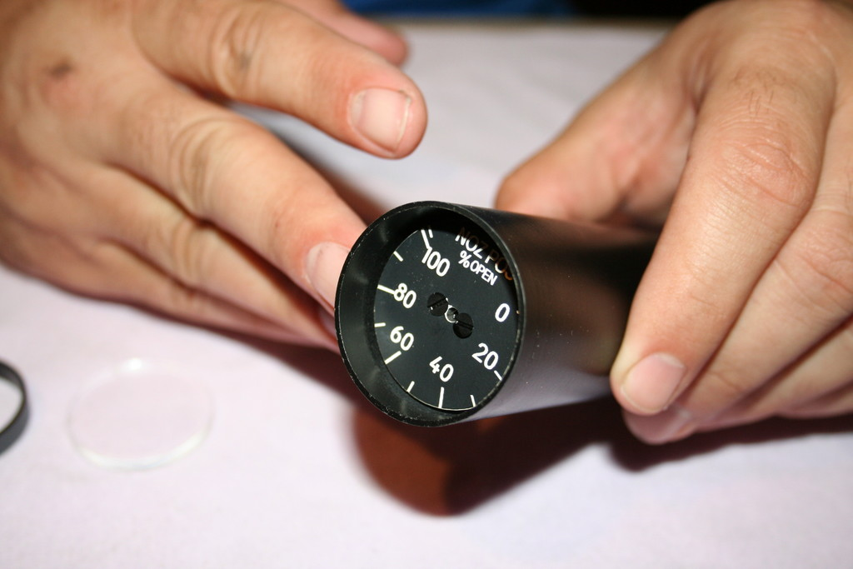
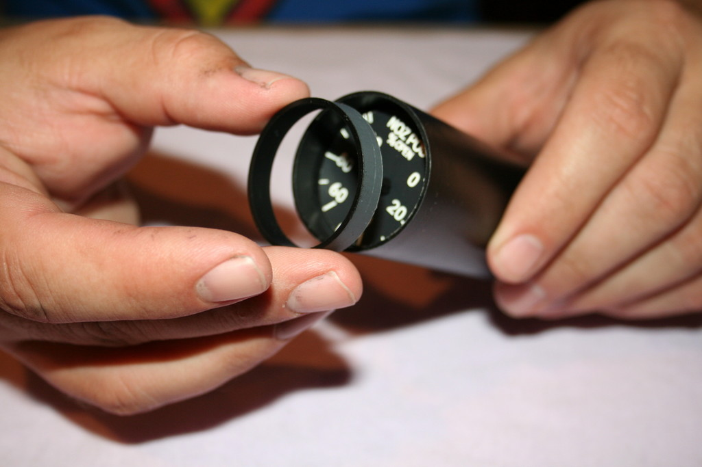
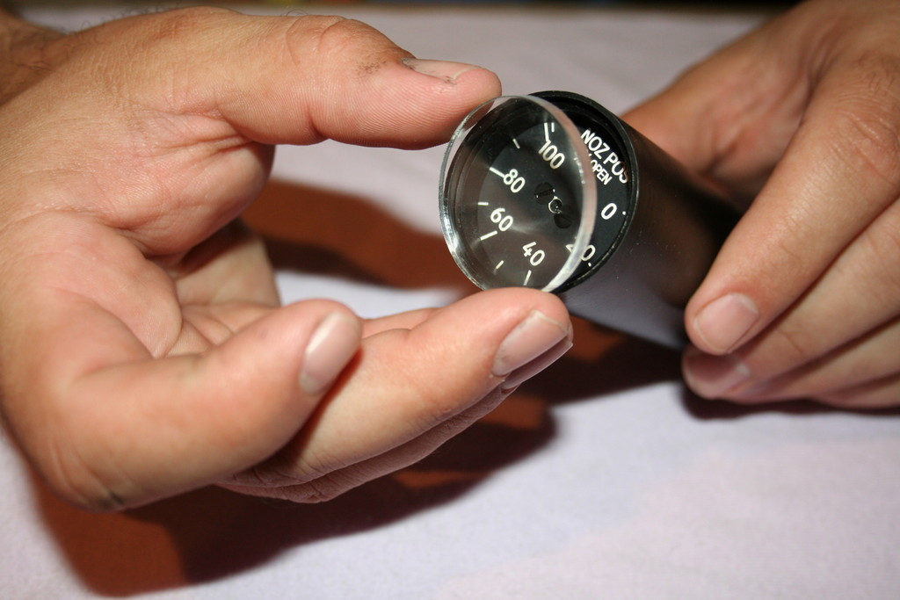
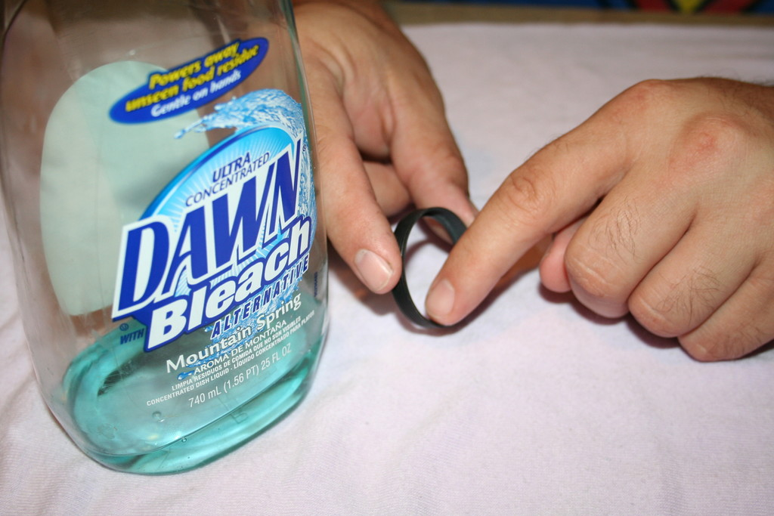
All of the bezels and tailpieces are custom fit to each tube. Be sure to keep them together. As each piece is handmade, some pieces may fit a little tighter or looser than others. Most of them should be plenty tight enough with just a dry interference fit. However, if the bezel or tailpiece fits a little loose, add some dishwashing soap as a "glue". This will make it to where you can disassemble the unit if ever necessary. I would recommend doing your gauge calibration of the needle before ever putting the glass and bezel in place.
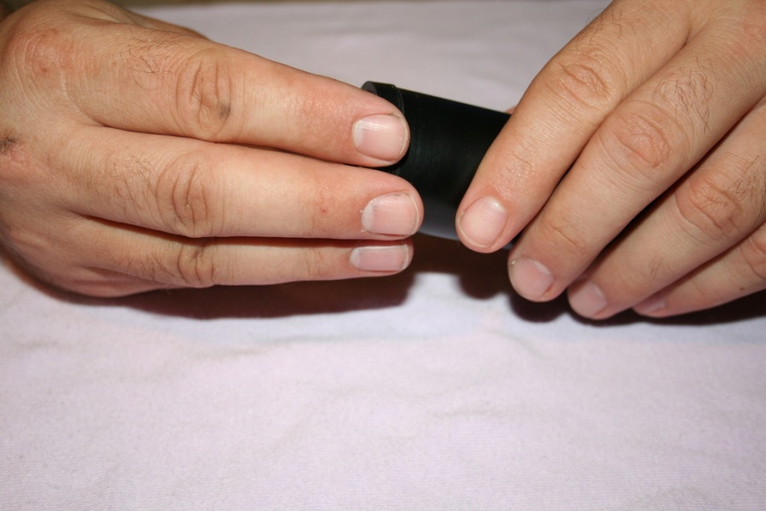
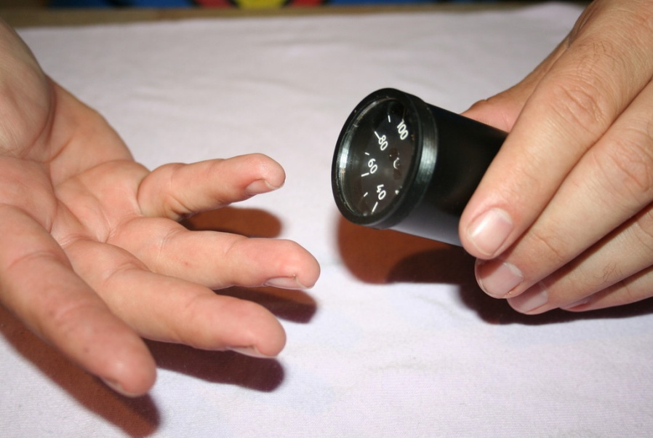
There you have it. The tailpieces are pretty straightforward. If anyone has any questions or anything....let me know...

Air Core Gauge Calibration Procedure:

Although the AC360 driver circuit does not require any hardware calibration, the pointer must be properly installed at the zero position on the gauge prior to use. Use the USBDACS.exe test utility for this purpose, which can be found in the USB toolkit.
Set the output to OV for analog gauges or 0 binary for digital gauges. Press the needle onto the Air Core Movement’s shaft at the minimum or zero position on the gauge.
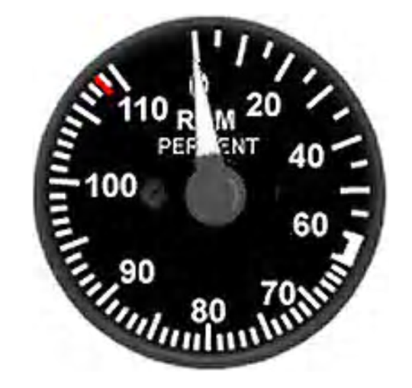
The Air Core driver circuit is now ready to use and will not need to be adjusted unless the physical range of the meter faceplate is changed. Additional in software calibration may be required depending on the intended application. Refer to the interface software help file for details.

Pin-outs for Analog type AC360X:

Connect JP1 of the AC360 driver to the expansion card using a maximum cable length of (22-24 AWG stranded wire). VIN: 0-5VDC analog input signal.
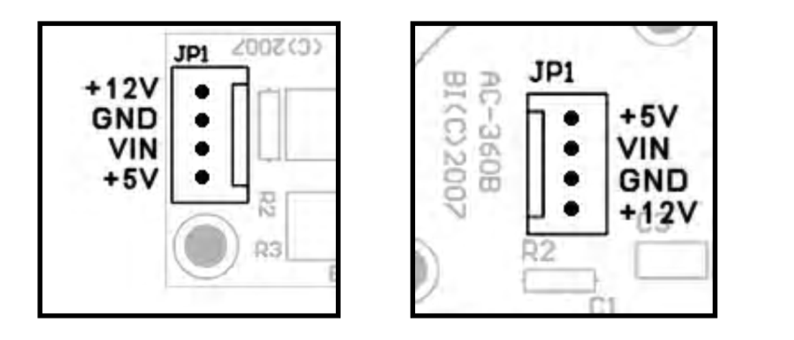

NOTE: When using the AC360 in conjunction with expansion cards, connect JP2 on the Dx10-8BIT card to an ATX PS or plug a 12-16VDC@1A AC adapter into the J1 power connector on the RXC or NITRO card. JP1 on AC360A & AC360B JP1 on AC360C

The Dx10 Expansion Module

It has 10 individually controlled voltage output channels through a single ElectronFlux port. 0 - 5VDC @ 8-bit resolution. 5V and 12V output pins for use with Air-Core movements.

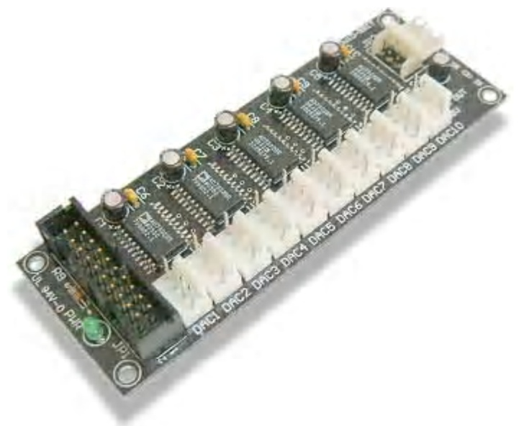

The Dx10-8BIT DAC output card is ideally suited for controlling up to 10 Air-Core Movement based gauges through the ElectronFlux module. The ElectronFlux port must be configured for 8- bit DACs mode (refer to user manual for details). When driving Air-Core movements requiring 12V power, the Dx10-8BIT can be connected to a standard ATX power supply reducing wiring complexity as each connector provides a 12V pin for this purpose. NOTE: unlike the 5V pins, the 12V source is not monitored nor protected against short circuits.

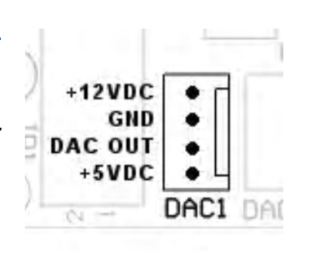

The Beta Innovations Test Bench

The test environment has:
- Plasma –lite
- Gammatron
- Electron-Flux
- 64-HV
- 64-Led
- DX-10
- DO10-RE5
- PBC-PWM

I did ask Leo about using the Nitro vs the 8 bit DAC, here’s the reply.

The Air-Core driver ICs I use are 10-bits. I found no difference between 8 and 10 bit resolution on gauges below 360 deg. I used the 12-bit ICs only because they had an SPI interface which made them convenient.

For continuous turn gauges that go beyond 360 deg, I would recommend using the full 10-bits. The next EF update will support 10-bits through SPI. Both DACs and AC driver ICs will be able to communicate directly with EF this way.

DAC

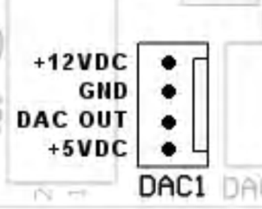

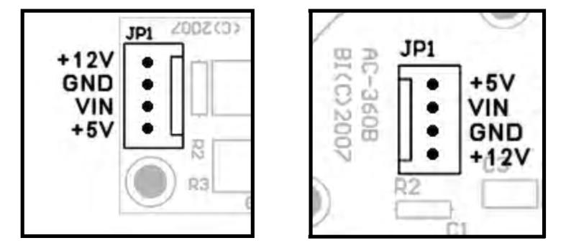

Whilst the simplest way to connect the Gauges to the DAC card would have been a straight through 4 way cable, its doesn’t include the two pins needed for backlighting.

An adapter card was added to take the PWM dimming and the DAC output and put it onto a single lead.

Outputs to Gauge Assembly (looking on lead side).

Pin | Description
1 | +12V
2 | Gnd
3 | DAC Out
4 | +5V
5 | Backlight Led +ve
6 | Backlight Led Gnd

Which Version of Falcon

Post by Red Dog at http://www.viperpits.org/smf/index.php?topic=3129.msg41043#msg41043

Some examples:
UHF panel: Not fully integrated with OF, but quite more than with AF where nothing is active

TRIM panel: Trims can be assigned as analogue axis with OF, which is way better than digitally programmed with keystrokes

COM1 panel: Same is true here. COM 1 & 2 volume may be analogue assigned

TWP&TWA: many improvement there and specifically the handoff button will need to be interfaced differently in the two versions as in OF it makes the difference between a short and a long press

JET ENGINE PANEL: I think that OF has the code for the PRI/SEC switch. AF doesn't. So that's one switch that will be wired for OF use while it is not required for AF flying.

DTC: this has nothing to do with cockpit but as far as realism is concerned the DTC is a giant step. OF has it, AF doesn't

CMDS: improvement was done on the CMDS panel, mainly the modes. The BYP mode is also possible to use where in AF it's not. I also think that AF doesn't allow such a versatile combination on the CMS and gives access to the slap button above the throttle where OF does all that

IVC: we mentioned that before, but that will be for MP flight mainly - but you flip many more buttons using the IVC than with any app as RW or Teamspeak. IMHO it adds a lot of realism to the intraflight comms, especially at ramp-start where too little knowledge of the system will let you communicate with hand-signs only (and hand signs are not easy over the internet... it usually ends like this... Sting 2.2, Sting 2.1 open your canopy if you can hear me Smiley Smiley )

TGP: the targeting pod is way better than in AF. Few influences on the cockpit building side except that the RIGHT HDPT power switch has to be wired now and has a realistic meaning where it doesn't in AF

IDM: datalink is active in OF. It doesn't really influence the cockpit building but it does influence the Hotas programming as you then need the radioswitch on the TQS

The store management is also quite closer to the real system, but those are mainly through MFDs

Try Air refuelling to see the difference between the two flavors,
AR checks works only with OF, so AP DISC switch and AR door switches works better with OF

As far as radionavigation is concerned, OF allows ILS with specific frequencies untied fromt the tacan station. You get middle marker and inner marker that you don't get in AF That's yet another light to interface in the cockpit.
It also means you have to press more buttons while setting the ILS through the UFC (and that's the essence of using a pit isn't it) Smiley

I am not sure the VMS is active in AF. It is in OF and the VMS switch can be wired

And I would add that beside wiring panels, the very essence of pit building is to throw switches in position. With OF you will be much busier in the UFC system and with the MFDs. So the overall realism feeling in our cockpit is quite increased, because a lot more actions (and understanding) is required to set the systems correctly which AF lacks

Furthermore I haven't been flying for the past three months

MFD Export from Lighting
http://www.viperpits.org/smf/index.php?topic=3376.30

Whilst this may not be the most recommended way to do this here’s what I’ve done.
- I didn’t have any computers lying around that had more than one PCI-E slot. So went out and brought a PCI video card (yeap not the highest performance but I wanted something to test against).
- After plugging the video card in, and getting no video, went to the desktop, properties, and enabled the monitor.
- Spun up Falcon, and of course it didn’t appear on the correct video screen, was running on one of the MFDs.
- Before fixing up the wrong screen issue installed MFD Extractor. Did a brief test to make sure it worked
- Went back to desktop properties and dragged the screens to the correct order
- On the screen that is to the be primary screen, right-click properties on it and set as primary display.
- Restarted computer.
- Rearranged outputs on MFD Extractor to fit
- Spun up Falcon4, got black screens on MFDs. After trying both OF4.5 and Falcon4 AF, guessed problem was with my setup.
- Punchline is MFD Extractor uses co-ordinates to determine where to grab screen information from, the primary screen was initially on the right hand side, so MFD had quite correctly used those as a reference point. As the primary screen had been relocated, there was no video to catch.
- went back into MFD Extractor and set co-ordinates to 0,0 400,400, now getting video, just the wrong information but that’s easily solved.
- Set the Desktop background to black with no pictures to tidy-up MFD output.
- The test rig had an ATI and NVidia card (primary display), so I was getting the horrid flicker issue.
- Copied the DLL Fix zip and extracted to the Falcon install directory. Still had flicker.
- Then read the instructions and started Falcon 4 in the windows mode, NO FLICKER!!! (falconaf –window)
- Went back into MFD Extractor and Reset to defaults
- Relaid out the screens.
- To get things sitting in the right place, ran Falcon in Windowed mode, paused, alt-tabed to a folder window (windows showing a list of files) and then iteratively changed the co-ordinated in for the Left hand MFD. With it paused, I could still see the MFD on screen so MFD Extractr was still displaying the MFd.
- when determining the co-ordinates display a radar view as it has green lines on the outside that can be used to determine the edges of the capture area.

To find the input coordinates, you can just start up Falcon, go into Instant Action, get into your #1 cockpit view, then hit PrintScreen, and then exit Falcon. Then go to your Windows Start menu and click Start/Programs/Accessories/Paint (or if you don't see Paint on the menu, then select Start/Run, then type "pbrush" (no quotes) and click Ok). Once Paint is launched, select Edit/Paste. Now you'll have a copy of the Falcon screenshot sitting inside of Paint. Now as you move around the image in Paint, if you hover your mouse over something, down in the lower right corner of the Paint window is a status bar that tells you the X,Y coordinates of where your mouse is hovering, relative to the entire image. Those are the coordinates you'll use for the inputs.
For the output coordinates, trial and error is probably best...or there are some simple tools out there that will show you the current x/y coordinates of wherever the mouse cursor happens to be...I'll see if I can dig one up for you...if not, I'll write one real quick.
Another thing you can do for the output coordinates, if you have a flat-panel screen, is just measure with a measuring tape or ruler, since you know the resolution of your screen, and you can measure the screen's width, then you can pretty much calculate how many pixels are between any given two points on the screen.
For example, if you have a 1680x1050 screen with a 22" diagonal measurement (and assuming the pixel groupings are square, which is a safe bet), then by the Pythagorean Theorem, we know that there will be 1981 pixels along the diagonal (1680^2 + 1050^2=c^2). If 1981 pixels=22", then each inch = approximately 90 pixels. So if you wanted an output window that appears, for example, 2 inches from the top and 2 inches from the left border of the screen, you would have an X/Y coordinate of 180, 180 for the upper left window coordinate. For the lower right window bound, if, say, you wanted a 2" window, you'd again just add 180 pixels to the upper left's X and Ys, so your lower right bound coordinates would be 360,360 in this example...

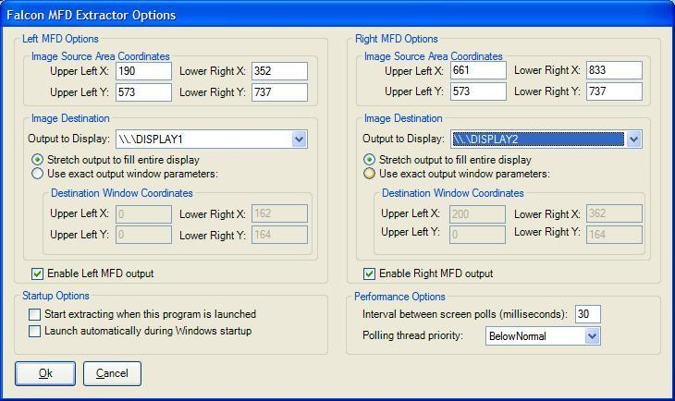

What about networking?
I'd originally written it as a client/server application where you passed a command-line argument into the program to tell it if it should send or receive data and to which IP address...but the performance sucks that way.
Now what I am doing is I am using MaxiVista to test with, and so what happens there is the remote machine is running the MaxiVista client and the Falcon machine is running the MaxiVista server. The remote (client) machine shows up like it's a second monitor. Then all you do is tell Falcon MFD Extractor to write to that "virtual" monitor and voila, you're streaming MFD data across the network. Performance is actually quite good that way.
I will keep looking into ways to reimplement the networking functionality now that the core functionality is in place, but I am pretty impressed with MaxiVista and I think that's probably going to be the way to go in the short term.

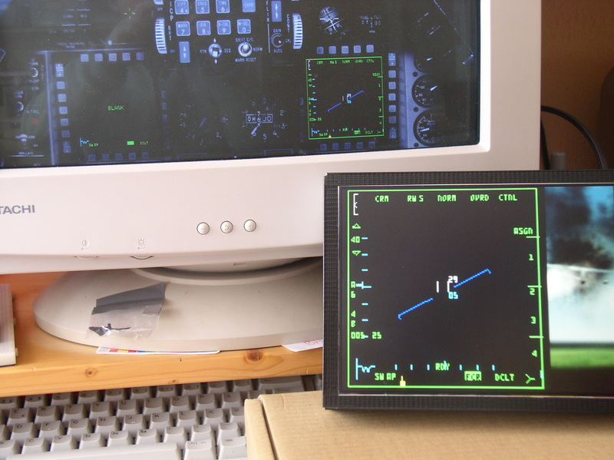

For today, the easiest way will be to set the input data coordinates for one of the MFDs to scrape from a single black pixel, and then output that pixel to an absolute coordinate output, say, the 0,0,1,1 coordinate (the upper left pixel) or alternatively the n-1,n-1,n,n coordinate (the lower right pixel).
With the technique described above you can send either or both of the MFDs to a single screen or to two separate screens...at any size and at any position...so if you output to the smallest possible size window (1 pixel square), and you scrape only a single black input pixel, effectively, you've hidden the output.
I should add a "none" option to the output display drop-down, though...just hadn't gotten to it yet. I also want to add a couple performance tweaking options like the ability to set the polling interval and the thread priority as well...

Right on! I spent the most time working on that little part. I deliberately crippled my installation by running as much crap in the background as possible and by not actually having a second monitor physically attached -- using MaxiVista incurs a performance penalty because the screen data has to be sent across the network, but I figured if I could get the refresh rate high enough over the network then it would look great when run purely locally. In the latest update you have full control over how often the screen refreshes take place...The tradeoff is, more refreshes per second means more CPU cycles are stolen away from Falcon...That's why you also have the ability to adjust the thread priority. When the priority is "BelowNormal" or lower, just about any other program on the system can steal cycles from the MFD extractor, but the MFD extractor won't be stealing cycles from those programs. If you set the thread priority higher than "BelowNormal" to just "Normal", then the MFD extractor will compete more for cycles with other programs, including Falcon (and you'll see that in the Task Manager if you look at the CPU utilization for the MFD Extractor).
Now one interesting combo you could use is to have a very short polling period (many polls per second) and a low thread priority...then you'll be able to use as much CPU time as happens to be free at the moment but whenever some other program like Falcon needs those spare compute cycles, it will get priority over the MFD extractor...
I set the default rate as 30ms between polls (which works out to ~33 polls/second, ideally) and I set the ThreadPriority to "BelowNormal" by default...but feel free to play around with that too, and see what happens!

Maxvista
http://www.maxivista.com/download.htm

Charos Led Modding tutorial:

If you are not into hacking bulbs and leds, the right mounting are available from
http://www.trainaidsa.com/shop-leds.html

http://www.viperpits.org/smf/index.php?topic=3437.0

Some folks wanted to know how to mod standard T1¾ bulbs to led, so here's a step-by-step tutorial:
First of all get some burnt (preferably) T1¾ bulbs, some 5mm leds and decide if you're gonna wire the anode or cathode to the bulb case (it should be the same for all bulbs you mod, to save you from headaches.
You can see the two solder points on the bulb, one on the side and one on the rear end.
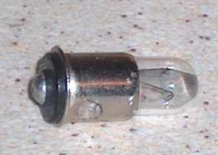
Break the glass using pliers. It's advisable to do it in a plastic bag to keep glass fragments from flying away (you know they'll end up in your eye at the end...)
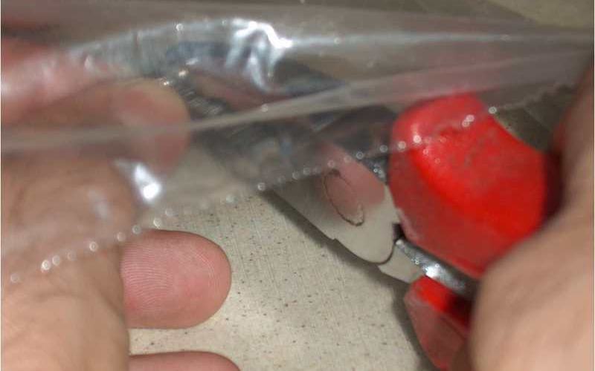
The glue holding the glass on the metal case is brittle, so just scrape it away until there's nothing left but two small wires, soldered to the two points mentioned above.
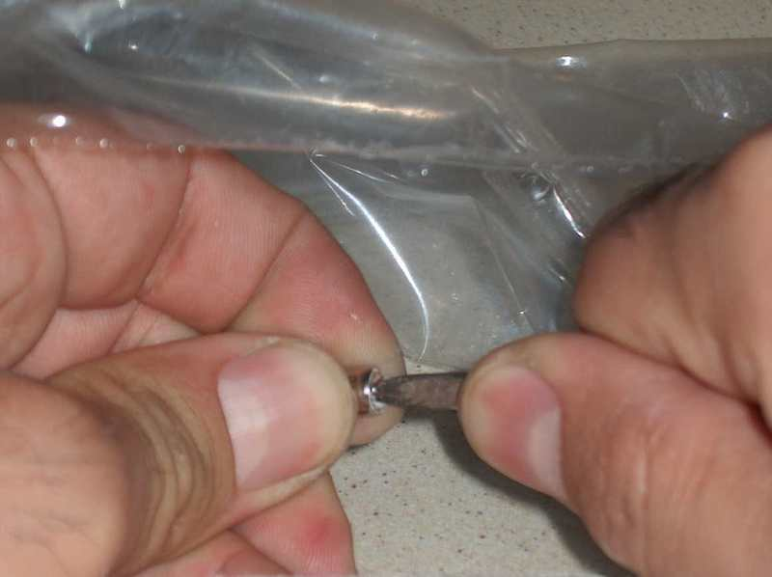
Unsolder the two wires. Doing that on the rear end will leave a nice, clean hole. The one on the side is harder to unsolder completely clean, and the led lead going there will come at an angle, making things harder. So, just drill it out (1.5mm will do fine).
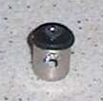
File the rim on the led (almost) off. It won't fit in the case if you don't, and if you remove it completely the fit might be sloppy. So...
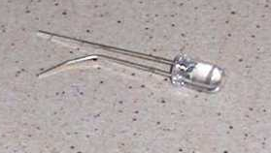
...do a dry fit first.
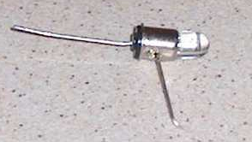
Solder, clip the leads flush, file or dremmel till they don't stick out of the solder blob. Congratulate yourself, you're done.
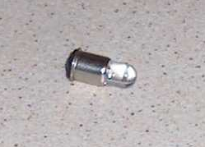
If you ever bought an original gauge from ebay, you might have some of these red filters around. But then again you're making a b52 pit, so you don't care...
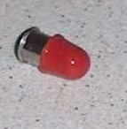
Optionally you can file the lenses flat to diffuse the light and/or glue the led in the case. I find the latter unnecessary, the solder joins are strong enough and you're not gonna apply force to the lense (or take your pit in a 4g negative dive ).
You might use colored leds, but I prefer to just use colored film behind the indicator lenses for the following reasons:
- The bulbs will be interchangeable, I'll make as many as needed plus some spares which can be used anywhere
- Different colour leds have different voltage and amperage specs
- It's cheaper to buy a large quantity of white leds than smaller ones for each color

Wiring Jays MFD Adaptors

WARNING – THE RIBBON CABLE’S FIRST COLOUR IS BLACK, SO COLOURS ARE OFFSET BY ONE – I.E. RED = PIN 3

The LDR output on pins 1 and 2 resistance ranges from 380K under a 60W bulb up to 6Meg in darkness.

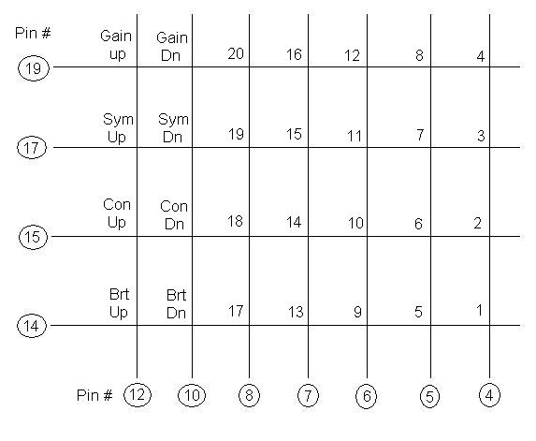
MFD Button Mappings

 | 1 | 2 | 3 | 4 | 5
20 |  |  |  |  |  | 6
19 |  |  |  |  |  | 7
18 |  |  |  |  |  | 8
17 |  |  |  |  |  | 9
16 |  |  |  |  |  | 10
 | 15 | 14 | 13 | 12 | 11

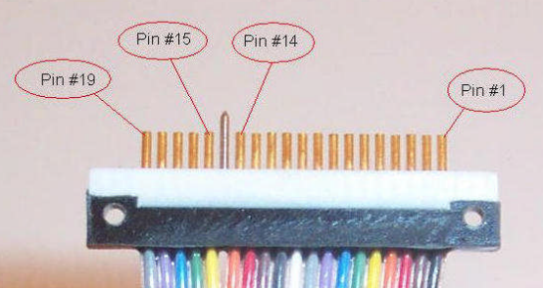

Plasma MM2

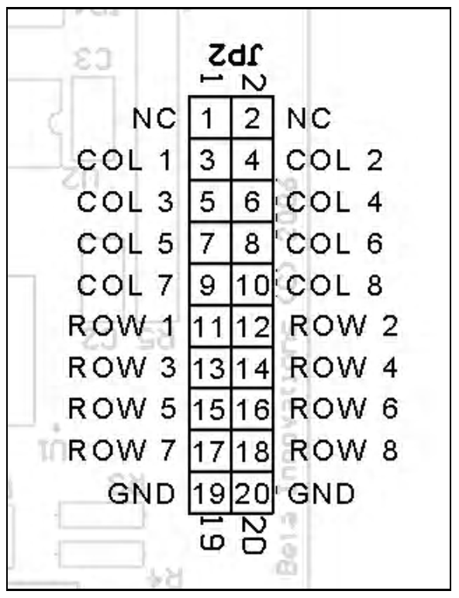

RIGHT MFD
Wire #4…..Pin #5…………………………………..Column 1
Wire #5…..Pin #4…………………………………..Column 2
Wire #6…..Pin #6…………………………………..Column 3
Wire #7…..Pin #7…………………………………..Column 4
Wire #8…..Pin #8…………………………………..Column 5
Wire #10…Pin #10…………………………………Column 6
Wire #12…Pin #12…………………………………Column 7
Wire #14…Pin #3…………………………………..Row 1
Wire #15…Pin #2…………………………………..Row 2
Wire #16…Pin #14…………………………………Ground
Wire #17…Pin #1…………………………………..Row 3
Wire #18…Pin #15…………………………………+5v
Wire #19…Pin #11…………………………………Row 4

LEFT MFD
Wire #4…..Pin #5…………………………………..Column 1
Wire #5…..Pin #4…………………………………..Column 2
Wire #6…..Pin #6…………………………………..Column 3
Wire #7…..Pin #7…………………………………..Column 4
Wire #8…..Pin #8…………………………………..Column 5
Wire #10…Pin #10…………………………………Column 6
Wire #12…Pin #12…………………………………Column 7
Wire #14…Pin #13…………………………………Row 5
Wire #15…Pin #2…………………………………..Row 6
Wire #16…Pin #11…………………………………Ground
Wire #17…Pin #15…………………………………Row 7
Wire #18…Pin #1…………………………………..+5v
Wire #19…Pin #14…………………………………Row 8

I/O Card Pinouts

Figure 28 Gammatron Input

Figure 29 Gammatron Rotary Push Mapping

Figure 30 GammaRay Inputs

Figure 31 GammaRay Rotary Inputs

Figure 32 LOLED64 Side A

Figure 33 LOLED64 Side B Pinout

Figure 34 Jay-EL Bulb Pinout
Pin | Bulb Position
 | Jay-EL Light Pinouts
C | Common
1 | Bottom Left
2 | Top Left
3 | Top Right
4 | Bottom Right

Figure 35 Comport Usage
Controller | Com Port
Flight Illusions | Com6
Parallax | Com4

From http://www.viperpits.org/smf/index.php?topic=1942.0 (to be checked)
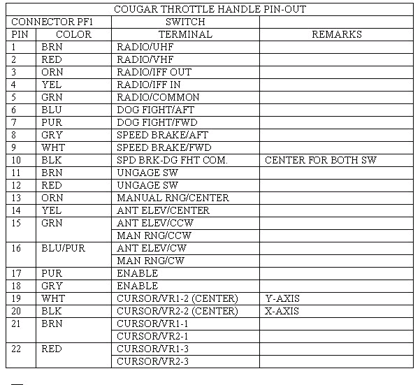

ICP Layout
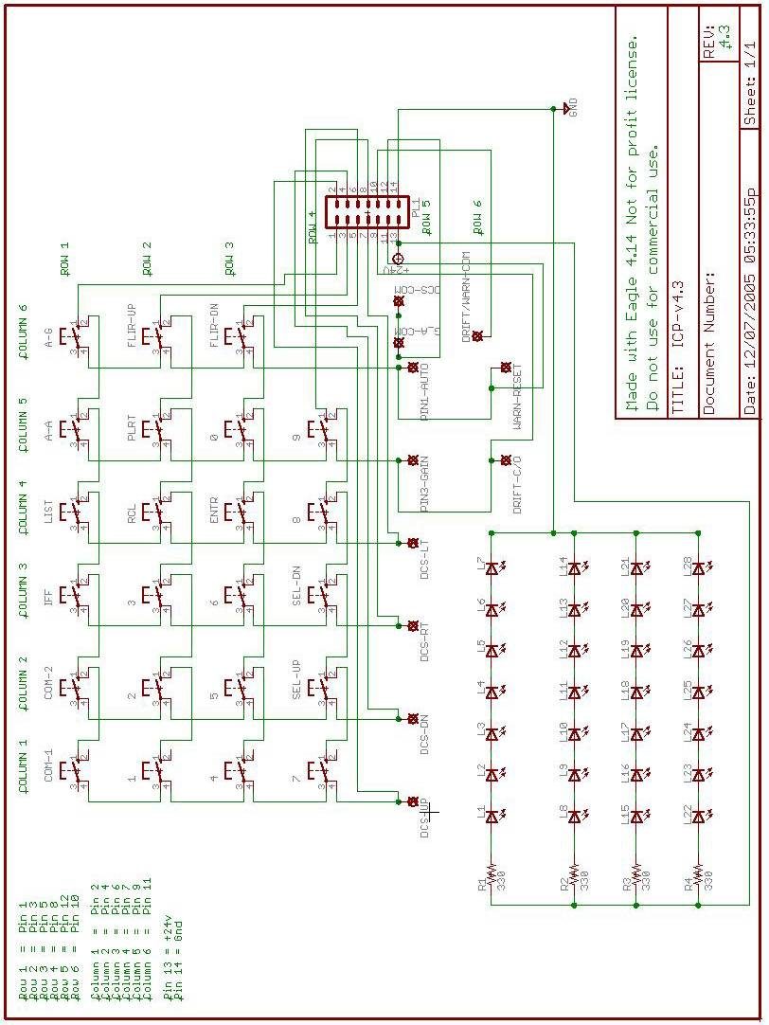

Pinouts for the PCBs

Mid_PCBs Bill of Material 23-May-07
----------------------------------------------------------------------------
Qty Product/Value Package Reference Designators
----------------------------------------------------------------------------
1 0.01uF 2PIN::H/200/200 C3
1 0.1uF 2PIN::H/200/200 C4
4 CAPACITOR 2PIN::V/200/400 C1-C2 C5-C6
----------------------------------------------------------------------------
2 DIODE 2PIN::H/400/100 D4-D5
1 LED 2PIN::H/200/100 D6
3 LED 2PIN::V/100/200 D1-D3
----------------------------------------------------------------------------
1 ACESII CON-HDR::2x5 J15
1 Analog_In CON-HDR::2x5 J27
1 Anti-G CON-HDR::2x5 J5
1 Audio CON-HDR::2x10 J31
1 Audio_2 CON-HDR::2x5 J11
1 Aux_Comm CON-HDR::2x8 J7
1 Aux_Comm_Channel CON-HDR::2x8 J8
1 AVTR CON-HDR::2x5 J16
1 Cen_Misc_Services CON-HDR::2x10 J39
1 Center_Pwr CON-HDR::2x5 J35
1 Centre_Pwr CON-HDR::2x5 J2
1 CMDS CON-HDR::2x10 J23
1 CMDS_Display CON-HDR::2x5 J21
1 ECM CON-HDR::2x5 J14
2 EFlux_Out CON-HDR::2x10 J19 J33
1 Elect CON-HDR::2x8 J17
1 EPU CON-HDR::2x5 J10
1 Ext_Light CON-HDR::2x8 J9
1 Flt_Control CON-HDR::2x5 J4
1 Fuel CON-HDR::2x8 J6
1 Gamma_Ray_V2_A CON-HDR::2x17 J18
1 Gamma_Ray_V2_B CON-HDR::2x17 J32
1 Gamma_Ray_V2_C CON-HDR::2x17 J40
1 Gear CON-HDR::2x10 J29
1 Guage_In CON-HDR::2x5 J26
1 Jet_Start CON-HDR::2x5 J13
1 Left_Cabin CON-HDR::2x5 J28
2 Left_Misc_Services CON-HDR::2x17 J25 J41
1 Left_Pwr CON-HDR::2x5 J34
1 Lighting_Controller CON-HDR::2x8 J42
1 Man_pitch CON-HDR::2x5 J3
1 Man_Trim CON-HDR::2x10 J30
1 Right_Misc_Services CON-HDR::2x10 J38
1 Right_Pwr CON-HDR::2x5 J36
2 Spare CON-HDR::2x10 J43-J44
1 Spare_Pwr CON-HDR::2x5 J37
1 Test CON-HDR::2x5 J12
1 Threat_Wrn_Aux CON-HDR::2x8 J22
1 UCC_Out_1 CON-HDR::2x17 J1
1 UCC_Out_2 CON-HDR::2x17 J20
1 UHF CON-HDR::2x5 J24
----------------------------------------------------------------------------
1 MOSFET_N TO::218 Q1
----------------------------------------------------------------------------
1 1K 2PIN::H/400/100 R5
1 47R 2PIN::H/400/100 R7
1 50K POT::TA_Circ300 R4
1 120 2PIN::H/200/100 R6
1 R_12V 2PIN::H/400/100 R2
1 R_28V 2PIN::H/400/100 R3
1 R_Bklight 2PIN::H/400/100 R1
----------------------------------------------------------------------------
1 LMC555 DIP::8D400Y300 U1
----------------------------------------------------------------------------

Totals: Elements=65 Pins=800 Nets=188

Right_PCB Bill of Material 24-May-07
----------------------------------------------------------------------------
Qty Product/Value Package Reference Designators
----------------------------------------------------------------------------
4 CAPACITOR 2PIN::V/200/400 C1-C4
----------------------------------------------------------------------------
6 LED 2PIN::V/100/200 D1-D6
----------------------------------------------------------------------------
1 Air_Cond CON-HDR::2x5 J34
1 Anti_Ice CON-HDR::2x5 J31
1 Avoinic_Pwr CON-HDR::2x10 J24
1 Cen_Misc_Services CON-HDR::2x10 J18
1 Center_Pwr CON-HDR::2x5 J1
1 DTU CON-HDR::2x5 J25
2 EFlux_Out CON-HDR::2x10 J10 J15
1 Eyebrow_L CON-HDR::2x5 J16
1 Eyebrow_R CON-HDR::2x5 J11
1 Fuel_Qty_Select CON-HDR::2x8 J12
1 Gamma_Ray_V2_D CON-HDR::2x17 J2
1 Gamma_Ray_V2_E CON-HDR::2x17 J13
1 Gamma_Ray_V2_F CON-HDR::2x17 J20
1 Gamma_Ray_V2_G CON-HDR::2x17 J22
1 Gamma_Ray_V2_H CON-HDR::2x17 J36
1 HIS CON-HDR::2x5 J5
1 Hud_Control CON-HDR::2x10 J29
1 Indexer_L CON-HDR::2x5 J8
1 Indexer_R CON-HDR::2x5 J9
1 Inst CON-HDR::2x8 J4
1 KY_58 CON-HDR::2x5 J30
1 Left_MFD CON-HDR::2x17 J3
1 Lighting CON-HDR::2x8 J27
1 Master_Zeroise CON-HDR::2x5 J33
1 Misc CON-HDR::2x10 J17
1 Nuclear_Consent CON-HDR::2x5 J28
1 OBOGS CON-HDR::2x5 J32
1 Ox_Reg CON-HDR::2x5 J26
1 Right_MFD CON-HDR::2x17 J6
1 Right_Misc_Services CON-HDR::2x10 J35
1 Right_Pwr CON-HDR::2x5 J21
1 Sensor_Pwr CON-HDR::2x5 J23
2 Spare CON-HDR::2x10 J37-J38
1 Threat_Wrn_Prime CON-HDR::2x8 J19
1 UCC_Out_3 CON-HDR::2x17 J7
1 UCC_Out_4 CON-HDR::2x17 J14
----------------------------------------------------------------------------
2 R_12V 2PIN::H/400/100 R2 R5
2 R_28V 2PIN::H/400/100 R3 R6
2 R_Bklight 2PIN::H/400/100 R1 R4
----------------------------------------------------------------------------

Totals: Elements=54 Pins=742 Nets=169

PCB Modifications

The most important change is that the 28V rail plumbed to all PCBs is now a return (aka Ground) for the Led Latched-Outputs.

Other Changes

- Ground added for GammaRay ports

- As Right Eyebrow uses more LEDs than original planned the spare port on the centre distribution PCB is now used to drive the Right Eyebrows. Used one for pins (so first part of pinout is the same, and then added new pins. DBU not wired end to end as out of ports of loled64.

- The Right and Left MFD connectors are not used on the Centre Distribution PCBs as an MM2 with Jays Adaptor PCB is used.

- The UCC connectors are used for driving Leds, even though UCC is not used for general outputs. The PCB had been designed to be driven either from the UCC or EFlux environment. This was before the LOLED64 had been released. To address this change in approach an Adaptor board is used to convert the LOLED64 outputs to pinout compatible with the UCC connectors.

PCB Circuit Diagrams
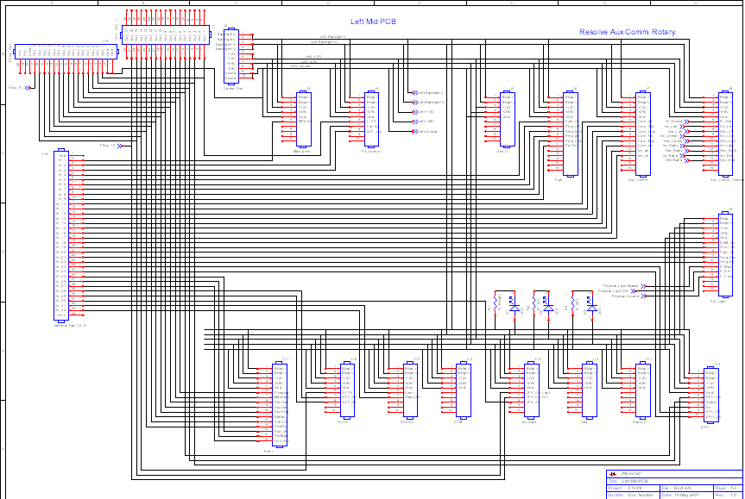
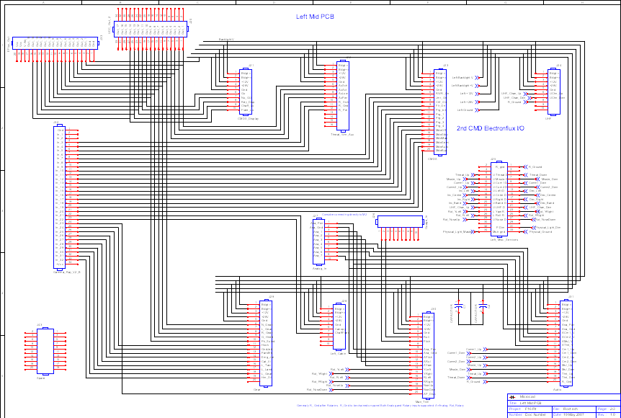
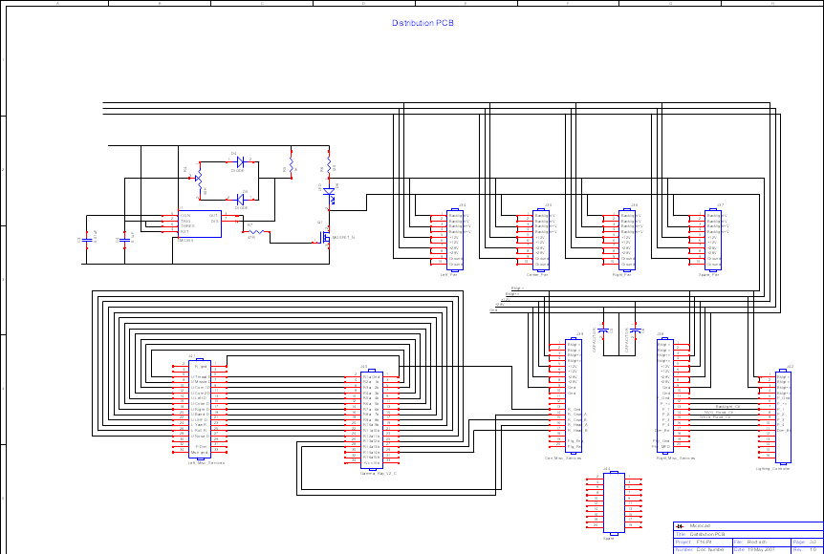
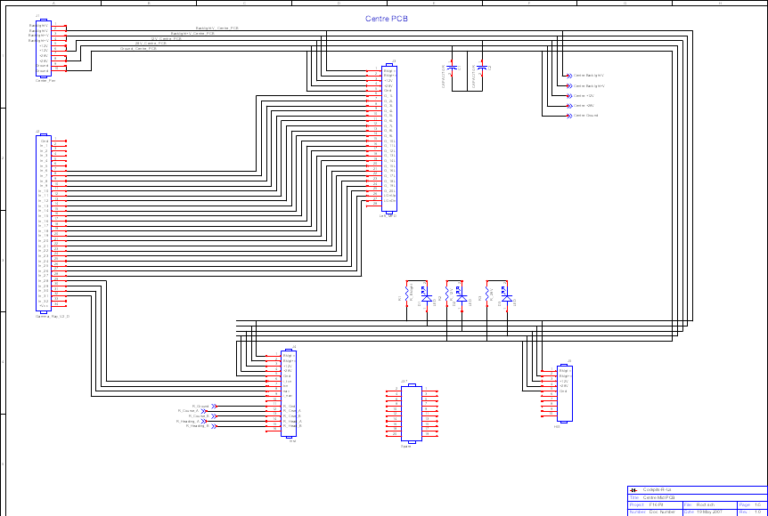
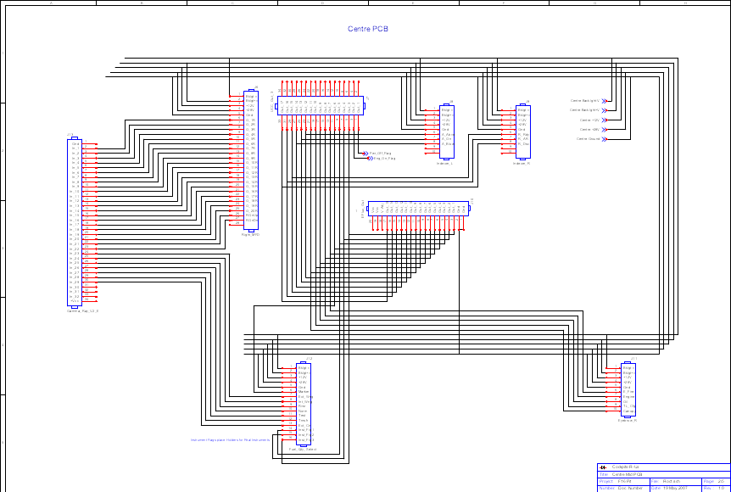
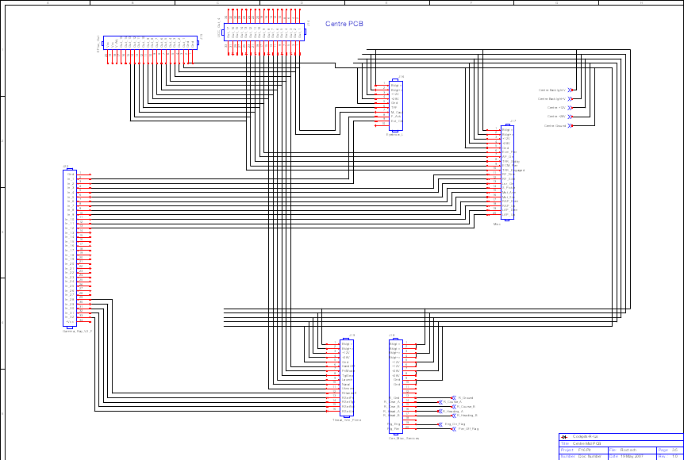
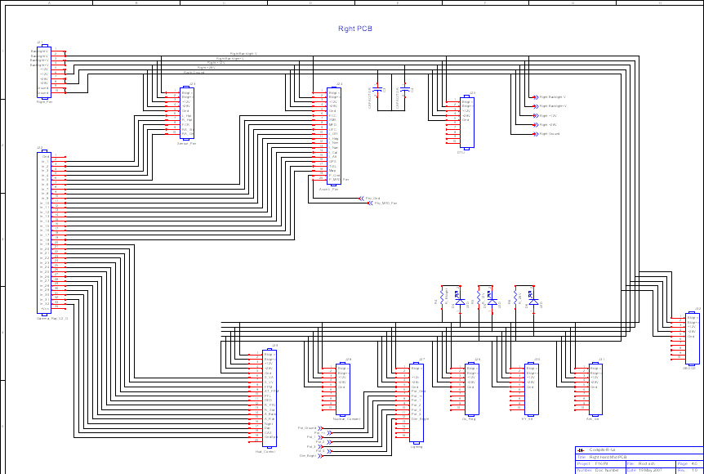
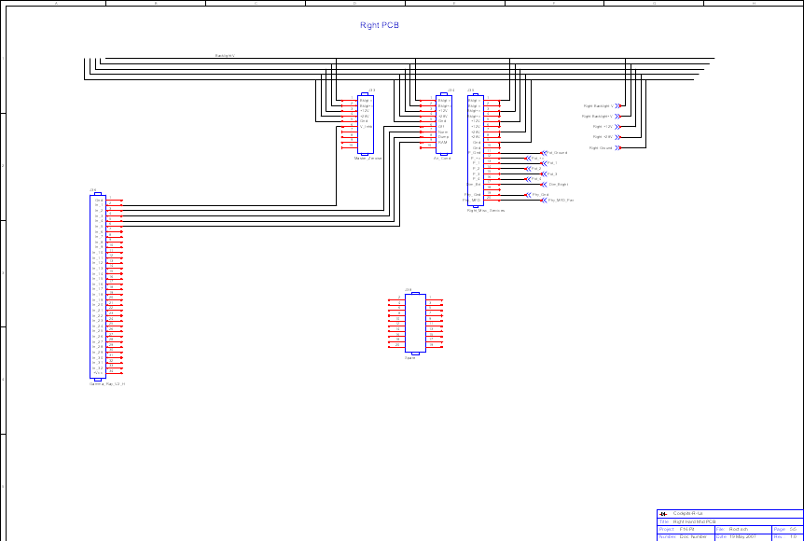
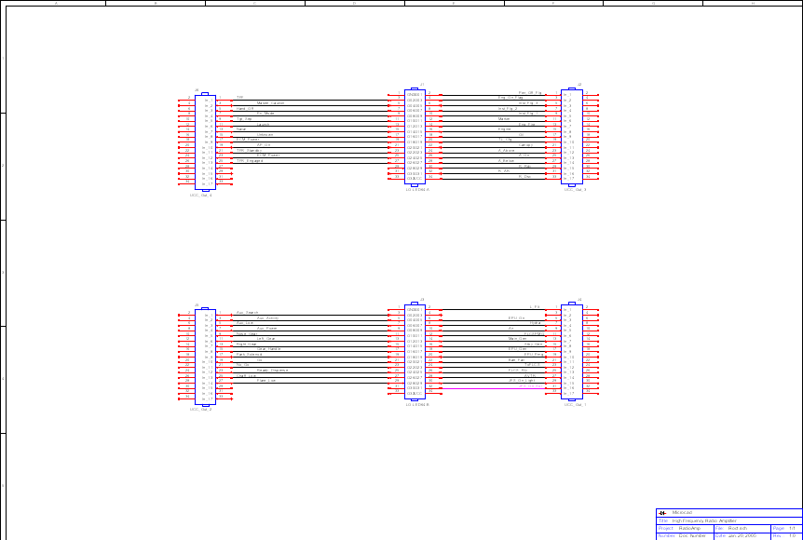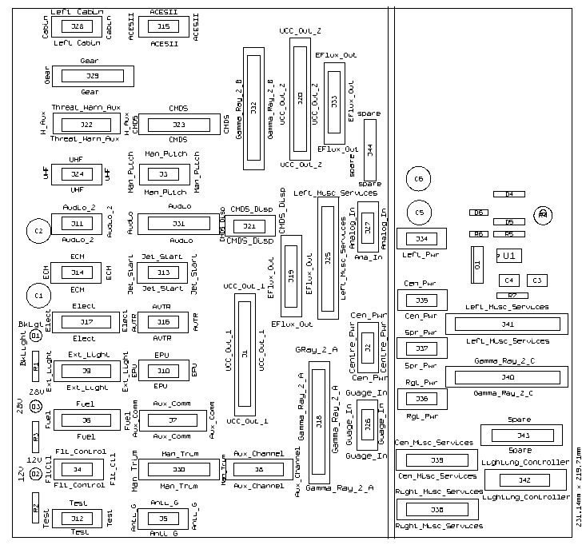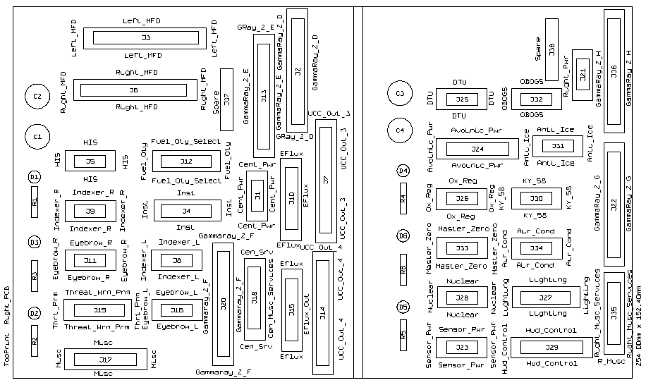
Capturing the PCB with multiple layers and colours. Tried MS Paint, Picssa2, and Office Picture editor, couldn’t find a way to chage the colour of the lines in the EMF file exported from WinQCad. Ultimately found by bringing all layers into PowerPoint the files stayed correctly overlaid.
Insert Picture from file (for Top, Bottom, and top Print) Then Right-click and edit picture, asked if you want to change to an Office Object, click yes. Can then select object – Right Click Format Object, select lines and then choose colour fro the layer. Then push modified layer ti back. Once the colours have been set you can then group them together. Colours used: Dark Blue for top layer, Dark Green for Bottom, and Red for Top print.
Then copy and paste directly into Word, it will paste as an Office Drawing Object.

There are two Cen_Misc_Services, Left_Misc_Services, Right_Misc_Services, Right_Pwr, three Centre_Pwr– to be investigated

Connector Totals:
Connector Size | Quantity
10 Pin | 36
16 Pin | 11
20 Pin | 19
34 Pin | 16
Total Connectors | 0

Connector | Type | Location
Audio | CON-HDR::2x10 | J31
Avoinic_Pwr | CON-HDR::2x10 | J24
Cen_Misc_Services | CON-HDR::2x10 | J18
Cen_Misc_Services | CON-HDR::2x10 | J39
CMDS | CON-HDR::2x10 | J23
EFlux_Out | CON-HDR::2x10 | J10
EFlux_Out | CON-HDR::2x10 | J15
EFlux_Out | CON-HDR::2x10 | J19
EFlux_Out | CON-HDR::2x10 | J33
Gear | CON-HDR::2x10 | J29
Hud_Control | CON-HDR::2x10 | J29
Man_Trim | CON-HDR::2x10 | J30
Misc | CON-HDR::2x10 | J17
Right_Misc_Services | CON-HDR::2x10 | J35
Right_Misc_Services | CON-HDR::2x10 | J38
Spare | CON-HDR::2x10 | J37
Spare | CON-HDR::2x10 | J38
Spare | CON-HDR::2x10 | J43
Spare | CON-HDR::2x10 | J44
19 | 19
Gamma_Ray_V2_A | CON-HDR::2x17 | J18
Gamma_Ray_V2_B | CON-HDR::2x17 | J32
Gamma_Ray_V2_C | CON-HDR::2x17 | J40
Gamma_Ray_V2_D | CON-HDR::2x17 | J2
Gamma_Ray_V2_E | CON-HDR::2x17 | J13
Gamma_Ray_V2_F | CON-HDR::2x17 | J20
Gamma_Ray_V2_G | CON-HDR::2x17 | J22
Gamma_Ray_V2_H | CON-HDR::2x17 | J36
Left_MFD | CON-HDR::2x17 | J3
Left_Misc_Services | CON-HDR::2x17 | J25
Left_Misc_Services | CON-HDR::2x17 | J41
Right_MFD | CON-HDR::2x17 | J6
UCC_Out_1 | CON-HDR::2x17 | J1
UCC_Out_2 | CON-HDR::2x17 | J20
UCC_Out_3 | CON-HDR::2x17 | J7
UCC_Out_4 | CON-HDR::2x17 | J14
16 | 16
ACESII | CON-HDR::2x5 | J15
Air_Cond | CON-HDR::2x5 | J34
Analog_In | CON-HDR::2x5 | J27
Anti_Ice | CON-HDR::2x5 | J31
Anti-G | CON-HDR::2x5 | J5
Audio_2 | CON-HDR::2x5 | J11
AVTR | CON-HDR::2x5 | J16
Center_Pwr | CON-HDR::2x5 | J1
Center_Pwr | CON-HDR::2x5 | J35
Centre_Pwr | CON-HDR::2x5 | J2
CMDS_Display | CON-HDR::2x5 | J21
DTU | CON-HDR::2x5 | J25
ECM | CON-HDR::2x5 | J14
EPU | CON-HDR::2x5 | J10
Eyebrow_L | CON-HDR::2x5 | J16
Eyebrow_R | CON-HDR::2x5 | J11
Flt_Control | CON-HDR::2x5 | J4
Guage_In | CON-HDR::2x5 | J26
HIS | CON-HDR::2x5 | J5
Indexer_L | CON-HDR::2x5 | J8
Indexer_R | CON-HDR::2x5 | J9
Jet_Start | CON-HDR::2x5 | J13
KY_58 | CON-HDR::2x5 | J30
Left_Cabin | CON-HDR::2x5 | J28
Left_Pwr | CON-HDR::2x5 | J34
Man_pitch | CON-HDR::2x5 | J3
Master_Zeroise | CON-HDR::2x5 | J33
Nuclear_Consent | CON-HDR::2x5 | J28
OBOGS | CON-HDR::2x5 | J32
Ox_Reg | CON-HDR::2x5 | J26
Right_Pwr | CON-HDR::2x5 | J21
Right_Pwr | CON-HDR::2x5 | J36
Sensor_Pwr | CON-HDR::2x5 | J23
Spare_Pwr | CON-HDR::2x5 | J37
Test | CON-HDR::2x5 | J12
UHF | CON-HDR::2x5 | J24
36 | 36
Aux_Comm | CON-HDR::2x8 | J7
Aux_Comm_Channel | CON-HDR::2x8 | J8
Elect | CON-HDR::2x8 | J17
Ext_Light | CON-HDR::2x8 | J9
Fuel | CON-HDR::2x8 | J6
Fuel_Qty_Select | CON-HDR::2x8 | J12
Inst | CON-HDR::2x8 | J4
Lighting | CON-HDR::2x8 | J27
Lighting_Controller | CON-HDR::2x8 | J42
Threat_Wrn_Aux | CON-HDR::2x8 | J22
Threat_Wrn_Prime | CON-HDR::2x8 | J19
11 | 11
82 | 82

PCB Connectors Alphabetically Sorted

Connector | Type | Location
ACESII | CON-HDR::2x5 | J15
Air_Cond | CON-HDR::2x5 | J34
Analog_In | CON-HDR::2x5 | J27
Anti_Ice | CON-HDR::2x5 | J31
Anti-G | CON-HDR::2x5 | J5
Audio | CON-HDR::2x10 | J31
Audio_2 | CON-HDR::2x5 | J11
Aux_Comm | CON-HDR::2x8 | J7
Aux_Comm_Channel | CON-HDR::2x8 | J8
Avoinic_Pwr | CON-HDR::2x10 | J24
AVTR | CON-HDR::2x5 | J16
Cen_Misc_Services | CON-HDR::2x10 | J18
Cen_Misc_Services | CON-HDR::2x10 | J39
Center_Pwr | CON-HDR::2x5 | J1
Center_Pwr | CON-HDR::2x5 | J35
Centre_Pwr | CON-HDR::2x5 | J2
CMDS | CON-HDR::2x10 | J23
CMDS_Display | CON-HDR::2x5 | J21
DTU | CON-HDR::2x5 | J25
ECM | CON-HDR::2x5 | J14
EFlux_Out | CON-HDR::2x10 | J10
EFlux_Out | CON-HDR::2x10 | J15
EFlux_Out | CON-HDR::2x10 | J19
EFlux_Out | CON-HDR::2x10 | J33
Elect | CON-HDR::2x8 | J17
EPU | CON-HDR::2x5 | J10
Ext_Light | CON-HDR::2x8 | J9
Eyebrow_L | CON-HDR::2x5 | J16
Eyebrow_R | CON-HDR::2x5 | J11
Flt_Control | CON-HDR::2x5 | J4
Fuel | CON-HDR::2x8 | J6
Fuel_Qty_Select | CON-HDR::2x8 | J12
Gamma_Ray_V2_A | CON-HDR::2x17 | J18
Gamma_Ray_V2_B | CON-HDR::2x17 | J32
Gamma_Ray_V2_C | CON-HDR::2x17 | J40
Gamma_Ray_V2_D | CON-HDR::2x17 | J2
Gamma_Ray_V2_E | CON-HDR::2x17 | J13
Gamma_Ray_V2_F | CON-HDR::2x17 | J20
Gamma_Ray_V2_G | CON-HDR::2x17 | J22
Gamma_Ray_V2_H | CON-HDR::2x17 | J36
Gear | CON-HDR::2x10 | J29
Guage_In | CON-HDR::2x5 | J26
HIS | CON-HDR::2x5 | J5
Hud_Control | CON-HDR::2x10 | J29
Indexer_L | CON-HDR::2x5 | J8
Indexer_R | CON-HDR::2x5 | J9
Inst | CON-HDR::2x8 | J4
Jet_Start | CON-HDR::2x5 | J13
KY_58 | CON-HDR::2x5 | J30
Left_Cabin | CON-HDR::2x5 | J28
Left_MFD | CON-HDR::2x17 | J3
Left_Misc_Services | CON-HDR::2x17 | J25
Left_Misc_Services | CON-HDR::2x17 | J41
Left_Pwr | CON-HDR::2x5 | J34
Lighting | CON-HDR::2x8 | J27
Lighting_Controller | CON-HDR::2x8 | J42
Man_pitch | CON-HDR::2x5 | J3
Man_Trim | CON-HDR::2x10 | J30
Master_Zeroise | CON-HDR::2x5 | J33
Misc | CON-HDR::2x10 | J17
Nuclear_Consent | CON-HDR::2x5 | J28
OBOGS | CON-HDR::2x5 | J32
Ox_Reg | CON-HDR::2x5 | J26
Right_MFD | CON-HDR::2x17 | J6
Right_Misc_Services | CON-HDR::2x10 | J35
Right_Misc_Services | CON-HDR::2x10 | J38
Right_Pwr | CON-HDR::2x5 | J21
Right_Pwr | CON-HDR::2x5 | J36
Sensor_Pwr | CON-HDR::2x5 | J23
Spare | CON-HDR::2x10 | J37
Spare | CON-HDR::2x10 | J38
Spare | CON-HDR::2x10 | J43
Spare | CON-HDR::2x10 | J44
Spare_Pwr | CON-HDR::2x5 | J37
Test | CON-HDR::2x5 | J12
Threat_Wrn_Aux | CON-HDR::2x8 | J22
Threat_Wrn_Prime | CON-HDR::2x8 | J19
UCC_Out_1 | CON-HDR::2x17 | J1
UCC_Out_2 | CON-HDR::2x17 | J20
UCC_Out_3 | CON-HDR::2x17 | J7
UCC_Out_4 | CON-HDR::2x17 | J14
UHF | CON-HDR::2x5 | J24

PCB Connector Pinouts

LEFT PCB

J2
BACKLIGHT-V
BACKLIGHT-V
BACKLIGHT+V
BACKLIGHT+V
+12V LEFT
+12V LEFT
+28V LEFT
+28V LEFT
GROUND
GROUND

J3
BKLGT-V
BKLGT+V
+12V LEFT
+28V LEFT,
GND LEFT
MPTCHO NET49_1,
7 OPEN,
8 OPEN,
9 OPEN,
10 OPEN

J4
BKLGT-V
BKLGT+V
+12V LEFT
+28V LEFT
GND LEFT
L_FLT
FLP_EXT
LEF_LCK
9 OPEN
10 OPEN

J5
BKLGT-V
BKLGT+V
+12V LEFT
+28V LEFT
GND LEFT
6 OPEN,
7 OPEN,
8 OPEN,
9 OPEN,
10 OPEN
);

J6
BKLGT-V
BKLGT+V
+12V LEFT
+28V LEFT
GND LEFT
FUEL_ON
PMP_OFF
PMP_NRM
PMP_AFT
PMP_FWD
FUL_DOR
12 OPEN,
13 OPEN,
14 OPEN,
15 OPEN,
16 OPEN

J7
BKLGT-V
BKLGT+V
+12V LEFT
+28V LEFT
GND LEFT
COM_OFF
COM_STB
COM_LOW
COM_NO
COM_BCK
COM_UFC
TCN_ATR
TCN_NTR
14 OPEN,
15 OPEN,
16 OPEN

J8
BKLGT-V
BKLGT+V
+12V LEFT
+28V LEFT
GND LEFT
R_GND
INC_LFT
DEC_LFT
INC_CEN
DEC_CEN
INC_RGHT
DEC_RGHT
INC_BND
DEC_BND
15 OPEN,
16 OPEN

J9
BKLGT-V
BKLGT+V
+12V LEFT
+28V LEFT
GND LEFT
EXTM_ON
ACOL_ON
FLSH_ON
WNG_DM
WNG_BRT
P_MSTR
P_DIM
P_CMN
14 OPEN,
15 OPEN,
16 OPEN

J10
BKLGT-V
BKLGT+V
+12V LEFT
+28V LEFT
GND LEFT
EPU_ON
HYDRA
AIR
EPU_OF
EPU_ON

J11
BKLGT-V
BKLGT+V
+12V LEFT
+28V LEFT
GND LEFT
6 OPEN,
7 OPEN,
8 OPEN,
9 OPEN,
10 OPEN

J12
BKLGT-V
BKLGT+V
+12V LEFT
+28V LEFT
GND LEFT
6 OPEN,
7 OPEN,
8 OPEN,
9 OPEN,
10 OPEN

J13
BKLGT-V
BKLGT+V
+12V LEFT
+28V LEFT
GND LEFT
JFS_ON_LGHT
JFS_ON_SOL
JFS_ST
9 OPEN,
10 OPEN

J14
BKLGT-V
BKLGT+V
+12V LEFT
+28V LEFT
GND LEFT
6 OPEN,
7 OPEN,
8 OPEN,
9 OPEN,
10 OPEN

J15
BKLGT-V
BKLGT+V
+12V LEFT
+28V LEFT
GND LEFT
EJECT
SEAT_ON
8 OPEN,
9 OPEN,
10 OPEN

J16
BKLGT-V
BKLGT+V
+12V LEFT
+28V LEFT
GND LEFT
AVTR
AVT_OFF
AVT_ON
9 OPEN
10 OPEN

J17
BKLGT-V
BKLGT+V
+12V LEFT
+28V LEFT
GND LEFT
FLCSPMG
MAINGEN
STBYGEN
EPUGEN
EPUPMG
BATFAIL
TOFLCS
FLCSRLY
PWR_OFF
PWRMAIN
WRN_RST

J21
BKLGT-V
BKLGT+V
+12V LEFT
+28V LEFT
GND LEFT
GO NET5_2,
NO_GO
RDY_DISP
CHAFF_LO
FLARE_LO

J22
BKLGT-V
BKLGT+V
+12V LEFT
+28V LEFT
GND LEFT
AXSCH
AXACT
AXLOW
AXPWR
R_SRCH
R_GND
R_PWR
13 OPEN,
14 OPEN,
15 OPEN,
16 OPEN

J23
BKLGT-V
BKLGT+V
+12V LEFT
+28V LEFT
GND LEFT
RWR_ON
JMR_ON
CHF_ON
FLR_ON
PRG_BIT
PRG_1
PRG_2
PRG_3
PRG_4
MDEOFF
MDESTBY
MDEMAN
MDESEMI
MDEAUTO
MDEBYP

J24
BKLGT-V
BKLGT+V
+12V LEFT
+28V LEFT
GND LEFT
UCHN_UP UHF_CHAN_UP_2,
UCHN_DWN UHF_CHAN_DWN_2,
8 R_GROUND_1,
9 OPEN,
10 OPEN

J25
R_GND
2 OPEN,
3 OPEN,
4 OPEN,
5 THREAT_DOWN_2,
U-THREAT-D THREAT_UP_2,
7 MISSLE_DWN_2,
U-MISSLE-D MISSLE_UP_2,
9 COMM1_DWN_2,
U-COM1-D COMM1_UP_2,
11 COMM2_DWN_2,
U-COM2-D COMM2_UP_2,
13 DEC_LEFT_1,
U-LEFT-D INC_LEFT_1,
15 DEC_CENTRE_1,
U-CNTER-D INC_CENTRE_1,
17 DEC_RIGHT_1,
U-RIGHT-D INC_RIGHT_1,
19 DEC_BAND_1,
U-BAND-D INC_BAND_1,
21 UHF_CHAN_DWN_2,
U-UHF-D UHF_CHAN_UP_2,
23 ROT_YRIGHT_2,
L-YAW-R ROT_YLEFT_2,
25 ROT_RRIGHT_2,
L-ROLL-R ROT_RLEFT_2,
27 ROT_NOSEDOWN_2,
U-NOSE-D ROT_NOSEUP_2,
29 OPEN,
30 OPEN,
P-DIM PHYSICAL_LIGHT_DIM_1,
32 OPEN,
GND PHYSICAL_GROUND_1,
MSTR PHYSICAL_LIGHT_MASTER_1

J26
1 NET54_2,
2 NET55_2,
3 OPEN,
4 OPEN,
5 OPEN,
6 OPEN,
7 OPEN,
8 OPEN,
9 OPEN,
10 OPEN

J27
ANA_PWR NET50_2,
ANA_GND NET49_2,
ANA_1 NET53_2,
ANA_2 NET52_2,
ANA_3 NET51_2,
ANA_4 NET48_2,
ANA_5 NET47_2,
ANA_6 NET46_2,
ANA_7 NET45_2,
10 OPEN

J28
BKLGT-V
BKLGT+V
+12V LEFT
+28V LEFT
GND LEFT
CANOPY
CHAFFFLARE
8 OPEN,
9 OPEN,
10 OPEN
);

J29
BKLGT-V
BKLGT+V
+12V LEFT
+28V LEFT
GND LEFT
N_GEAR
L_GEAR
R_GEAR
G_HNDLE
PK_SOLND
HOOK
GNDJETT
PARKBRK
EMG_JET
CAT_III
L_TAXI
L_LAND
L_GEAR
HRN_SIL
20 OPEN

J30
BKLGT-V
BKLGT+V
+12V LEFT
+28V LEFT
GND LEFT
ROLL
PITCH
8 OPEN,
ANA_PWR
ANA_GND
APITCH
AROLL
AYAW
YLEFT
YRGHT
RLEFT
RRIGHT
NSEUP
NSEDWN
AP_DISC

J31
BKLGT-V
BKLGT+V
+12V LEFT
+28V LEFT
GND LEFT
ANA_PWR
ANA_GND
ACM1_V
ACM2_V
AMSL_V
ATHRT_V
CM1_UP
CM1_DWN
CM2_UP
CM2_DWN
MSL_UP
MSL_DWN
THRT_UP
THRT_DWN
R_GND);

J34
BACKLIGHT-V
BACKLIGHT-V
BACKLIGHT+V
BACKLIGHT+V
+12V
+12V
+28V
+28V
GROUND
GROUND

J35
BACKLIGHT-V
BACKLIGHT-V
BACKLIGHT+V
BACKLIGHT+V
+12V
+12V
+28V
+28V
GROUND
GROUND

J36
BACKLIGHT-V
BACKLIGHT-V
BACKLIGHT+V
BACKLIGHT+V
+12V
+12V
+28V
+28V
GROUND
GROUND

J37
BACKLIGHT-V
BACKLIGHT-V
BACKLIGHT+V
BACKLIGHT+V
+12V
+12V
+28V
+28V
GROUND
GROUND
);

J38
BKLGT-V
BKLGT-V
BKLGT+V
BKLGT+V
+12V
+12V
+28V
+28V
GND
GND,
P_GND
P_+V
P_1 BACKLIGHT_CTL_3,
P_2 NVG_FLOOD_CTL_3,
P_3 WHITE_FLOOD_CTL_3,
P_4
DIM_
18 OPEN,
PHY_GND OPEN,
PHY_MFD OPEN
);

J39
BKLGT-V
BKLGT-V
BKLGT+V
BKLGT+V
+12V
+12V
+28V
+28V
GND
GND
11 OPEN,
12 OPEN,
R_GND
R_CRSE_A
R_CRSE_B
R_HEAD_A
R_HEAD_B
18 OPEN,
FLG_ENG OPEN,
FLG_PWR OPEN

J41
R_GND
2 OPEN,
3 OPEN,
4 OPEN,
5
U-THREAT-D
7
U-MISSLE-D
9
U-COM1-D
11
U-COM2-D
13
U-LEFT-D
15
U-CNTER-D
17
U-RIGHT-D
19
U-BAND-D
21
U-UHF-D
23
L-YAW-R
25,
L-ROLL-R
27
U-NOSE-D
29 OPEN,
30 OPEN,
P-DIM OPEN,
32 OPEN,
GND OPEN,
MSTR OPEN
);

J42 :
BKLGT-V
BKLGT-V
BKLGT+V
BKLGT+V
P_GND
P_+V
P_1 BACKLIGHT_CTL_3,
P_2 NVG_FLOOD_CTL_3,
P_3 WHITE_FLOOD_CTL_3,
P_4 NET38_3,
DIM_BRT
12 OPEN,
13 OPEN,
14 OPEN,
15 OPEN,
16 OPEN

_________________________
RIGHT PCB

J1 : CONNECTOR__HEADER_10 PORT MAP
(
BACKLIGHT-V
BACKLIGHT-V
BACKLIGHT+V
BACKLIGHT+V
+12V
+12V
+28V
+28V
GROUND
GROUND

J2
GND OPEN,
IN_1 OPEN,
IN_2 OPEN,
IN_3 OPEN,
IN_4 OPEN,
IN_5 OPEN,
IN_6 NET29_1,
IN_7 NET28_1,
IN_8 NET27_1,
IN_9 NET26_1,
IN_10 NET25_1,
IN_11 NET24_1,
IN_12 NET23_1,
IN_13 NET22_1,
IN_14 NET21_1,
IN_15 NET20_1,
IN_16 NET19_1,
IN_17 NET18_1,
IN_18 NET17_1,
IN_19 NET16_1,
IN_20 NET15_1,
IN_21 NET14_1,
IN_22 NET13_1,
IN_23 NET12_1,
IN_24 NET11_1,
IN_25 NET10_1,
IN_26 NET9_1,
IN_27 NET8_1,
IN_28 NET7_1,
IN_29 NET6_1,
IN_30 NET5_1,
IN_31 NET4_1,
IN_32 OPEN,
+VCC OPEN

J3
BKLGT-V
BKLGT+V
+12V
+28V
GND ,
O_1L NET29_1,
O_2L NET28_1,
O_3L NET27_1,
O_4L NET26_1,
O_5L NET25_1,
O_6L NET24_1,
O_7L NET23_1,
O_8L NET22_1,
O_9L NET21_1,
O_10L NET20_1,
O_11L NET19_1,
O_12L NET18_1,
O_13L NET17_1,
O_14L NET16_1,
O_15L NET15_1,
O_16L NET14_1,
O_17L NET13_1,
O_18L NET12_1,
O_19L NET11_1,
O_20L NET10_1,
LGNUP NET9_1,
LGNDN NET8_1,
28 OPEN

J4
BKLGT-V
BKLGT+V
+12V
+28V
GND ,
I_TCN
TCN
NAV
I_NAV
10 OPEN,
R_GND
R_CRSE_A
R_CRSE_B
R_HEAD_A
R_HEAD_B
16 OPEN

J5
BKLGT-V
BKLGT+V
+12V
+28V
GND ,
6 OPEN,
7 OPEN,
8 OPEN,
9 OPEN,
10 OPEN

J6
BKLGT-V
BKLGT+V
+12V
+28V
GND ,
O_1R NET29_2,
O_2R NET28_2,
O_3R NET27_2,
O_4R NET26_2,
O_5R NET25_2,
O_6R NET24_2,
O_7R NET23_2,
O_8R NET22_2,
O_9R NET21_2,
O_10R NET20_2,
O_11R NET19_2,
O_12R NET18_2,
O_13R NET17_2,
O_14R NET16_2,
O_15R NET15_2,
O_16R NET14_2,
O_17R NET13_2,
O_18R NET12_2,
O_19R NET11_2,
O_20R NET10_2,
RGNUP NET9_2,
RGNDN NET8_2,
28 OPEN

J7
OUT_1 PWR_OFF_FLAG_2,
2 OPEN,
OUT_2 ENG_ON_FLAG_2,
4 OPEN,
OUT_3 NET30_2,
6 OPEN,
OUT_4 NET31_2,
8 OPEN,
OUT_5 NET32_2,
10 OPEN,
OUT_6 NET33_2,
12 OPEN,
OUT_7 NET38_2,
14 OPEN,
OUT_8 NET37_2,
16 OPEN,
OUT_9 NET36_2,
18 OPEN,
OUT_10 NET35_2,
20 OPEN,
OUT_11 NET34_2,
22 OPEN,
OUT_12 NET44_2,
24 OPEN,
OUT_13 NET43_2,
26 OPEN,
OUT_14 NET42_2,
28 OPEN,
OUT_15 NET41_2,
30 OPEN,
OUT_16 NET40_2,
32 OPEN,
OUT_17 NET39_2,
34 OPEN

J8
BKLGT-V
BKLGT+V
+12V
+28V
GND ,
A_ABVE
A_ON
A_BLOW
9 OPEN,
10 OPEN

J9
BKLGT-V
BKLGT+V
+12V
+28V
GND ,
R_RDY NET41_2,
R_AR NET40_2,
R_DSC NET39_2,
9 OPEN,
10 OPEN

J10
GND ,
GND ,
OUT_1 NET30_2,
OUT_2 NET31_2,
OUT_3 NET32_2,
OUT_4 NET33_2,
OUT_5 NET38_2,
OUT_6 NET37_2,
OUT_7 NET36_2,
OUT_8 NET35_2,
OUT_9 NET34_2,
OUT_10 NET44_2,
OUT_11 NET43_2,
OUT_12 NET42_2,
OUT_13 NET41_2,
OUT_14 NET40_2,
OUT_15 NET39_2,
V-ADJ OPEN,
VCC OPEN,
VCC OPEN

J11
BKLGT-V
BKLGT+V
+12V
+28V
GND ,
E_FIRE
ENGINE
OIL
TL_CFG
CANOPY

J12
BKLGT-V
BKLGT+V
+12V
+28V
GND ,
MARKER
EXT_WNG
INT_WNG
RVSR
NORM
TEST
TRNSFR
EXT_CTR
INST_FLG1
INST_FLG2
INST_FLG3

J13
GND OPEN,
IN_1 NET29_2,
IN_2 NET28_2,
IN_3 NET27_2,
IN_4 NET26_2,
IN_5 NET25_2,
IN_6 NET24_2,
IN_7 NET23_2,
IN_8 NET22_2,
IN_9 NET21_2,
IN_10 NET20_2,
IN_11 NET19_2,
IN_12 NET18_2,
IN_13 NET17_2,
IN_14 NET16_2,
IN_15 NET15_2,
IN_16 NET14_2,
IN_17 NET13_2,
IN_18 NET12_2,
IN_19 NET11_2,
IN_20 NET10_2,
IN_21 NET9_2,
IN_22 NET8_2,
IN_23 NET7_2,
IN_24 NET6_2,
IN_25 NET5_2,
IN_26 NET4_2,
IN_27 NET3_2,
IN_28 NET2_2,
IN_29 NET1_2,
IN_30 OPEN,
IN_31 OPEN,
IN_32 OPEN,
+VCC OPEN

J14
OUT_1 NET30_3,
2 OPEN,
OUT_2 NET29_3,
4 OPEN,
OUT_3 NET23_3,
6 OPEN,
OUT_4 NET22_3,
8 OPEN,
OUT_5 NET21_3,
10 OPEN,
OUT_6 NET20_3,
12 OPEN,
OUT_7 NET19_3,
14 OPEN,
OUT_8 NET18_3,
16 OPEN,
OUT_9 NET28_3,
18 OPEN,
OUT_10 NET27_3,
20 OPEN,
OUT_11 NET26_3,
22 OPEN,
OUT_12 NET25_3,
24 OPEN,
OUT_13 NET24_3,
26 OPEN,
OUT_14 OPEN,
28 OPEN,
OUT_15 OPEN,
30 OPEN,
OUT_16 OPEN,
32 OPEN,
OUT_17 OPEN,
34 OPEN

J15
GND ,
GND ,
OUT_1 NET30_3,
OUT_2 NET29_3,
OUT_3 NET23_3,
OUT_4 NET22_3,
OUT_5 NET21_3,
OUT_6 NET20_3,
OUT_7 NET19_3,
OUT_8 NET18_3,
OUT_9 NET28_3,
OUT_10 NET27_3,
OUT_11 NET26_3,
OUT_12 NET25_3,
OUT_13 NET24_3,
OUT_14 OPEN,
OUT_15 OPEN,
V-ADJ OPEN,
VCC OPEN,
VCC OPEN

J16
BKLGT-V
BKLGT+V
+12V
+28V
GND ,
TFF
M_CAUT
F_ACK
EXT_CTN
10 OPEN

J17
BKLGT-V
BKLGT+V
+12V
+28V
GND ,
ECM_PWR
AP_ON
TFR_STDBY
ECM_PWR
TFR_ENGAGED
RF_NRM
RF_SILNT
LSR_ON
S_PICKLE
MST_ARM
MST_SIM
RAP_DWN
RAP_UP
LAP_DWN
LAP_UP

J18
BKLGT-V
BKLGT-V
BKLGT+V
BKLGT+V
+12V
+12V
+28V
+28V
GND ,
GND ,
11 OPEN,
12 OPEN,
R_GND
R_CRSE_A
R_CRSE_B
R_HEAD_A
R_HEAD_B
18 OPEN,
FLG_ENG
FLG_PWR

J19
BKLGT-V
BKLGT+V
+12V
+28V
GND ,
HANDOFF
PRIMODE
TGTSEP
LAUNCH
NAVAL
UKNOWN
RHANDOFF
RSETPRI
RSETTGT
RSETNVL
RSETUN

J20
GND OPEN,
IN_1 NET17_3,
IN_2 NET16_3,
IN_3 NET15_3,
IN_4 NET14_3,
IN_5 NET13_3,
IN_6 NET12_3,
IN_7 NET11_3,
IN_8 NET10_3,
IN_9 NET9_3,
IN_10 NET8_3,

J21
BACKLIGHT-V
BACKLIGHT-V
BACKLIGHT+V
BACKLIGHT+V
+12V
+12V
+28V
+28V
GROUND ,
GROUND

J23
BKLGT-V
BKLGT+V
+12V
+28V
GND ,
L_HPT
R_HPT
FCR
RA_STD
RA_ON

J24
BKLGT-V
BKLGT+V
+12V
+28V
GND ,
FCC
SMS
MFD
UFC
I_OFF
I_HDG
I_NRM
I_NAV
I_CAL
I_ATT
GPS
TISL
MAP
P_GND PHY_MFD_PWR_4,
P_MFD_PWR PHY_GND_4
);

J25
BKLGT-V
BKLGT+V
+12V
+28V
GND ,
6 OPEN,
7 OPEN,
8 OPEN,
9 OPEN,
10 OPEN;

J26 : CONNECTOR__HEADER_10 PORT MAP
(
BKLGT-V
BKLGT+V
+12V
+28V
GND ,
6 OPEN,
7 OPEN,
8 OPEN,
9 OPEN,
10 OPEN

J27
BKLGT-V
BKLGT+V
+12V
+28V
GND ,
POT_GND POT_GROUND_4,
POT_+V POT_+V_4,
POT_1 POT_1_4,
POT_2 POT_2_4,
POT_3 POT_3_4,
POT_4 POT_4_4,
DIM_BRIGHT DIM_BRIGHT_4,
13 OPEN,
14 OPEN,
15 OPEN,
16 OPEN

J28
BKLGT-V
BKLGT+V
+12V
+28V
GND ,
6 OPEN,
7 OPEN,
8 OPEN,
9 OPEN,
10 OPEN
);

J29 : CONNECTOR__HEADER_20 PORT MAP
(
BKLGT-V
BKLGT+V
+12V
+28V
GND ,
S_VA
S_VV
FPM
AT_FPM
PFL
DED
R_PRI
R_STD
A_BARO
A_RDR
NIGHT
DAY
CAS
GNDSPD
20 OPEN

J30
BKLGT-V
BKLGT+V
+12V
+28V
GND ,
6 OPEN,
7 OPEN,
8 OPEN,
9 OPEN,
10 OPEN

J31
BKLGT-V
BKLGT+V
+12V
+28V
GND ,
6 OPEN,
7 OPEN,
8 OPEN,
9 OPEN,
10 OPEN

J32
BKLGT-V
BKLGT+V
+12V
+28V
GND ,
6 OPEN,
7 OPEN,
8 OPEN,
9 OPEN,
10 OPEN

J33
BKLGT-V
BKLGT+V
+12V
+28V
GND ,
V_INHB NET5_5,
7 OPEN,
8 OPEN,
9 OPEN,
10 OPEN

J34
BKLGT-V
BKLGT+V
+12V
+28V
GND ,
OFF
NORM
DUMP
RAM
10 OPEN

J35
BKLGT-V
BKLGT-V
BKLGT+V
BKLGT+V
+12V
+12V
+28V
+28V
GND ,
GND ,
P_GND POT_GROUND_4,
P_+V POT_+V_4,
P_1 POT_1_4,
P_2 POT_2_4,
P_3 POT_3_4,
P_4 POT_4_4,
DIM_BRT DIM_BRIGHT_4,
18 OPEN,
PHY_GND PHY_GND_4,
PHY_MFD PHY_MFD_PWR_4

J36
GND OPEN,
IN_1 NET5_5,
IN_2 NET4_5,
IN_3 NET3_5,
IN_4 NET2_5,
IN_5 NET1_5,
IN_6 OPEN,
IN_7 OPEN,
IN_8 OPEN,
IN_9 OPEN,
IN_10 OPEN,
IN_11 OPEN,
IN_12 OPEN,
IN_13 OPEN,
IN_14 OPEN,
IN_15 OPEN,
IN_16 OPEN,
IN_17 OPEN,
IN_18 OPEN,
IN_19 OPEN,
IN_20 OPEN,
IN_21 OPEN,
IN_22 OPEN,
IN_23 OPEN,
IN_24 OPEN,
IN_25 OPEN,
IN_26 OPEN,
IN_27 OPEN,
IN_28 OPEN,
IN_29 OPEN,
IN_30 OPEN,
IN_31 OPEN,
IN_32 OPEN,
+VCC OPEN

Now that I am using Mikes EL sheets, this is much less of an issue.
The EU661 also included PDF, DED LCDs and hardware to drive all Leds in cockpit.
The original table only had two poles, but this is a three position switch. So initially will only have RF Norm and RF Quiet.
This input is for the HSI, not the roatry on the INST panel. The roatry on the INST panel in the sim has no input.
A single rotary is dual roled, with role changing dependant on whether it is pushed or not.

